PSIONIC


POWER
BY
CHARLES W. COSIMANO
© copyright Charles Cosimano 2004
PREFACE
When this book was first written in the summer of 1987, the world was a much different place and I was a much different person. My first book, then called Psionics 101, was out and receiving much critical acclaim, except from some absolutely horrified new agers and wiccans who were terrified of someone who could use their ideas and reject their philosophy.
It was great fun.
Not a lot of money, but great fun.
I was rapidly making a name for myself as the enfant terrible of the new age, even though by then I was certainly no longer an infant. I was showing the signs of being the scary person I have become, but not quite.
It was, in fact, a personally dreadful time for me. My grandparents had just died and my mother was dying. By Xmas of that year my family would consist of me and the cats. And, no doubt, some of that came through in the writing of this book but I have not quite been able to find where it did. And I was mad. I was mad at the new agers and the wiccans because they were trying to censor me and anyone who knows me knows that nothing will send me into a blind rage faster. I would cheerfully have blown their stinking brains out.
Well, anyone who knows me also knows that I react to critics in a ways far different than the critics want. I take what they don’t like and jam it down their throats. I have always said, “If you don’t like this, wait until you see what is coming next.” And the last chapter of this book reflected that (and I’ve totally changed that chapter in this edition because it was hardly nasty enough. I can assure you, the new one will make your blood run cold. It is Uncle Chuckie at his most evil.).
The world was different too. The Cold War was ending. I had spent the 80s dueling with Soviet psychics and usually winning (we really were psychic terrorists in those days). I’m even told that I killed at least two of them but there is no way proving that, thank badness. The psychic battle field was changing in ways we could not imagine.
And I did not know it at the time, but I had broken the back of the radionic/psionic monopoly. Now it is relatively easy for anyone to get a good radionic device but back then they were damned rare and incredibly expensive. In that I succeeded beyond my wildest dreams.
So, here it is, the second book of my canon. It was written to fill in the gaps left by the first one and has needed considerable updating but I’ve managed to leave most of it intact. And for those of you who have original, you will find the page count much shorter. That is due to font size and spacing which is much different in electronic format than in print format.
Have fun.
WELCOME BACK
For those of you who many years ago were fortunate enough to have read my Psionics 101 (before it went through all its name changes), not to be confused with the Room 101 of George Orwell fame, I feel an obligation to explain that this work is going to be a bit different. Yes, it will have the same biting wit and fascinating repartee, but this book is going to be just a bit harder to understand, because, while in my first volume I was primarily concerned with teaching my readers how to make such useful things as thoughtforms, pendulums, and radionic boxes, this book will explain in some detail greater than in that book why the methods introduced in the first volume work, and will introduce a few more advanced techniques. In addition, I will try to dive into waters in which most researchers fear to swim by commenting on research methods and even the ethics (or the non-ethics) thereof.
When I wrote those words seventeen years ago I never dreamt of what I was ultimately going to get into.
But enough of this merriment, as the inquisitor said to his victim. Let us begin with a consideration of one of the most difficult problems facing any student in the field of the psychic, that is to say, language. For no matter how important what we have to say is, it will not matter one bit if no one can understand what we are talking about. This fact should be obvious to everyone with the possible exception of social scientists and bureaucrats.
Old Montague Summers, that most credulous and hostile chronicler of things occult and arcane, once began a work by quoting some advice given by a well-known (at least to his students) tutor at Oxford. That worthy gentleman never missed an opportunity to remind his students to “define your terms.” I will set aside my prejudices against all things British and foreign and follow that adage by trying to make some sense out of the words used to describe our study.
Some of the words under which the material I will cover are clearly inappropriate. Occult and supernatural are the most obvious.. Occult means “hidden” and if it is available to the public on the internet it is most certainly NOT that; and supernatural is impossible. There is no such thing as the supernatural, there is only that part of nature that we do not understand. For example, to the most knowledgeable person in the fifteenth century, television would have been supernatural. Now it is merely annoying and stupid. Or, to give a more modern example, the flight of the bumblebee is impossible according to the classical theories of aerodynamics. All this means, however, is that there was an error in the theory somewhere and the specialist in that field did will to discover it before he got stung.
Finding things with a rod or a pendulum used to be commonly called “divining,” and it still is in some quarters. That term has gone out of fashion because of a number of factors. For one thing, we do not know believe that the art is the result of divine intervention. The other reason is that the word “divine” has been stolen to describe the more bizarre manifestations of the entertainment industry and thus can longer be taken seriously by anyone with more than half a brain. It has been popularly replaced by “dowsing,” which is as good a word as any, provided you are not near a swimming pool at the time. Its meaning is limited to finding information by psychic means with the aid of some instrument.
The godless French, with their ridiculous, unpronounceable language and love of making the simple complex, coined the term radiesthesia, which, in addition to being a pain to remember how to spell, literally means distant sensing. This word has two strikes against it. First, it only refers to gathering information which is only half of what we are doing and dowsing works ever so much better for that. Second, and this is a personal prejudice born out of too much time spent ill, is that the word itself sounds like something you would hear under less than comfortable circumstances. Imagine yourself lying in the hospital, watching some god-awful soap opera because the hospital doesn’t have any decent cable channels and wondering when you are going to be assaulted by the PCA (Pestilential Care Assistant) when in comes someone in a white coat who says, “Hi! I’m Bobby and I’ll be your radiesthesist.” And before you can say, “I’M ONLY IN FOR TESTS!” you are on your way to the operating table about to donate a kidney to someone you don’t even like.
Radionics might seem at first glance to be the perfect term. It implies not only the gathering of information by psychic means but also acting by those means.
Of course magick covers the same territory, but it also includes all manner of other stuff and can be serious encumbered by lots of mumbo-jumbo and social prejudices. Radionics seems almost respectable by comparison, at least it was until I hijacked it (now Mahmud, tell me about the virgins again and try to keep this thing level.). Unfortunately radionics refers to a very specific form of psychic activity, which virtually requires the use of certain instruments with nice dials and numbers (or computer programs that do much the same thing). There are those who wish to expand the meaning of the term and break out of that mold, but it must be admitted that they have served to cause more confusion than knowledge.
It is due to the weakness of the other terms that I have chosen to use the word psionics. I admit that it too has its deficiencies. Psionics has a certain sciencefictiony tone to it, which is hardly surprising as it was coined by two science-fiction writers, John W. Campbell and E. E. Smith. It also creates a certain confusion on the part of those who are not familiar with the terminology of the field and, when told that a book is about psionics return a blank stare and ask something stupid about role-playing games. But these difficulties aside, I find it to be the perfect word for all device-assisted psychic activity, much better, for example, than the term coined by the late Christopher Hills, supersensonics, if only that it is much less of a mouthful to pronounce.
To put it another way, radiesthesia is sensing at a distance. Radionics is defined as acting at a distance. Radiesthesia, plus radionics, plus psychic development in general, equals radionics.
The Joy of Power
I hope that my little opening digression did not annoy you too much. For, with that out of the way, we can get busy as start making you a true adept at psionics.
Before we begin, however, I should point out to you that this was the second volume of what has become the canon of my writings on this subject and much of the material when it was written was a continuation of the material in my first book, now titled Elementary Psionics. But do not let that deter you. There will be a great deal of material in this one that does not need the background of the other book and the equipment that is mentioned is not only mostly described on my website, http://www.geocities.com/c_cosimano but also in the Appendices of this book as well. Therefore, if you have not had the pleasure of reading my other books (hang your head in shame!) I recommend that you begin looking there and build the pendulum, radionic box and amplifying helmet, as well as the teleflasher. These are basic tools and you will profit much by the exercise.
Assuming, however, that you are among the lucky masses who have studied my work, you may begin to use this book in earnest, and it is well to begin with a good, honest look at yourself and your view of the world around you. This may seem like strange advice with which to start off a book on psionics, but it is very important, far more important than I realized so many years ago when I wrote my first book. I you will recall, I told you in that work that you should not be afraid of having and using power. I explained that power is nothing more than the ability to accomplish your ends. Well, my friend, there is more to it than that.
All psychic functioning, no matter how sugar-coated its advocates like to make it, is designed for the sole purpose of giving its user the capacity to accomplish things that he might not otherwise be able to accomplish. It also gives the user an advantage in the great struggle of life, for, as Thomas Hobbes said, “Man is wolf to man,” to which a dentist friend of mine added, “And the wolf with the best teeth wins!”
This simple fact of existence drives some people absolutely nuts. They whine and preach about Karma and the “Law of Three,” and other such nonsense. Those who have a hard time recognizing life as consisting mainly of struggle and conflict are going to have a very bad time in using psychic power, with or without the aid of psionic devices, to achieve anything.
You must be willing to understand that guilt is an emotion and it can be a most pernicious emotion at that. Every time you set it off, you put out a certain amount of energy, and if you do that often enough you are inevitably going to create a thoughtform which will draw disaster to yourself. In effect, your conscience will be doing to you what no outside force is able to.
So it really, really is very important that you be able to function with psychic energy and not feel guilty about doing so. And you must also feel absolutely no guilt about gaining results from using that activity, no matter what the effect on others may be, and that can be a hard thing to achieve.
Now, I am not asking you to give up your conscience entirely, even though the psychopath is a higher stage of evolution being not so encumbered. What I am asking you to do is to take a good look at the world around you and realize that there are times in life when what we most definitely do NOT what is a fair chance. What we want is a deck stacked in our favor.
There is also the element of freedom. I am a firm believer in the freedom of the individual to pursue his destiny, and there are times when in pursuit of that freedom it will be necessary to step on someone’s foot. Remember, your right to swing your fist does not end at the other person’s nose. His nose merely interferes with the trajectory of your swing.
If you are going to evolve, if you are going to grow, you are going to have to whatever is necessary to maximize that freedom without which nothing else is worth having. Psionics can do that for you. It can give you those abilities which are necessary to stack the deck in your favor. It is all very nice to speak of cooperation, what you are working with here is a fundamentally individualistic system, and if you cannot act as an individual you are going to be of damned little use to anyone else.
Once you have mastered that element, then you may work with others as you wish and as it serves your purposes. Co-operation is often useful but only when it occurs with a primary respect for the individuals involved in the effort. Nothing lasting or of value is ever achieved by people acting as a flock of sheep, mindlessly following their leader or guru into some idealistic never-never land. No, what you must do is stand first on your own legs and be responsible for your own actions.
In psionics you are responsible ONLY to yourself, and that is more than enough. You do not have to justify your actions to anyone or your interests in this area to anybody else. No law can call you to account for anything you do with it. But you must also be willing to face the results of your actions and if a dozen or so innocent people should die in a wreck that keeps you from getting a traffic ticket because the pigs are occupied (or better still part of the casualty count) you must not let it bother you.
Psionics gives you a tremendous advantage over other people, such as if you make an enemy (and no one accomplishes anything in life without making enemies) or if you are faced with a problem that might otherwise create a great deal of hard feelings if an attempt to solve it were allowed to take the normal course of screaming, yelling, fistfights and lawsuits. So, let me explain that advantage with one of my favorite stories.
A long time ago, in the early 80s, one of our neighbors had the extraordinarily bad luck to be afflicted with several offspring. And, due to undoubtedly bad management and lack of foresight on his part in not selling them immediately for medical experiments, they grew into late adolescence. As if this were not a bad enough situation, one of them, in spite of much good counsel from his elders, decided he had an ear for what passed for music in those days and wished to make is fortune as a rock musician (and yes, I know that is an oxymoron). To make matters worse, he formed his own band and was using his father’s garage for a practice site. The result was that I, and the rest of my neighbors, were fervently wishing for a nuclear attack to restore peace and quiet in our lives. They were even drowning out the low-flying jets looking for O’Hare Field! (Mahmud! You idiot! The Sears Tower is the other way!) To add to my difficulties was the fact that I actually liked the neighbor. He was a good, albeit honest, person who on many occasions had helped me push my car out of the snow. He was always ready to loan his tools and was full of advice on the arcane mystery of killing crabgrass. So hiring a hit man to kill off his children was not what is termed a “viable solution.”
It was at that point that I was beginning to experiment with what are termed “disruption patterns” (they get explained later), and thus I used a radionic device (which is sitting on a table right next to me as I type this) to transmit such a pattern at the band. After a few days of this, during which I wondered if the machine were actually going to work, I discovered that a strange, eerie quiet had descended upon the neighborhood unbroken only by the distressed outcry of the baby-sitter who had discovered that her young charge did not know where its parents left the keys to the handcuffs.
What had happened? Had my neighbor come to his senses and shipped his son off to the merchant marine? No, the answer was much simpler than that. Another neighbor, who was far less patient and long-suffering than myself, had summoned various attendant spirits in the form of the local constabulary to annoy, harass and otherwise persuade the source of the god-awful racket that his efforts lack artistic merit and were not appreciated by the philistines next door. This situation had the advantage to me in that the opprobrium was on that neighbor who had to deal with cars being vandalized and other such nuisances while I was able to go back to doing my research and flogging my girlfriend in peace.
There is another way to enjoy psionics and the power it brings, and that is in the playing of little pranks. In my first book I got into some hot water with a few readers who got their panties in a knot about one small, fun little exercise that involved visualizing a drill boring into back of someone else’s neck. The person who published Borderland Research actually called me on the phone to remonstrate with me. I confess that I expected a few of my ideas to raise a few hairs, but I was really surprised that that one method would create such a response. It seemed pretty harmless to me. After some thought, and a rather serious tantrum that ruined a couple of pieces of furniture, I think I found the answer. It was not the experiment that bothered people, it was the idea of having fun with it. To most people who got involved in psionics back then this stuff was as serious as a Russian novel, not to be taken lightly or treated with irreverence and let us be honest, I don’t have a reverent bone in my body.
Now, I should not be too harsh on some of those who have viewed with alarm anything which might detract from the seriousness with which they take their subject (even if they do walk around with large “Kick me!” signs on their backs). Psionics had a very bad reputation in this country and I have done a lot to make that reputation worse. (tee hee hee) Some of them, poor fools, have worked very hard to try in the face of all unreasoning opposition to make it respectable, almost a new branch of physics. In doing so they get laughed at a lot and then along comes someone like me who laughs at everything, well they turn all sorts of colors and throw people out of meetings saying, “We don’t mention HIM here.”
But is anything served by that intensity, other than providing me with new cannon fodder for my sense of humor? The answer is no. My demands are quite simple. All I expect of you is a little uncommon sense. Realize that you have certain abilities, and don’t be afraid to use them, no matter what utter purblind nonsense and control-freak garbage people around you or other writers (may Allah damn them for their ignorance and not give them a chance to be martyrs and get virgins!) say. Face life without fear, and know that as you progress you will be more than a match for any slings, arrows or old beer bottles that outraged and outrageous fortune may see fit to hurl in your general direction.
THE FIELD
When this book was first being written (the summer of 1987) it had been ten years since the movie Star Wars popularized the idea of what in the series was termed “The Force.” The concept had been floating around for some time, but it was the movie that made the idea of an all-pervasive universal energy field that could be manipulated by those with the skill truly common. Unfortunately the New Agers got their sticky hands on it and almost destroyed the idea.
While calling it The Force may have been good cinema, especially when the words were intoned by Sir Alec Guinness, it was hardly accurate (which is why the New Agers liked it, they hated accuracy). What is really out there, at least what we think may really be out there, is an energy field that interpenetrates everything. This field is the basic stuff of life itself, and it is, as I explained in my first book, the building material of matter itself. Just how this works is pure conjecture and anyone who says otherwise is either nuts or lying so I don’t have the last word on it, but a convenient explanation of how it functions goes something like this. Beside, I’m writing the book so I can conjecture all I want. So there!
The field begins as a pure energy flow, from what source we cannot begin to guess and it doesn’t matter very much anyway, and continues until for some reason it is interfered with. This interference slows it down and in the process creates the ultimate in sub-atomic particles. Each particle has a polarity, and it is the nature of polarity to attract and repel. Thus the particles tend to grow. This particle we will term a psion (and why some folks in this field call themselves that is beyond me because I know I’m NOT a subatomic particle no matter how much weight I lost), because it is a longstanding tradition that the names of subatomic particles have an ON at the end of their names. Let me admit that I have absolutely no way of proving that these particles actually exist, but if they do it is a very convenient way of explaining certain things that happen in psychic work, such as the creation of thoughtforms.
A psion does not have to be created by the original energy wave. It may also come from electrical activity in the human brain. This fact would seem to have some very far-reaching implications, as the television morons would like to say, but we not concern ourselves with them at the present time. Suffice it to say that this seems to be the reason why certain forms of psychic functioning and ability are influenced by the magnetic field of the earth and by certain weather conditions, two things that one would not expect to matter at all. It also explains why certain radionic experiments are aided by the input of either electric current or light beams.
I have a confession to make at this point. I have long found discussions of magnetic fields and their relation to dowsing annoying. It did not make any sense to me that a function which one could assume would be purely a function of the human consciousness should be concerned in any way with the amount of humidity in the air, or the direction in which the dowser was standing, in spite of the tremendous evidence to the contrary. I put it down to some weird eccentricity on the part of the writers, who one must admit can be pretty eccentric. Well, it is not the first time I have been wrong.
Clearly there is such an effect, and some have gone to great lengths to avoid problems that may result from it. Guyon Richards, an early radionic researcher, for example, would work inside of a Faraday Cage to insure that no stray electromagnetic field would disturb his findings. Obviously I do not expect you to go to such extremes. I do not if only because Faraday Cages take up a lot of room!
This explains why the psionic amplifying helmet will sometimes work better if the wearer aligns himself north-south, and may even explain the problem of pyramid alignment. Of course it leaves us with another difficulty that may concern those who find this book (print version) in an antique shop some centuries from now, and that is what will people out in space do with no Terran magnetic field to work with? I hope I live to see dowsing experiments done in space so that I can study the results.
But enough of this tech stuff. Just bear in mind that there is a relationship between psychic activity and electromagnetic energy, something akin to the relationship between electromagnetic energy and torque.
Dr. Robert Massey, an associate of Christopher Hills, put together a number of laws on the practice of dowsing, which by extension may apply to all psychic activity. The most important is the first, “If it exists, it is known.” The assumption behind this is that anything that exists or occurs has a reflection in the consciousness of the universe itself. If the universal consciousness is aware of it, then the human consciousness can be become aware of it by the proper tuning, either by direct knowledge, or by the aid of instruments.
From this concept we may make another assumption—that anything which exists can be studied and analyzed. There is nothing that man is not meant to know.
From analysis we can make a further statement. Anything that exists can be manipulated. Hence, as we know about the psychic energy, we can therefore study and analyze it, and, as we do that, we learn how to put it to work for us.
So let us start putting this stuff to work! We will begin by using the stuff you learned studying Elementary Psionics—meditation and visualization.
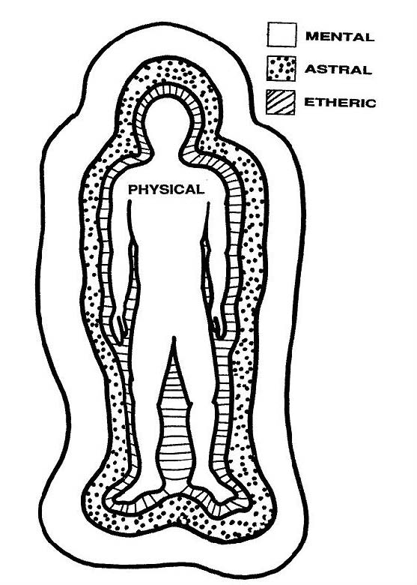
As you already know, you have an energy body surrounding and interpenetrating your physical one. This we call the etheric body. In my first book I simply lumped all the functions of your energy body into the etheric body and I did this for the sake of simplicity. Actually, it gets a bit more complex. Your etheric body has a number of gradations within it and these gradations each have different functions.
Closest to your body is your aura. It is the densest level of the etheric body aside from the physical body itself. The colors that are sometimes seen in this aura reflect various aspects of the personality and health of the person. At times, waveforms and thoughtforms are also picked up by those who are sensitive to such things, though these usually appear at the next level, which is the etheric body proper. It is less dense than the aura and is rarely visible except to certain extraordinarily gifted individuals. It is at this level that most waveforms and thoughtforms that can affect the health of the physical body are found.
The etheric body is the stuff which the physical body is hung on, and it contains those somewhat mysterious vortices called chakras. I will discuss these in more detail later. The phenomenon known as kundalini also occurs in the etheric body. Most psionic work that affects the physical body will involve manipulating this level.
Of a somewhat less dense nature is what is sometimes called the astral body. This is the level where emotional responses have their greatest effect and it is sometimes more accurately termed the emotional body in older literature.
Moving to the finest degree of density that we are able to work with is the mental body. As you can guess, all intellectual activity has its manifestation at this level. The nineteenth century produced writers who delighted into going into great detail about these various levels went further and divided the mental level into what they called the upper and lower mental. The lower mental was concerned with the usual everyday thoughts of a person, as to what to make for dinner, what whip to use on the girlfriend, that sort of thing, while the higher mental was concerned with more abstract matters, such as how much to tip the waiter after dinner. In point of fact the distinction was quite arbitrary and, like much of the nonsense of the nineteenth century, probably has no basis in fact. It may have been put because the human was supposed to have a seven-layered body (perish the thought it should be a lowly six) and when you take out the two that were purely spiritual in nature, you have to add an extra one to make it fit the system.
It is important to understand, however, that all of these levels continually interact with each other and none is completely independent. They also are continually influencing and influenced by the physical body, which by the normal five senses picks up and transmits to them the information that causes the various reactions in each body.
It’s example time again. Let us assume that you are having a reasonably good day. The air is warm and the sun is shining and your brother-in-law’s cancer is progressing nicely. In other words, no more than the usual disasters. Then mail comes, in the morning for a change. You go to the door and bring it in, separating your mail from the neighbors which has been delivered to you by mistake, and seeing that one of the envelopes is undoubtedly a bill, you resist the urge to throw it in the wastebasket and open it. At this point your day turns into a very bad one indeed for the company has billed you several thousand dollars for something that should have been $13.95.
As your brain processes this information, the message goes to the mental level, which literally screams ERROR and is about to send the blue screen of death to your heart and screams it so loud that the astral, or emotional, level which had been more or less dozing, wakes up and begins to go berserk—or rather you go berserk. The emotional message is transmitted back to your etheric body, which sends a message to the adrenal glands to get to work and your heart rate takes off like a rocket. Speaking of rockets, your aura is taking on the appearance of a fireworks display, full of nice reds and blacks and blasting merrily off around your body. At this point the clairvoyant next door comes over to borrow a cup of sugar, takes one look at you and runs home in terror to have a heart attack herself.
You go to the telephone, dial the company number and get the billing manager, frantically demanding an explanation of the mistake. The billing manager is used to such small problems and is thus not as upset as you. After all, it is not his money. He calmly explains that the error was the result of an incompetent computer operator who has since been transferred to their branch office in Chechnya.
Your brain transmits this glorious information to your mental level, which in turn passes it down to your emotional level, which tells your etheric body to turn off the adrenalin; and your aura begins to take on more normal coloring which is of great comfort to the clairvoyant next door who sees you just as she is being wheeled into the paramedic truck.
This is, I will admit, an extreme example, but you can see from it how the various levels interact with each other. With psionic devices, we can isolate the function at each level and influence it, thus allowing ourselves a great deal of control over our subjects.
Another feature of the various levels is the fact that while they all interpenetrate, the finer levels are more spread out from the physical body. So now we can do our first experiment.
For this experiment, you will need the following objects.
One subject, preferably human.
A radionic box.
A patch cable to connect the box to a psionic amplifying helmet.
a table
a large sheet of paper.
Lay the paper down on the table and seat your subject at one end of the table, laying his hand (either one will do) on the paper. Set your box on the table as far from the hand as the length of cable will allow. Now, write “etheric body” on a small piece of paper and place it in the input witness can of the box. Take a rate for the etheric body of the subject. Now, move the box a little closer to your subject so that you can rub the stick pad while holding the one end of the patch cable to a finger of the subject. Plug the other end of the cable into the left hand jack on the box.
While slowly moving the end of the cable away from the finger, rub the stick pad and continue to do this until you get a stick. This point will be the extent of the etheric body from that finger. Repeat this procedure going around the hand and connect the points. The drawing that results will be a picture of the subject’s etheric body. Of course, the etheric body extends in all directions from the physical, and there is some debate as to whether or not it forms an egg, a sphere, or a rough outline of the physical body itself. These minor details are really of very little importance to you and so if you should run into the varying descriptions given on this subject, do not be overly concerned. Psionics is still something of an inexact science, which causes some annoyance to all of us who work with it, but it is a fact which cannot be ignored.
Once you have the drawing of the etheric hand, you should try to get the astral hand. This may prove to be a bit difficult as the astral body tends to expand or contract with the amount of emotion being put into it. Therefore, with your subject as calm or as happy as possible, repeat the procedure, only this time with the box set for the astral level. With any luck you should get another drawing, but do not be surprised if you run out of paper or even table. The astral level can extend quite far, even covering the entire house.
It is doubtful that you will be able to draw the mental level, unless you have a very large table and lots and lots of paper. What you can do is to set the box for the rate for the subject’s mental body and walk back from him while rubbing the plate, always keeping the idea in mind that you will get a stick once you reach the limit of that body. Do not be surprised if you find yourself in another room when the stick occurs. I remember the first time that I tried this experiment I found myself in my girlfriend’s backyard, in the snow, without a coat. Needless to say I advised her not to think so much. She could have gotten a headache.
What this small activity will teach you is just how far-reaching your energy body is under normal circumstances. Given the proper stimulation, it is possible to extend these bodies even further. In fact we have no idea at all just how far they can go.
Reset the box for the emotional body. Now have your subject think of something dreadful that has happened to him recently, preferably not the last practical joke you played which left him standing naked in front of a dozen people. Once he is good and upset, begin measuring the distance that the astral body extends. You will find it to be quite a bit larger than when he was just sitting.
The same is true of the mental body. The more energy that is put into a body, the larger it becomes. Think of all the people on a crowded street, with all their physical bodies touching at various unwanted places and then think of what it must look like if one were able to see the continuous intermingling of the various energy bodies. It is enough to make one quite frightened of crowds but for a simple fact. Most people have so little in common that the nature of their bodies is such that they can bang into each other without the physical brain even registering the contact. When it does, the result is a feeling extreme unease that can turn into claustrophobia. There are individuals so sensitive to such things that they cannot even sit near even their closest family without being uncomfortable. This is not a cultural matter. It is true that different societies have a different tolerance for closeness, and we Americans need a lot of space compared to the rest of the world and that spatial need is growing larger, but the discomfort caused by the intermingling of the energy bodies is something quite different. It is not a learned response but rather quite instinctive.
Of course, given the right amount of energy it is possible for the energy field of any individual to influence another person. Surely you have had the bad luck to walk into a room where someone has been really hopping mad. (does anyone really hop when he is mad?) It feels like somehow the air pressure in the room has suffered a dramatic and unhealthy increase. By now I’m sure you can figure out for yourself what has happened. The anger of the person has been translated into a marked increase in both size and power of the emotional body. What you are feeling is not a physical sensation at all but rather a psychic one, which has been translated by your brain into the only response your nervous system is designed to handle. As I said before, it is possible to so expand this body that it can fill an entire house, so if you get absolutely furious, you can make every person in the home uncomfortable without leaving your room or even saying a single word.
It’s a good way to get rid of the relatives.
It is useful to be able to measure these bodies, not only in the amount of space they cover but also in the energy level that they are functioning at. This is usually done by using a pendulum and a scale divided off between 0 and 100. But I have found that there is an even better method.
Print out this chart.
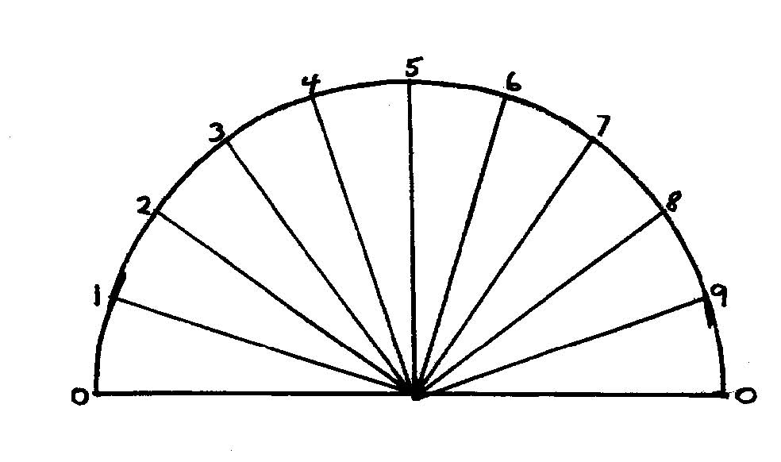
Now, cut it out and glue it to a piece of poster board. Cut off the excess so you have poster board left over.
Put a an extra 0 after each number except the right hand 0 which you will mark 100
Ok, now you have a chart that runs from 0 to 100.
Now, further divide the space between each number with small hash marks so that they are marked from 1 to 9. This will give you an easy-to-read scale of 0 to
100.
Punch a hole at the point in the baseline where the lines all meet. Cut out a strip of poster board from what was left over and cut the ends of that strip to make a point. Punch a hole in the end of that strip and fasten it to the scale with a paper fastener.
Ok, now you have your gauge. Are you ready for another experiment. What do you mean, “No?”
This one is just as easy as the last one and not as much work, so stop complaining. At least you will not have to move around as much and there is no danger of you backing off the front steps. (Damned near broke my neck that time!)
Find your subject again. She is probably hiding in a closet. Now, this time, instead of measuring the size of the various bodies, you are going to measure the amount of energy in them. Sounds simple. And it is. Have your subject hold the probe wire and take a rate for his aura this time. Now set the gauge in front of you (it is not necessary to attach it to the box in any way) and place the pointer at 0. You should not get a stick there when you rub the pad because if you do that means that your subject is dead. You will also not likely get a reading at 100 for that is the theoretical maximum point that anybody can reach and may not still be human.
With that out of the way, you can begin to take a measurement. Set the pointer between 0 and 10 and ask if the level of the aura is in that range. Do not expect a stick yet as this is a very low range and healthy, or even living, subject rarely reads in it. Repeat the process for each 10 points until you get a stick, let us say between 60 and 70.
Set the pointer at 63 and ask if the measurement is between 60 and 65. If you do not get a stick on your machine, set the pointer again, this time at 68 and ask again. This time your thumb stops. So put the pointer at 65 and move it up one number until you get a stick, this time let us say at 66. You know now that your subject has an aura of 66% of theoretical maximum.
By this time you have probably figured out that all of our measurements are arbitrary, including the all-important rates. Therefore, if somewhere along the line you want to change the numbering system, go right ahead.
You may now repeat the procedure with each of the other bodies until you have a series of measurements that will give you a pretty good idea of the overall condition of your subject. For example, if your subject is weak at the level of the mental body, it may be that he is not as his best thinking capacity that day rather than being a stupid person. As time and practice goes by, you will be able to interpret your findings with greater accuracy.
But how does this knowledge benefit you? After all, I promised to give you more information on meditation and visualization, and then I lead you on a merry romp measuring your friend’s various energy fields and making you build a new, albeit incredibly useful, gadget.
All kidding aside, you will need to know how to do these things in order to measure your own progress. It is terribly frustrating to be working at a visualization and not know if you are getting any results.
We are now going to teach you how to mold your etheric body for various purposes. This is not always as easy as it may sound. Some writers have suggested that visualize while looking at yourself in a mirror. It sounds good but it is very difficult to do. I know because I spent years trying and never got anywhere with it. A far better method is to simply imagine yourself. Think of your aura, that part of the etheric body which is closest to your physical one. Try to see that aura in your mind. Do not worry about color or anything else at the moment, simply hold the image of your aura in your mind and know that the aura is there. Now expand your image of yourself to the etheric level. Realize that the etheric body is as much a part of you as the physical and the aura.
Move your awareness now to the level of the mind itself, the mental body. Here is all your thinking capacity and processes by which you think. There is relatively little data stored here, most of that being kept available in the physical brain, but it is from here that the data is accessed and used. It is surprising that relatively few thoughtforms are found in the mental body, but the nature of the energies involved in thoughtform production usually place them in the astral body or the aura. The mental body is a very cold place for no emotion is found there at all.
Now return your awareness to your physical body. Feel the incredible solidity of it and rejoice in that solidity. You are a physical being as well as a spiritual one and you must enjoy you physical presence.
The purpose of that little guided tour was to give you a feel for what I have been talking about. Once you have looked into each body you will know what that body does, and, perhaps more importantly, what it does not, do.
Now you are going to repeat one of your experiments, using yourself as the subject. Take a picture of yourself and put it into the sample can. Once you have done that, take a rate for your aura. Set your gauge at 0 and begin stroking the pad. As soon as you have the distance you will get a stick. Repeat the experiment with each body until you have a series of measurements to start with. Then go back to the aura rate and measure the strength of each body in turn. Be certain to record these measurements so that you have a base line for the next series.
Once you have done this, reset the machine for your astral body. Begin to meditate, and, while meditating, let your memory wander back to some emotionally charged incident in your life, preferably a happy one. Hold onto the memory and let it fill up all the available disk space in your astral body so that it seems that your emotional capacity is dedicated to that moment in time. Now pull back to earth and using the gauge, measure both the size and strength of your astral body. You have a much larger figure for both, don’t you?
Once you have finished this experiment, it is a good idea to meditate again, this time on something very calming so that you will again be fit for human company. Also, one small word of warning. If you are working with an angry memory it is a bad idea to do this with a partner. The emotions built up can be very strong and the results downright dangerous to anyone else in the room with you. I remember one time I tried with a memory that made me absolutely furious and I almost smashed some furniture. So be careful! There are a few people out there who think we should all contact our most unpleasant memories and they are usually happy to supply some if they are not there. But there are some memories that should be repressed and unless there is an overwhelming reason not to, it is best to treat the worst experiences of our lives as sleeping tigers, to be walked carefully around and never to be kicked.
What you should learn from the above, aside from my most sensible warnings, is that it is possible to the control the output of energy from the emotional body. In fact, that is the level which is most responsive to such changes. It is also the level that has the greatest impact on a subject whom you wish to influence. In spite of the more pervasive nature of the mental level, it is much easier to motivate a subject by producing an emotive response in him that by trying to put an idea in his head.
In my first book, I taught how to use the eye-beam. If you will recall, the procedure required that you focus the energy of your etheric body through your eyes to the target. Well, by using the astral body, one can attain some pretty significant results without even focusing on a specific target.
So now that you know this, let’s have some truly harmless fun. (Ok, I know that harmless is out of character for me, but just this once...) For this trick, I am assuming that you have some capacity for self-control first, otherwise you might find yourself gaining a few pounds. So study yourself a little. And be honest!! Can you get really hungry and hold off eating everything in sight including the neighbor’s children? If you can, you are going to have a little fun the next time you go into a restaurant. (And HOWIE! Skip this section!)
Before you walk into the eatery, get yourself good and hungry, practically famished. Be so hungry that if you did not have consummate self-control no one would have any food left on their plates. Feel the hunger gnawing at your astral body and feel the astral body expand as the hunger energizes it. Let the desire cause that body to expand until it fills the entire room, but control yourself and do not mug the waiter.
While you are waiting for your own gargantuan repast, which you will have no trouble finishing, focus your thoughts on the solar plexus of somebody else in the room. The solar plexus is the spot where the response to emotion is the greatest. That is where the term “gut feeling” comes from. Know that the person at the other table is feeling the desire and is responding to it.
At this point, the old principle of harmonics comes in. I am sure that you remember the ancient, high-school physics demonstration of the two tuning forks, one set to humming and the other simply held. Remember what happened? The other fork began to hum at the same frequency as the first one, to the amazement of the class. Well, you are doing the same to your subject’s astral body. His emotions are responding to your hunger. Pretty soon he is going to be absolutely ravenous and you will be able to tell when that point is reached when he starts devouring the dinner rolls in spite of the fact that they are at least four days old and have little green and blue spots.
At that point you may begin to work on subject number two and soon the cook in the restaurant will be working overtime and the management will be absolutely overjoyed at the sight of so many people enjoying their food. The diners, being so happy to have their bellies filled, will reward the waiters with extra tips and everyone will be happy.
Ok, that is really out of character for me, so once everyone has really overeaten, aim a nasty thought at the pit of their stomachs and see how many can be made to throw up. Ah, that felt good. Now my conscience is clear.
There is another aspect of the field that you should be aware of: color. To be honest with you, this is something that at times seems to be more trouble than it is worth, as there are a number of conflicting interpretations as to the meaning of certain colors in the aura, and by extension, in the rest of the field. Color is, after all, nothing more than the way the physical brain translates frequencies of visible light. We could just as well say that a person’s field is showing certain wavelengths, but that would only confuse the issue more. Because of this it is very tempting to dismiss the whole thing.
However, the detection of color in the etheric body, in particular at the levels of the aura and the astral body, can be of great use. Unfortunately, very few of us have the natural power to such detection, and it may be just as well that we do not have it. Those who do often find that it makes their lives even more difficult than they would normally be. Besides, with psionics, there is no need to actually see the colors. One may study the aura and the astral body with the aid of another simple device, the color disk.
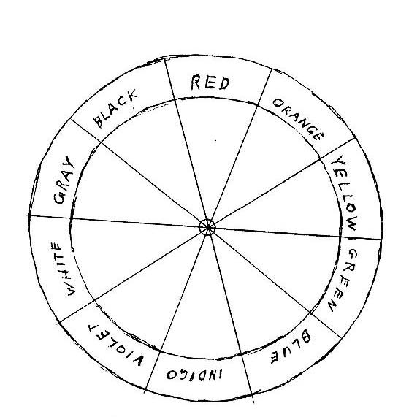
These disks can become quite complex, as various researchers have tried to use color to interpret everything from the aura to various minerals and elements. You should be content with a relatively simple one.
Make a copy of the above illustration, or print it out separately. Now, make another pointer as you did on your gauge and cut out a sheet of poster board the size of a piece of typing paper and glue the disk to it. Punch a hole in the center of the disk and at the flat end of your pointer. Attach the pointer to the disk with a paper fastener and you now have a color gauge.
You will notice that each color has a bit of area to it. This is because there are only so many colors and you have to fill the whole disk. But it has another advantage. The closer the pointer is to the center of a color wedge, the purer the color. This can be of some importance if you are making a detailed analysis of the subject.
So, what do the colors mean? As I said, this is a subject of some controversy and seriously Talmudic hair-splitting, so do not view my word as being completely authoritative on the matter. Experiment for yourself and see how your own mind interprets these things. The view I give you here is one that seems to fit most cases.
Black is a color you would not wish to find in an analysis of someone you like but might be nice to find in your in-laws. It means that there is a deep malice, a serious wound that has never healed. And in the case of the in-laws you would expect to find deep malice. Occasionally seen as a slash across a red background by panic-stricken clairvoyants, it can denote great anger.
Red means anger. The purer the red, the greater the anger. It can also mean a person given to sensuality and thus can be a difficult color for the average clairvoyant to interpret, especially if found in a potential bedmate. You on the other hand, can ask your pendulum which it is.
Orange is color that does not mean much unless your subject is from Northern Ireland or a juice seller from Florida or some paranoid nutcase on the news holding up a roll of duct tape. If it is strongly present it means a very well balanced personality, which may also mean a very bland personality. It is the color associated with the flow of the vital force from the spleen chakra, so it may also mean good health.
Yellow is usually a good color to have, unless you are a European diplomat, all easily recognized by the yellow stripes down their backs. It means that the subject is smart. There are also those who say that a lot of yellow means that the person has a highly spiritual nature, which may be a very bad thing as such folks are often so heavenly minded that they are no earthly good. It is very difficult to make a determination in such matters so the best thing to do is judge by the behavior of the individual. A spiritual person rarely beats his wife outside of the bedroom or the dungeon or his children ever, no matter what platitudes he may repeat, while a person with a highly developed intellect cannot help but show it.
Green is another hard color to figure out. It may mean anything from cleverness to avarice, both very good things to have.
Blue, on the other hand, is relatively easy to figure out. It almost always means a tendency to mental rather than physical activity. Hence a chess master will have more blue in his aura than a basketball player, at least in general.
Indigo is usually mistaken for either blue or violet, so its presence can be a modification of the qualities of either. It is never found in basketball players. Those poor devils who emphasize the spiritual as opposed to the mental would think that the presence of indigo would mean a transition is taking place between the two, but they also eat tofu so you can’t take them too seriously.
Violet, on the other hand, is an almost entirely spiritual color and those who have it are usually so damned heavenly minded that martyrdom is too good for them, self-righteous bores that they are. Fortunately it is very rare to find anyone with this color in any great proportion.
Do not expect to find any white. It is almost never present in the aura or the astral body. But if you find gray, watch out. Your taxes might get raised (sorry about that). Gray is a bad color because it tends to bring out or show rather, the worst aspects of all the other colors.
Now that you have some idea of what the various colors can mean, you are going to do a little research. There is a little project that is sometimes given to students in beginning psychology courses, namely to write what is called a “psychological profile” of someone in which not only the behavior but the possible motivations of the person are analyzed. (I would love to have someone do that with me and watch them turn pale and flee!) So pick a person whom you know well enough to study without his or her knowing it and write up such a profile. Consider everything you know about this person, how smart he is, his strengths and weaknesses (often the same thing in different contexts). Once you have done this, acquire a witness sample of the person. This should be easy if you know him well enough.
Set up your machine and take a rate for his aura. Now place the color gauge and the number gauge in front of you and begin to look at his colors. Place the pointer on each color and ask the stick pad if this color is present in the subject’s aura. Write down each color that gives you a positive stick.
Once you have a list of colors, write % on the paper next to the word “color”. Your sheet will ultimately have three columns and this is the second. Set the color dial again at each color you got a stick for and ask the numerical gauge what percent of the aura is taken up by that color. By the way, do not be disturbed if your numbers do no quite add up to exactly 100%. There is a constant fluctuation of color in the astral body, between each reading, as short a time as it is, the relative percentages will change. What you will get is a good, working approximation.
Now you may do the last part of this reading and set the pointer on the color disk at the first color. Write “intensity” on the paper at the third column. Take a numerical reading again for each color, with 0 being the total lack of color and 100 making the aura glow in the dark.
The chart you get should look something like this: Now, from this chart you can see right away that my friend Joe has a problem. There is only ten percent black, but it has an intensity of 30 which means that some deep hurt is still gnawing at him. Combine that with the presence of gray and you have a person who can be quite unhappy at times. Now, Joe’s profile says that he is given to fits of melancholy at time that can almost become depression, that fits. You will notice that red is only 25 percent, while yellow and blue add up to 45 percent. That combined with the far greater intensity of blue and yellow over red means that Joe is a much more mental than physical type of person. He does not now and never has played basketball. We also know that Joe is a sensible person will little time for spiritual nonsense, therefore we can reasonably assume that both yellow and blue in his case mean mental nature. The balancing factor of orange is a mere five percent, and that means that Joe has some small grasp on his problems but the combination of the others means that he is probably feeding his misery by thinking about it too much. We know from his profile that he is a decent person who rarely inflicts his troubles on others and therefore is keeping the fury bottled up. It is not dangerous at present, but any significant increase in either the gray or the black could mean than an explosion is imminent. Watch out if he has a financial reversal.
color | % | Intensity
Black | 10 | 30
red | 25 | 10
orange | 5 | 10
yellow | 15 | 60
blue | 30 | 60
gray | 12 | 20

Well, now you have seen how it is done. You should repeat the procedure, first setting the radionic box for the subject’s astral body. Doing this will give you an idea of the emotional make-up of the person you have chosen and again, after you have finished, study the chart and compare the information with the data in his profile. This last is very important, for it can prevent you from making embarrassing mistakes.
There is one man I know who has some clairvoyant abilities but has never learned to control them. He is too quick to make judgments based on incomplete data and is always giving people advice based on his spiritual (overly so) studies and his-er-visions.
This would be less of a problem for this person if he would only take the time to learn something about the people he is talking to. Once he looked at my aura (and lived!) and decided that I could use some advice whether I wanted it or not (and still lived, which means I must have been in a very good mood that day). So he began doing an impromptu reading of my character (which I do not have, character is for the servants) from what he saw in my aura and naturally got everything wrong. For example, he told me that I was afraid of the dark. I should explain that at that time due a weird architectural fluke, my bedroom had no windows. Air came in through vents aided by fans. Thus, when I finally got to bed, usually around two or three on the average morning in those happy bachelor days when I did not have to get up with my wife to make sure she got to work on time, it was quite impossible to find my hand without the aid of a flashlight.
As you can imagine, I was somewhat less than impressed with both his information which was wrong and his advice which was worthless. If he had bothered to find something out about me first, he could have saved himself much embarrassment and trouble, to say nothing of being on the receiving end of my humor for the next year.
Thus I hope you have not only learned what do, but also what not to do which can be even more valuable. You will see this even more clearly as we go along.
As you now have some practice in the basic method of analysis, you are about to have the pleasure of applying that same skill to yourself. Remember, you cannot hope to influence other people unless you can control yourself, at least most of time (I rip doors off of hinges when I lose my temper) and the first rule is to know enough about yourself to have some idea where are likely to run into a weak point. After all, if you know that a potential character weakness is present (like my temper) you can act to compensate for it before anyone can take advantage of it.
Be ruthless with yourself in this, chain Ruth in the basement if you have to. Remember, anything you miss may be the heel where the arrow hits. Begin by making a profile of yourself. Do no underestimate, nor overestimate, any weakness or strength. Once you have done this, study the colors of your aura and astral body and compare that information with your profile. Do not be afraid to admit to yourself that you have some quality that needs work.
Let me give you another example. I have one quality that works both as a strength and a weakness. I have been blessed with the ability to be totally oblivious to the feelings of other people. I am the exact opposite of an empath. Often I do not even recognize their physical presence. This is the sort of thing you must look for. The more you know the less you can be surprised.
Once you gain this information, what do you do? First determine if what you think is a weakness really is one, so you will look not only at your profile, but also at your life to see if any change should be made. In my case, I happen to really like the ability that I mentioned. It enables to me to do and say the things I do. I would not change it for the world. At the same time I do not wish it to backfire on me, so I simply create a thoughtform (remember those?) to block any opponent from grabbing onto my blind spot. Also, if I am going to be in such a position where there is a great likelihood of such an occurrence, I create a stationary thoughtform in that location and design it to block anyone who may be a problem.
How does this work? You are, I’m sure, familiar with the various forms of self-protection that are used when walking in bad areas or driving in areas known for predatory cop-type people. Most folks into psychic stuff usually just surround themselves with a white light, and that is often sufficient for their purposes. But sometimes someone comes along who is not receptive to that and the individual who depends upon that simple defense is in for a shock.
I prefer something a little more aggressive. Meditate and visualize yourself as wearing a suit of armor. It does not have to be a full outfit—a simple breastplate and helmet are usually sufficient. See yourself as wearing this armor, and at the same time command that your etheric body take the form of the armor. If you can see this as being either black or red, so much the better, for in any aggressive working the more of these colors we can get the better. Know that as you charge this image, anyone who comes near you will with hostile intent will feel an overriding fear that reaches down to his very bones and he will not be able to stay in your presence. Keep working on this. It is a very effective modification of your field, so effective that I have seen large people cross the street to avoid making contact with me.
There are those who will contend that the above exercise is more in the manner of a creation of a thoughtform, but, on close examination, you will find there is a great difference between molding the astral or mental bodies, as you have done, and creating a thoughtform. For one thing, the thoughtform will, after some use and charging, take on a practical life of its own. A molded field will only keep its shape as long as it is being used. Therefore, it is a good idea to remake the armor now and then until you no longer need it. If possible, keep the visualization active in the back of your mind while it is being used, like a program running in the background on your computer. This technique is not so difficult as it may seem. It is something akin to carrying on a conversation and watching television at the same time. There are other, more subtle, differences between a molded field and a thoughtform, but these need not concern you and we will not be discussing them at this present time.
A thoughtform may also be made that will serve to strengthen and mold your field automatically, and I will cover that in another chapter. For now, let us concentrate some more on your field.
I have gone on at some length about analysis, because as you progress in psionics you will learn that most of your activity will in some way involve ability to study your subject. Remember, the more you know about a person, the more effectively control that person. And, when conflicts come, as they most assuredly will, you will have a storehouse of data that will give you an overwhelming advantage.
Up to know we have concentrated our efforts on studying the aura and the astral body. As most people are primarily influenced by their emotions, it was necessary to spend some time on the subject. But now we will take a short look at analyzing the mental level. This level is a bit harder to study because it is more complex, containing as it were much more information than either the aura or the astral body and the information is somewhat harder to get at. To begin with, color plays a very small role in the mental level. There, color is just another piece of data to be used or rejected. Also, much of the activity at the mental level is extremely transitory and it is thus very hard to grab onto a single thought and put it into the can, so to speak.
Because of these difficulties, when we study the mental level we are not going to be looking for those individual thoughts, no matter how powerful they may be. Rather, we are going to looking for thought patterns—how a person thinks rather than what he thinks. In this area, psionics gives us an advantage that is not normally available.
This is not a new idea. As long as people have had conflicts, major or minor, one side has always tried to understand the other. It often takes the form of gaming in which simulations are used to predict the possible actions of opponents from what is known of their behavior patterns.
So, what we look for when we analyze the mental body is not what we already know about a person, but rather what is hidden—those patterns that do not show but are nevertheless dominant in the character of the subject. Once you know these, the mind of anyone becomes an open file.
One never studies the mental level without first making a complete analysis of the aura and the astral body. People are not dominated by thoughts but by emotions even when they imagine that they are being unemotional so you must first know what the emotional nature of the subject is. Once you have that information, you may begin to look for thought patterns to emerge. In order to accomplish this, you must first look for the basic desires, likes, dislikes and other dominant features of the person’s thoughts. It will thus be necessary to make a dial chart similar to the color gauge, with a pointer. When dividing the circle, make a space for each aspect of thought that is likely to influence the subject. These should include home and family, education, religious or spiritual beliefs, peer influence, work. sex, politics, health and any other you may think of. One of the nice things about these gauges is that you make new ones with great ease if the old ones become obsolete. And, as we always manage to leave something out, it is a good idea to have a space marked “other.”
Once you have done this, take a rate for the mental body of the subject and set your gauge to the first place, say, family. Use the stick pad to see if that is a significant determiner of the subject’s thoughts and do not be surprised if it is not. You will become amazed as you go along with this and discover just how unimportant things can be to people. Assume nothing, that is the easiest way to be wrong.
Go around the gauge and test each category, marking on a piece of paper the ones that get a response.
After you have your list of things that influence the thoughts of your subject, get out your numerical gauge and repeat the procedure you learned to analyze colors. You want both percent and intensity. Once you have made a chart similar to the one for the colors, take a piece of paper and write “analytical” on one side and “emotional” on the other. Take the witness sample out of the can and place it on the paper between the words, a little lower than they are so the words are at an angle to the witness.
Now get out your pendulum. Hold the pendulum over the witness and ask if the subject is more analytical or more emotional in nature. The pendulum will swing towards the correct answer. Write that answer on the chart.
Now that you have chart that will tell you the basic mental makeup of the subject, you can begin to study his thoughts. Of course what you do with this knowledge is up to you. And inducing suicide is usually more of an emotional thing than a mental thing, just thought you should know that.
Next we will look at the influence of the mental body on other people and how their mental bodies in turn influence us. As you can well imagine, this is a matter of some importance to anyone who works in the area of the psychic. After all, influence is what it is all about.
There is no question that the mental body and its transmissions can reach anyone, anywhere, on the face of the earth. Telepathy experiments have been done involving not only people but animals including very small animals—like snails. SNAILS?!?!?!?!?
Yes, you read right, snails. In 1852, which is long before even I was born, a Frenchman (figures) named Benoit came up with the idea that certain relationships in the animal kingdom could be proven. He must have been having dinner at the time, because he chose snails as his subject. He gathered 52 very cooperative escargot, saving them from the saucepan and garlic butter, and set them to living in pairs. On the shell of each pair he wrote a letter, the same in each pair, so that he had two A’s, two B’s, etc.. Then he sent one set of lettered snails to a friend in America with explicit instructions not to eat them, telling him when the experiment would take place. At the appointed day and hour, he proceeded to give a very mild electric shock to Snail E. It was reported that the other Snail E in America became very animated for a snail and threatened to sue Mssr. Benoit. Just kidding. Anyway, it was proposed that a “snail telegraph” be established. Fortunately nothing came of it because snail lovers all over the world would have been furious at being deprived of their favorite delicacy and the Society for the Prevention of Cruelty to Snails would have raised all manner of hell.
It is easy to laugh at the Great Snail Experiment (in fact it is impossible not to) but on August 25, 1965 (my 16th birthday) The Delawarre Laboratories conducted an experiment between Oxford and New York using equipment somewhat more sophisticated than what was available in 1852. After all, television had been invented. The Delawarre people had invented a gadget they called a psychoplotter, which measured changes in body tissue by the change in the sound frequencies inside of them. And by means of this they were able to tell when their victims-er-subjects were responding to their treatments. It also made a nice graph using a plotting pen and rolling paper.
Anyway, a photograph of a 17 year-old subject with a leg problem was sent to John Hay of Fairfield, Connecticut (nice little town, spent a year driving through there one day) along with a piece of radionic equipment (nice of them to remember that little detail). The boy stayed in Oxford and was wired to the psychoplotter. After the boy’s leg had been run through the plotter for an hour to determine the usual state of affairs, the boy’s photograph was placed in the radionic box at 10:25 EST (by which time the redoubtable Mr. Hay had finished breakfast and done his stock trades). The graph noted a strong change. After twenty minutes the photo was removed and the plot resumed its normal course. Another twenty minutes passed and the photo was given a shot of light from an ordinary light bulb. Again, the plot showed a marked change.
The significance of this experiment is striking, for there is no reason why it cannot be repeated in any laboratory. You can even do a similar test yourself.
You will need, in addition to a willing victim, a galvanic skin response meter (GSR), a radionic box, and a convenient light. It is also good to have another friend watch the subject—that way he can be in a different room, or different part of the world for that matter.
Take a rate for the subject and have him set the GSR (which can be a cheap one from an electronics store) at the point just under where either the buzzer starts or the needle moves. Have the other assistant stay by the subject to make sure he doesn’t run away or cheat and watch the equipment. Do not tell them when the experiment is going to begin but do not make them wait too long either. Not only is that impolite but it may cause the subject to get disgusted and leave. After a few minutes turn on the light, aiming it at the machine. When you do this, there should be an immediate response on the GSR meter. Have your friends note the time when this happens.
I know this is not going to be as good an experiment as you could conduct with more sensitive instruments, but it will give you some good, hard evidence that your radionic device is working.
Now that you have proven that you can influence the mental body, you may begin to measure the degree of that influence. For this you will follow a procedure that should be well familiar with by now.
One thing you should have learned by now is that the key to getting any answers right in psionics is simply knowing which questions to ask. In this case you are going to take a measurement of the degree of influence a person’s mental body will have on another person simply by being in the same room with that person.
Up to no we have been taking a rate on the radionic box for the subject before asking any questions. If you feel you still need to do this, please continue, but there is a faster method which by now you should have the experience to use. For this you will need only the numerical gauge and stick pad (a plastic coffee can lid will do nicely). There will be no connections made. Place the witness of the subject in front of you and ask the question as you begin to move the gauge, as you have done before. 0 means no influence whatsoever and 100 would mean that the subject’s mere presence would turn everyone into a virtual robot.
Once you have done this with a subject, try it on yourself. Write down the figure you get and put on your psionic amplifying helmet and try again. You should get a reading somewhat higher than your first one. Of course if you have a friend who can use the equipment so much the better. It can be very difficult to get an accurate reading when we are asking something that truly concerns us. If you have a strong interest in seeing a higher reading for something, that is what you will get. So if you must test yourself, be as honest and disinterested as possible and bear in mind you may make a mistake. It happens to all of us. I can think of a number of times when my gauges said all was going according to plan and the reality was nothing of the sort.
Never forget that the mental level is primarily concerned with thinking and is energized and expanded by mental activity as opposed to emotional activity. It is important not to confuse the two. Fortunately, however, when experimenting it is quite easy to eliminate the emotions entirely. There are few people who can become either ecstatic or infuriated over long addition unless you are addicted to a calculator like I am and then it can become difficult to remember how to add at all, but then I forget my name on occasion. But this simple exercise can energize the mental body without letting emotion get in the way.
Take a reading to see just how far your mental body is reaching and what its intensity is. Write that down so you do not forget it and then begin adding lots of numbers. Do this for about five or ten minutes and then take a new reading. You should find that its size and intensity are both increased.
The influence of the mental body, however, is not as much in these areas. The real effectiveness lies in the fact that all telepathy comes from the mental body, though it may carry and be energized by emotion.
A message can only be effective when it is sent from the mental level and is clear. The greater the clarity, the greater the possibility that it will influence the receiver. In Elementary Psionics we studied ways of sending clear and concise messages. Never forget that at the mental level there is almost continuous activity and any message that is sent has to get through that interface. That is why emotional messages have greater impact than purely intellectual ones (think of the mental body as the carrier wave for the emotional one) and why a thoughtform, with its capacity to take root in the aura, is more effective than a directed thought.
CHAKRAS
One of the peculiarities of the etheric body is the presence, at the etheric level, of centers or rather vortices of energy known as chakras. Now I know that everyone and his grand-nephew has written about these things. And if that were not bad enough, none of the writers agree on anything except that that poor, benighted Theosophist, Bishop Leadbeater, did not know what he was talking about when he wrote his pioneering study of them which was based in toto on his own clairvoyant investigations which seemed to be in conflict with what everyone else has to say on the subject, from ancient Hindu texts to modern radionic researchers.
But what all are agreed upon is that these centers are essential for the functioning of the physical body. As one lecturer put it, “You don’t have to worry about opening your chakras because if they are closed you are dead.” But after that, it’s like a Theosophical Society Convention. Nobody agrees about anything.
First, no one is quite sure just how many of these things there are. They try to keep the number of the major chakras to seven, because of both tradition and the idea that each chakra has a color attached to it. This causes even more confusion, especially when they add in the minor chakras and fight over which are major and which are minor.
For example, David Tansley, who did what was probably the best research in this area, was convinced that the spleen chakra, while essential, is a minor chakra, thus making room for the pelvic chakra and keeping to the sacred seven thing. There is a small problem with this, for we can be sure of the function of the spleen chakra and that function is to make sure that the body gets its proper dose of vital energy, called prana, the stuff that keeps it running. How he could say that the chakra that performs that most necessary of functions was a minor one is still beyond me. But at least Dr. Tansley had the good sense not to go to the ridiculous extreme of some others (notably Christopher Hills) who ascribed to each chakra a certain function and then tried to extrapolate that function to societal behavior.
We have to be careful about when making judgments about these things so please take everything I say with a lot of salt, some pepper, a bit of paprika and remember that we are in an area where there is more disagreement than agreement. Like our study of the field, you must be willing to experiment for yourself to see what works and what is true.
I differ from most students of this subject in that I use an eight chakra system. For one thing, I have no use for tradition, considering nothing more than mold on the walls of the mind. I include the normal seven chakras and the pelvic chakra, which controls the genitalia and generally keeps people busy. In this I have taken Tansley’s interpretation and restored the spleen chakra to its place of honor.
Much of what has been written about the chakras concerns the use of these vortices as a means of gaining psychic abilities. At one time this was of great importance as there was no other way besides ritual of increasing these talents. With the aid of psionic devices, however, that need is largely gone and the fact is that increasing the activity of a particular chakra at the expense of the others can create more problems than it is worth. Therefore I will not waste your time with meditations on each chakra. You simply do not need them. For those actions that require the use of a specific chakra, you will find that you probably have, assuming that you are in reasonably good physical and mental health, more than enough energy available now.
The purpose of our studying the chakras is not so much how they can be used as how they can be controlled. One of the very very few times that the dire, and often absurd, warnings of the older writers makes sense is when they talk about the problems that can come from chakras working too hard, too soon. This is usually associated with the phenomenon known as kundalini, the rise of energy in the etheric body up the spinal column into the brain. This is an energy that lays dormant in all of us and it may be best that it stays that way.
It is very easy to laugh our heads off at the cautions given by the mad Bishop Leadbeater on this subject. Much of his concern was grounded in Victorian moralizing and that stuff is purest garbage. But in the case of kundalini, the Bishop was actually right, mirabile dictu! There are very real, practical, survival type problems that can result from letting this force run rampant through your etheric body.
First, you must understand that each chakra functions in such a way as to affect certain organs and functions of the physical body. If a chakra gets out of control, that organ or function can be damaged, sometimes quite seriously. If enough of them get screwed up it can drive a person to suicide. (I know of at least one such case, he was a friend of mine.)
Second, and this is perhaps more important, is the possibility of psychological damage. There are certain psychic abilities that do come from the rise of the kundalini energy, but if these are unexpected or worse, uncontrolled, they can make it impossible for an individual to live any sort of normal life. There are few instances more tragic than the person who suddenly discovers that he can see the astral plane and the discovers with horror that he can no longer distinguish between the astral and physical worlds!
Leave Kundalini alone!
So much for the dire warnings, now back to our regularly scheduled chakras.
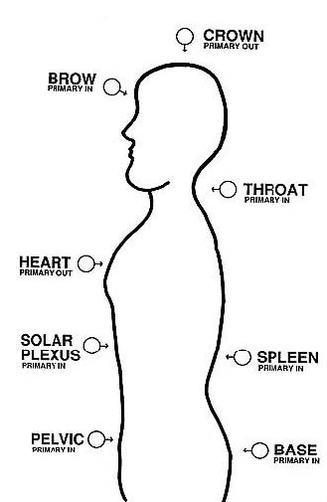
As I said, I have found that an eight-chakra system is best for my work. As you progress in your own experience you may wish to use a different one in which case you have to write your own book.
It is traditional in discussing each chakra that we start from the bottom and work up, sort of like climbing a totem pole (and please do not take that literally). There are no major chakras in the legs as they are pretty much expendable unless one is into walking, so the first one that we encounter is appropriately enough the base chakra. This is also sometimes called the anal or sacral chakra, though the term “sacral” is also sometimes applied to the pelvic chakra. You see how this can get confusing. Anyway, the base chakra is roughly located at the bottom of the spine but you probably figured that out already. This chakra is primarily concerned with the spine itself. It is also the place where the kundalini is supposed to be stored, coiled up and waiting to burst forth and cause all manner of havoc. Because of its relationship with the spine, the lower parts of the central nervous system are controlled by the action of this chakra.
Next we encounter the pelvic, or whoopee, chakra. The location and function of this chakra should be obvious.
Once we have risen past the pelvic chakra, which we don’t do until extreme old age when it no longer matters tee hee hee, we come to the spleen chakra. This is one of the biggies, as far as the minor matter of staying alive is concerned. The action of this chakra and those minor chakras associated with it determines the amount of vital force taken in by the body and how that force is distributed. As a result, this chakra has the tendency to absorb energy from other people if one is unwell and this, as you can imagine, can cause some difficulties for people around such a person.
The solar plexus chakra is one you have already encountered. If you will remember my little experiment with hunger, you were using the fact that all emotion is transmitted by the solar plexus chakra. It is a direct link between the physical and the astral bodies. In the physical body, it controls much of the endocrine system, the digestive system and the skin. Malfunctions of this chakra can cause all manner of troubles, like cancer.
The physical counterpart of the heart chakra should be obvious even to the most unenlightened of gravel truck drivers. Like the solar plexus, this chakra has a role in the emotional level but in a much more limited way, unlike the solar plexus which works with all emotions.
The throat chakra is roughly in the area at the top of the throat. It governs the throat and the lungs and works with the solar plexus in controlling the intestinal tracts. Malfunctions in this chakra can result in such things as allergies, fatigue, menstrual irregularities and asthma, as well as all maladies of the throat and its glands.
The two brain chakras, the brow and the crown chakras, are a bit hard to pin down as to their physical manifestations. The brow chakra is assumed to be associated in some way with the pituitary gland. More importantly, for our purposes, the brow chakra is a major psychic receptor point. It is the location of the “third eye” and all psychic transmissions that are first handled by the mental body come through here first.
The crown chakra seems to be the controlling center for the entire system. Here lives a funny little man with a big control panel with lots of dials and levers—just kidding. It is supposed to be related to the pineal gland. The crown chakra is the other main emitter of the of energy in the system, like the heart chakra. In this way it cooperates with the brow chakra which controls the eyes as receivers and transmitters of psychic energy.
As I said earlier, we will start by learning the procedures for controlling the functions of the chakras. They are really quite simple and should present you with little trouble.
The malfunction of any one chakra can produce various side effects on the physical body. Therefore by knowing how to restore a chakra to normal, balanced operation, you will be able to improve your health. Now remember, never consider psionics as a substitute for conventional medicine. Rather use it as a supplement and do not tell your doctor. He will have a fit and maybe a heart attack. Even if your machines say you are cured, do not stop your treatments until the diagnosis is confirmed by standard means. There are too many idiots out there dying because the spirit of Darwin has determined that they prefer the nonsense of faith healers and witch doctors. Do not be one of them!
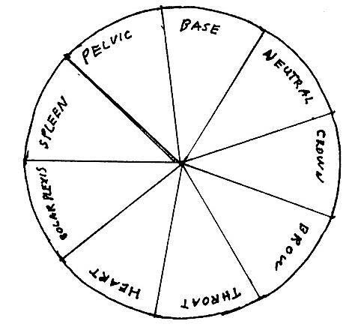
Now that we have that boring stuff out of the way, here is how you work with chakras. You will want to make another gauge, in fact you may want to make two. The first will look like the one above. You will notice that I left a space for a neutral position. This is to make asking an all-important question easier; namely, is the particular problem cause by the malfunction of a particular chakra or not.
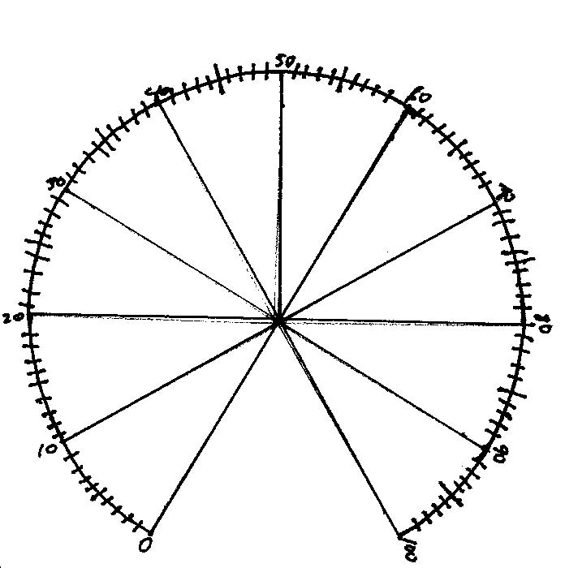
Once you have made the circle for the chakra gauge, make another numerical gauge which will look like the figure above. Then make the pointers. Now, cut out the gauges and attach them to a sheet of cardboard. Make a circle for the witness between them and you should have sheet that looks like this.
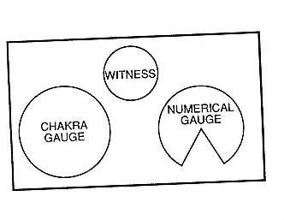
Only hopefully yours will not be lopsided. Now attach the pointers in the traditional and approved manner. You now have a double gauge specifically designed to study chakra function. Incidentally, you may make gauges for analyzing just about anything this way. 20 years ago I made one I jokingly called my Pervometer. It had the same numerical gauge but the other gauge was marked off with various sexual activities I liked and also did not like. When I would meet a likely prospect, I would check her against the gauge at home to see if she were worth following up on.
Anyway, back to chakras.
This is a system that is rarely worked blind. Unlike the methods of the last chapter, you do not give didly about the mental or emotional state of the subject. What you will have is person who is not feeling well and in fact may be in Death’s living room having a beer with Mrs. Death waiting for him to come home. Hence you may already know what is wrong with the person and will use that information to aid you in using the chakras to help the poor sufferer.
Let us say that your Aunt Mathilda is in the hospital. She is doing rather poorly and as she is not rich and thus you have no material interest in her shuffling off the mortal coil you think that you might like to be of some help to her. You are already using the general balancing method for healing that is pretty common (taking a rate and then resetting the dials by subtracting each dial reading from ten to get the corresponding rate), but this is having little effect to your great annoyance and displeasure. Therefore you decide to work on her chakras.
First you must find out if the illness is in any way related to a specific chakra. In spite of much new age nonsense, most externally caused diseases, which are the result of viruses and bugs, are not related at all to chakra function and working on the chakras in such cases is simply a waste of good machine time.
Set up your chakra analyzing gauge that you have just made and place the witness of Aunt Mathilda in the place provided. Once you have done this set the chakra dial to neutral and the numerical dial to 0. Ask the stick pad if treating a chakra will help her condition. If you get a stick, continue. If not, the problem is probably not chakra-oriented.
Assuming that you have gotten a positive response you must then determine which chakra is in most need of treatment. The chakra dial at the “base” segment and stroke the pad, mentally asking if this is the one to work on. If you get a stick there, stop and ask the numerical dial what level of disruption is present. By now you should have enough experience with the numerical gauge that this should be no problem. The purpose of taking a numerical reading is to discover not only how bad the situation is but also how the subject is progressing.
Once you have a reading for the level of disruption, write it down because this operation is going to take some time.
Now that you know that Aunt Mathilda has something worse than the cold everyone thought she had (at least until the paramedics came and hauled her away in the meat wagon), you have to determine the method of treatment. This means you will need your radionic box, your pendulum and some colored filters which can usually be made from colored cellophane found at card and gift shops most of the year and just about everywhere around Easter so remember that and stock up. You will also need a small lamp, your desk lamp will work quite nicely.
The first thing you do is find the treatment rate for the particular chakra. You do this by writing the name of the chakra on a small piece of paper. Place this in the witness can of the box with the witness of your aunt and take a rate. This rate will correspond to the disruption of the chakra and you balance that by the usual procedure.
You will remember that in the previous chapter I gave you an experiment using light to energize a witness sample to prove the fact that people can be affected at a distance. Now we will use a similar procedure for healing (which I know is boring and usually a waste of good machine time but what the hell, it worked on me). Take the witness of Aunt Mathilda out of the can and replace it with Prince Albert. Just kidding, I couldn’t resist it. Put her witness on the stick pad of the machine which will dump her into the receiving end of the circuit.
Lay the colored gels in a semicircle on the table in front of you. Ask which color is best to treat the condition of the chakra. Where the pendulum swings, that is the color to use. Once you have this information, put the colored gel on top of the witness and turn on the light bathing the witness in the light colored by the gel. Ask the pendulum to tell you how long to leave the light on by letting it hang next to wall and letting it bang on the wall, once for each hour.
While this is going on of course, your aunt’s doctor will be calling in various specialists and Uncle Harry will be planning the funeral and you can experience the shocked looks on their faces when your aunt begins to recover, along with the joy all will feel at not having to eat the dreadful food they serve at funeral lunches. Just be certain not to mention what you have done. Some doctors have actually heard of radionics and tend to be quite emotional about it, causing them to want to do miraculous cures on its practitioners by the laying on of hands and feet.
This is the basic procedure for treating and controlling the activity of any given chakra. Leave the rate for about a week before testing again to find if there has been any change in the degree of disruption.
Assuming there has been, and there usually is, take a new rate and balance it and ask the pendulum if you need to change the color. Keep that up until you get to around 0, (which usually never occurs so be happy if you get a low number) and once that point is reached go on to treating the physical part of the body, such as the heart or lungs or pancreas.
You can see that with radionics there is no need for the elaborate and boring meditations prescribed for activating the chakras. Also you have the ability to correct for any problems that may arise from working in this area. One cannot stress to strongly that greater the energy running around the chakras the greater the need for control and now that you know how to do it, you can begin to learn how to efficiently use the chakras for psychic purposes.
Now remember, while each chakra acts as both an emitter and receiver of energy, some are primarily receivers while others are primarily emitters. This is very important to working with the chakras because those who try to use a chakra and its energy in the wrong way usually fail if they are lucky.
You will not be using the base chakra for any psychic work unless you want your in-laws to get a premature case of kundalini. And while the thought of your idiot brother-in-law becoming enlightened and blaming it on the beer may be fun, it is a lot of work. So, let us begin with the pelvic, or whoopee, chakra. It is primarily a receiver and its use should be obvious. When transmitting to this center, you must be careful to transmit only physical responses. It will not respond to verbal command or emotion. It is, therefore, a very difficult target to work on without the benefit of psionics.
You will need a witness of the subject, a radionic box and helmet and piece of paper with “pelvic chakra” written on it. Set up the machine and helmet for a contact rate for the subject and the chakra. This is done by putting the witness and paper in the witness can and taking a rate on both box and helmet. Now all you have to do is put the helmet on and masturbate. Nature will do the rest.
This is the quick way to get laid and it has rarely been know to fail. And if there is someone you really dislike, it can easily function as psychic rape.
Moving up the line, we have the spleen chakra to deal with. Because of its peculiar role in controlling the distribution of prana, or vital energy, to the physical body, most of your work with this chakra will be therapeutic. Not only can you increase the amount of vital energy in your subject but you can help yourself as well.
Once in a while you may come across the term “psychic vampire.” This is a person who, consciously or unconsciously, drains energy from another person, which can be a very useful skill to have. It is not necessary to wear a black cape and speak with a fake eastern Eurotrash accent while doing this, fun though that may be. Now, if you are on the receiving end, you can always tell if because you will feel quite drained after only a few minutes. And if you are doing it, you will energize just as quickly.
If you are on the receiving end, you have to do something because you can hardly attack the person with a wooden stake without getting sued and waving garlic may only cause the person to run for the nearest cookbook. There is no need for such foolishness because you can protect yourself by means of a simple visualization.
When you meditate, concentrate on your own spleen chakra. Now create a thoughtform in the form of a simple valve, which can be nothing more than a tube with a hinged flap. Visualize this flap as opening and closing towards you so that when you inhale it is open and when you exhale the force of the energy going out pushes it shut. Hold this image in your mind and then command it to be activated whenever you are around the person. Thus the flow of vital energy will come into your system as usual, but whenever you are near the other person the valve will block any outflow from your spleen chakra.
Now, this method can also be used to vampirize someone or even a group of people. All you do is visualize the valve pulling in energy from the target when you inhale and blocking the outflow when you exhale. I used this many years ago when everyone in my family was dying and I needed to re-energize. I would go out and when among people I would just sort of suck them dry and be functional again for a week.
You may also use the spleen chakra to pump up the vital energy of another person and it is very easy to do. Let us assume that your Aunt Mathilda is in the hospital again and this time she is in a very bad way indeed. There is no time to use the normal balancing methods, she needs a good strong shot of vital energy now so she can get her will changed and leave you all her money!
Take the witness of Aunt Mathilda and place it in the radionic box with the paper that says “spleen chakra.” Take a contact rate. Using the numerical chart ask first what level is necessary to keep Aunt Mathilda among the breathing. Once you have this, ask what level she is at now and don’t faint. This will give you an idea of how well you are doing. All you have to do now is shine a red light on the witness of Aunt Mathilda. There should be an immediate improvement in her condition.
Now here is something that you have to remember. Everyone dies eventually and even psionics can, at best, put off the inevitable only for a while. It may be that Aunt Mathilda is so far gone that the kindest thing is to let her die in peace, will or no will.
On that happy note we can leave the spleen chakra to vent and move on. We have dealt with the solar plexus chakra already. Simply remember that when you transmit to this chakra, you can only transmit emotions, not a physical response or an intellectual concept. The solar plexus is only open to feeling.
This bringeth us unto the heart chakra. The heart chakra is the principal emitter of emotional energy, but there is some question about the nature of the energy that it transmits best. There are those who contend that all forms of emotion come shooting out of it with equal force, while others contend that only emotions of affection and love will work. I must confess that I am not sure myself. Clearly all emotions can be transmitted and usually anger is the one that transmits best. By the same token, anger is not good for the physical heart and therefore may not be the best thing to send out from this particular chakra.
The throat chakra is associated with not only the functions that I have already mentioned in the overview, but also much of the sensory responses of the brain. This is why the usual instructions to visualize a drill boring into the back of the target’s neck are so effective, usually more effective than visualizing a hammer hitting him on top of the head. Any input to this chakra automatically activates the involuntary nervous system and thus if the command to turn is sent, the chakra sends the message to the involuntary nervous system and the subject turns without thinking while a sensory message will bring an even more pronounced response. It is even possible to send verbal messages to this center, but it is best to confine such transmissions to the brow chakra.
The brow chakra is one of the two head chakras, and both it and the crown chakra cooperate in the practice of psychic power. The brow acts as the receiver and the crown as the transmitter. Both are wired to the eyes and thus if a thought is sent to the eyes, it is seen being shifted to the brow chakra, while if it is being transmitted the energy comes out of the crown chakra.
Any thought can be transmitted to the brow chakra. this is the center that you will aim at when you send a command or an idea to a target subject. This can be done by one of two methods, the first being visualization.
Let us assume that your Uncle Harry is so happy about Aunt Mathilda’s miraculous recoveries (he doesn’t know that she has changed her will yet) that he has taken to humming Sousa marches during football games. He does not hum very well and you Aunt is getting very happy that she has changed her will and wishing that he had his twitch back. At least it kept him occupied. This would not be a problem for you except that it is Thanksgiving and he is trying to hum with a mouthful of sage dressing. Not only is this being very disrespectful to the memory of your great grandmother who originated the recipe, but it is disgusting as well. You are trying to send him a message to be quiet and swallow his food but you cannot get through to him. If this is the case, you have to aim directly for the brow chakra.
Visualize a cross in a circle, like in the crosshairs of a telescopic gunsight, right on the center of the forehead. Now, exhale and gently, oh so gently, lovingly, squeeze the trigger. Sorry about that, I was getting in touch with my inner Oswald for a moment. Aim the beam from your eyes and send the message, “Shut the FUCK UP!” as strongly as you can. Uncle Harry should give a start and swallow.
If your subject is at a distance, you may direct your sending to that point with the aid of your machine and helmet. It is not necessary to set up a contact rate to the brow chakra of the subject, though you may if you wish. The normal contact rate to the subject should be sufficient.
Once you have the contact rate for the subject on the both box and helmet, you should have little trouble holding the image in your mind. Once you have that image, try to concentrate on the brow chakra to the exclusion of the rest of the face. This is not really as difficult as it may sound. Just hold that gunsight steady and pull the trigger.
While holding the image of the brow chakra in your mind, think of the message you are going to send. In the case of the brow chakra, you can send verbal messages with no trouble as long as your subject speaks the same language. Back in the fun days that presented a real problem transmitting to Saddam Hussein. He does not speak a work of English so I had to send images of World War films with poison gas blowing over the battlefield (it seemed like a good idea at the time). Anyway, the brow chakra is designed to receive verbal images.
I have found it helpful to use the counting string for this with each knot being pulled through the fingers as the message is repeated. A counting string is nothing more than a string with 25 knots tied along it. It can be quite useful because even with the psionic amplifying helmet you may have trouble holding an image. By running the string you can rebuild the image with each knot and thus your sendings become the more powerful. A target who is on the receiving end of this technique is, quite literally, a sitting duck. It is almost impossible for him to not receive what you are sending.
Now we can move on to the crown chakra. This the principal emitter of all psychic energy coming out of the chakra itself and the eyes.
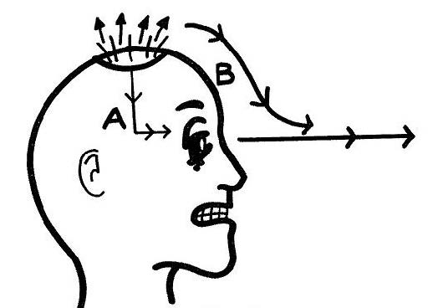
The illustration shows how this works. (Hey! I’m a mad scientist, not an artist!) Path A takes the energy from the crown chakra through the optic nerves to the eyes while the energy emitted directly from the chakra follows the lines of the etheric body (B) down to the beam coming from the eyes and links up with it. This is why the eyes have traditionally been considered the most powerful transmission points for this energy.
One of the features of the crown chakra is that it emits such a powerful blast of energy when being used that when this energy is forced downward into the brain area it can actually hurt. This is why, unlike most radionic devices that do not need an antenna, the psionic amplifying helmet actually has to have one, to act as a wave guide directing the main flow of the chakra energy outward, even when the helmet is used in the receiver mode.
At this point you may be wondering why the plate in the helmet is kept on the crown chakra instead of having a second plate from the brow. The reason is quite simple. I found it quite uncomfortable to use a forehead plate so I was forced to rely on the crown plate.
The crown chakra works automatically. It is neither necessary nor desirable for you to visualize thought energy being poured out of the chakra. To do so will only increase the activity of that chakra to possibly dangerous levels that can do really weird things to the brain. Let it work on its own and you will have no trouble with it.
THOUGHTFORMS
In my books I make frequent references to thoughtforms and in Elementary Psionics I taught the basics of their manufacture and use. Now it is time to go into a little more detail as to how they are made, how they work and how you can use them to make life more enjoyable, meaningful and have nasty fun at other people’s expense.
In many ways, even more that psionic devices, the thoughtform is the basic tool of psychic function. It is the means by which our thoughts are made more powerful and therefore more effective. Because of this fact the better you are able to create and use thoughtforms, the more effective you will be.
Let us look at the thoughtform itself and begin to understand how it works.
A thoughform is a clump of very basic psychic energy. It may even be considered to be a form of pre-matter. It contains information and this information determines how its energy will function. Once it is created and set to work, the more coherent it is the more likely it will be able to influence events in the physical world. This influence takes the form of what can be considered psychokinesis, but a PK of a type that creates coincidence. For this reason we will call the action IPK, for incidental psychokinesis, as opposed to when an angry psychic causes the school bus to drive off the bridge.
Got that? The thoughtform is made up of those particles I posited earlier, the psions (and why some folks in this field choose to identify themselves as subatomic particles is a mystery to me). Each psion has polarity, and thus positive and negative psions attract. It is therefore impossible to have a thoughtform with less than two particles and the number of particles in any given thoughtform will always be even. At least that is the hypothesis we are working on. If there is an odd number of particles, the basic coherence of the thoughtform will be upset and the thoughtform will dissipate.
In this model the production of the thoughtform works something like this. When the mental body ends a message to the physical brain, the waveform involved causes the neurons to fire. Ass this occurs, the fact that life energy is involved causes a new wave to be sent outward from the physical body to the level appropriate to the nature of the thought. At this point it is still a wave. But along the way something happens. The psychic stuff that makes up the various energy fields of our bodies interferes with the wave and causes it to kind of scrunch together.
Let me use an analogy. It is a foggy morning and the freeway is crowded with cars, all moving at a pretty good clip, rather close together and seen from the air they make a continuous moving line. All of a sudden the elderly driver in the front of this line runs into a patch of very heavy fog and slams on her brakes.
The other cars are moving too fast to stop quickly and are too close together to miss each other and very soon, amid much crunching of metal and breaking of glass, twenty-seven cars are packing into a space that would normally hold three and from the air it looks as if something incredibly interesting has happened in an accordion factory.
This what happens to the wave. It gets jammed together and the result is the formation of a basic particle, perhaps the basic particle—the psion.
Each time the wave hits the interference pattern it forms at least one psion, and any give thought will produce a bunch of them.
So you have a bunch of these little psions floating around in space, each containing the information from the thought and each having polarity. What happens then?
The psions naturally attract each other and, in doing so, acquire mass. Very small mass to be sure, but mass nonetheless. This means that the thoughtform cannot stay at the purely mental level. It is either propelled through the void to a specific target, moves back towards the person and takes root in the either the astral level or the aura or it joins with a massive, pre-existing thoughtform that sits like an amorphous blob floating in the general mental atmosphere or forms a tight, very coherent and potentially very powerful thoughtform within the already existing large one.
A thoughtform cannot remain at the mental level of an individual. This is important because if you read older writers you will often find them speaking of their clairvoyant findings of thoughtforms in the mental body. Upon closer examination however, you will discover that what they are really looking at is the astral level and merely getting their movies mixed up. And, let us be honest, most clairvoyants are crazy as June bugs anyway and you can’t take their writings with much seriousness. I’ve only known one in my life who was sane and she was highly eccentric.
Most thoughtforms are neither very powerful nor coherent. As a result they do not hold together well and do not last very long. If you can imagine each thoughtform as a light, you will notice that around any given person you will see lots of small lights flickering on and off, like demented xmas tree bulbs. A few stay on rather longer, growing gradually dimmer as their batteries wear out until they too disappear and a very few continue to burn with a constant brightness. This is the normal state of affairs.
A problem working with thoughtforms comes when you run across the traditional belief that the more people concentrating on a single thing, the likely that thing will come about. I hate to disappoint folks, but that is very rarely the case. The fact of the matter the matter is that in thoughtforms, as in dinner, too many cooks burn the roast. There is a way around this problem and I will explain that later but we will not be speaking of that at this present time.
Anyway, why should this be?
Because I say so!!!
Seriously, the power of a thoughtform to influence events depends not so much on the amount of energy in the thoughtform as is it does on the coherency of the thought itself. Each thoughtform created by an individual has at least two psions, each containing information directly relating to the thought but also containing sidebands of stray images and emotions that the given thought will evoke. Each sideband will decrease the coherence of the thoughtform. In fact by now you will have noticed that one of the greatest problems that you face with your own visualization work, which includes thoughtform creation, is the tendency of the mind to just take off on its own without your knowing about it until it is too late to bring it back. If you are having that kind of trouble working with just yourself, think of the chaos created by a group visualization.
We can, for our purposes, calculate the number psions in any given thoughtform as 2+x. X will always be unknown, but this gives us a point at which to start. As each psion will have at least one sideband, the formula for the coherence of any thoughtform will be ½+x. Now, let us figure in the number of people trying to put energy into the thoughtform: C=1(2+X)P, where P is the number of people working on the thoughtform. (Not bad for someone who flunked algebra in high school, isn’t it?) We will term this the Principle of Ultimate Instability. What that means is that no thoughtform is going to last forever, and the ability of the thoughtform to actually influence people and events will be in inverse proportion to the number of people trying to work on it. This is particularly true of those attempts by various groups who try to get large numbers of people to concentrate on one thing, but it can also cause strange things to happen to small groups when they try to create a thoughtform.
Let me tell you another story. One time I got very upset with the people in our study center because they consistently refused to believe that mere thoughts could influence physical reality. So I figured that I would show them and set up a little experiment. We all sat in a circle and tried to visualize a blue sphere over a piece of paper in the center of the circle. You must understand that the mix of the people in the group virtually guaranteed that the form created would be extremely unstable, and as I had them aiming for a specific target, would be very powerful. In fact I was beginning to worry that it might be just a bit too powerful. You see we were meeting in the library of the Theosophical Society headquarters in Wheaton, Illinois and there are some objects of serious value in that building. I started to worry that one of them might break because there is no way of predicting how the unstable energy of thoughtform will behave. Fortunately that did not happen. But what did happen was painful enough, for just as some of the members began to actually see the sphere, an electric shock went all around the circle causing all of us to jump, in order! Well, that ended that experiment.
But, as you can see, coherence is the main concern. With an abstract principle, such as peace, coherence is almost impossible and well-meaning folk who gather to together to try to meditate on bringing peace to the world are wasting their time. The truth of the matter is that while they are feeding a blob of energy that can influence absolutely nothing, one adolescent playing a first-person shooter on his gaming machine can create a thoughtform for violence that is much more effective. (Which was the basis of my Watchtower Project in which hundreds of people beamed pure violence into the consciousness of the planet.)
In spite of that, even the most incoherent thoughtform will contain a tremendous amount of energy simply because it remains as a thoughtform, but this energy will be more in the form of potential energy rather than kinetic energy. It will not be able to influence events in and of itself but it can be tapped and used by individuals, which is how religion works.
I am not going to get drawn into a debate over the existence or nature of the divine. That is not the purpose of what I am now going to explain, so do not get these ideas confused. Great Jehovah may in fact exist somewhere but whether or not he does is irrelevant to the fact that a very large and incoherent thoughtform corresponding to him does. As annoying as this may be to the religious beliefs of some, this is a truth that we will deal with. There is no possible way that the prayers and thoughts of millions of people over a period of millennia cannot create a thoughtform and the Principle of Ultimate Instability requires that the thoughtform be very incoherent. In fact, the thoughtform that corresponds to the Xtian deity may be visualized as a cloud with an elderly male face floating around its surface.
There are three (or more) basic techniques for tapping the thoughtform. One, the religious, two the magickal, three, the psionic. The magickal is outside of the purview of this book and we’ll deal with the psionic later. Right now let’s look at the religious approach.
Now, try not to laugh too hard at me with this next example.
Much as one with my education, literacy, intelligence and liberal Protestant upbringing hates to admit it, the disgusting Roman Catholic thoughtform of the Virgin Mary is one of the most powerful and coherent of the religious thoughtforms. It is matched only by certain Hindu deities. And the reason for this is obvious. Here you have cult dedicated to the worship of a specific individual with a definite character and history (even though the historic mother of Jesus was probably a prostitute who got nailed by a Roman soldier) who has well defined physical characteristics that have become part of the tradition. Combine this with a ritual specific to that being and you have worshippers working on a very well-defined image and idea. In short, just what you need for a good, coherent thoughtform. As a result, while the Principle of Ultimate Instability still applies, it is somewhat blunted and some very interesting and usually bizarre things can occur. These are usually the result of a spontaneous tapping of the thoughtform, combined with a variety of poltergeist activity.
What do I mean by that last bit of gibberish? For an excellent and hilarious example, we must go to Portugal to a really weird place called Fatima. And the thought of one of the biggest shrines in Catholicism being named for one of the Prophet Mohammed’s (may vultures tear at his liver forever) daughters is priceless.
Anyway, as I said, I was raised liberal Protestant and to say that my opinion of the cult of Mary was and is not very reverent would be an understatement indeed. It disgusts me! And it disgusted me when I was a good, materialist adolescent. So, one Good Friday afternoon I was looking for something to do and I turned on my television and discovered what is undoubtedly one of the most unintentionally hilarious movies ever made (Plan 9 From Outer Space is serious cinema by comparison): The Miracle of Our Lady of Fatima.
It is priceless! The first time I saw it I laughed so hard I almost fell out of my chair. The story line is beyond sappy and the acting, even with Gilbert Roland and Jay Novello who somehow got conned into being in this thing, is atrocious. Combine that with the idea of a strange woman dancing around in the treetops and, well, you get the idea. And to make matters even worse, it claimed to be a portrayal of real events! These events included the Sun doing a dance and mud being instantly dried, along with the usual boring tale of some worthless cripple being made to walk, as if anyone would care.
Now, if this had all happened in, say, 252 A.D., we could put it down to strange drugs mixed in with copious draughts of sacramental wine. But this was 1917, in living memory when the film was made in 1950. Anyway, having some small interest in the paranormal I managed to put aside my perfectly rational prejudice against the ravings of lunatics and the beliefs of sundry morons and wonder if part of this farrago of nonsense might actually be true. So I did a little digging over the years and was horrified to discover that the events depicted sort of actually happened. Ok, we leave out the bad acting and the political McCarthyite overtones to the subplot (this is the only movie that actually had me rooting for the Communists). Three idiot and incredibly ugly children (not cute at all like the actors playing them) did see some strange woman floating in the treetops and these visions attracted a humongous crowd on one particular day. (You can’t believe the numbers though, they are undoubtedly greatly inflated.) The crowd did not see the woman but they did see the sun behave very strangely and the ground, which had been a muddy mess from a driving rain and being trampled by the boots of the faithful, dried for no good reason whatsoever.
There were also the usual prophecies given in the approved manner of such things but those are not worth worrying about since they were probably a bit edited to fit subsequent events.
What we are concerned with is the final day when the Sun danced in the heavens, a woman ran screaming towards the camera (one of the funniest scenes in the movie, very short, if you blink you’ll miss it) and the ground dried up. For what happened that day is unquestionably a thoughtform that went totally berserk!
Let us begin by examining the physical phenomena. There is no question that the ground was mud when things got hot and then got dried out after the sun calmed down and went back to where it belonged. There were just too many witness to doubt that claim, crazy that most of them undoubtedly were. There is also no question that the sun was seen to move towards the earth. The image was recorded by people living forty miles away. It is also true that at no time in 1917 (nor any other time in human history for that matter) did the relative positions of the earth and sun deviate from the normal orbit of the earth. So it must be assumed that what was seen at Fatima was an optical illusion, but one of such power that it was seen for some distance.
Now, let us examine the participants. The three children were not only incredibly ugly but also of despised, peasant stock. (God created peasants so the rest of us would have people to despise.) They were uneducated and probably quite stupid. Ok, we have this pattern occur too many times in history to mistake it. The eldest child, a girl, is approaching puberty. Yes, by our standards very young, but in that world giving birth at twelve would probably have been common. There is no question that she was the prime recipient of the visions and prophecies. The other two brats were much younger and by all accounts played a secondary role. The crowds see nothing but the Sun, the mud and the priest with his hand out.
The fact that Lucia, the eldest, was approaching puberty seems here to be the key, for that is the age when poltergeist activity is most likely to erupt. You may well wonder why I would bring that up but it is because I am convinced that the key to Fatima lies in such activity.
The poltergeist is generally assumed to be what one author called “a mind on the rampage.” The faculty that produces true psychokinesis, which lies dormant in us all, is activated by a process we know virtually nothing of and it manifests in various unpredictable and usually destructive ways. While the events at Fatima were on a massive scale, they were nothing more than the behavior of a poltergeist grown very big as would be expected from a mind energized by both at thoughtform and the directed energy of the crowd.
Let me explain what I think probably occurred. Lucia was given a shot from the basic, fat Virgin Mary thoughtform. From this and her own natural psychic capacity, she created a second thoughtform. This thoughtform took the form of the Virgin and was coherent enough to actually become visible to the two other children who have also tapped into the larger thoughtform due to cultural conditioning.
At this point the peculiar combination of energies is causing nothing more to occur than the vision and audible messages from it. But things do not stay that way because it is in the nature of such visitations that they will inevitably attract the faithful and the curious to the site, along with the usual souvenir sellers. These increase in numbers and expectations, and finally the stage is set for the climatic performance.
On the fateful day, thousands (we can at least be sure of that) people concentrate energy on the three children, particularly the eldest. This energy increases the power of the transmissions from all three children, with the eldest being the primary agent and the other two adding their beams to hers. The result was a tremendous power loop between the Virgin thoughtform, Lucia and the others. Now, remember that this whole thing is fundamentally unstable. It cannot go on indefinitely but the energy must find an outlet somewhere. At that point such things become truly unpredictable.
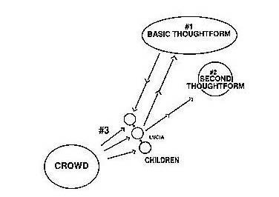
And it is at this point where we find our greatest difficulty. For while this may explain how the energies involved in Fatima worked, we have no idea at all why they took the particular form that they did. In that regard, we are faced with the classical problem involved in all poltergeist manifestations. The mind of the primary operator unconsciously instructs the energy and then it goes to work. What monsters were floating around in the mind of Lucia at that point we cannot begin to guess.
Anyway, that is essentially what happened at Fatima. Once the main miracle occurs, however, Principle of Ultimate Instability takes over and the Virgin disappears for all practical purposes. That thoughtform is replaced by a far more unstable one which has, however, a much greater pool of energy to draw upon and which can be tapped into at a later time by the faithful and unfaithful alike. We find something much similar at Lourdes and we will learn how to tap that energy in the next chapter.
Much of what we will now cover may seem like a complicated rehash of the basic material in Elementary Psionics, but bear with me. The time will come when you will want to not only create very powerful thoughtforms but also to analyze those of others.
There are three inherent characteristics of a functional thoughtform. These are form, function, and identity. It is possible to create a very short-term thoughtform that will simply have form and function but for any thoughtform that is going to last you must give it a name. This is not so much of importance to the thoughtform, which is going to have a very limited intelligence at best, but to your yourself because it makes calling up the power or function of the thoughtform so much easier.
Let us begin with form. The purpose of a thoughtform may be embodied in its shape, for we know that certain shapes seem to have an intrinsic meaning. For example, the shape of a shield is always seen as defensive, even though in real life shields were offensive as well. A sword, having two edges and a point, can be seen as aggressive or defensive in nature but always combative. A spear or its modern variant, the rocket, is always aggressive. For our purposes, let us use the four traditional symbols of magick: the rod, the cup, the shield or disk, and the sword to explain how these can be used.
The rod can be seen as any connecting link, such as telephone cables, which are really nothing more than long rods stretched over great distances. All beams are rods, therefore any time you make a thoughtform in the shape of a rod you would be making a connection of some kind.
The cup, on the other hand, is always a receptacle. A cup holds things; things are poured into it. Energy can be poured into a cup and stored there for later use. The energy can be made to flow along a rod into a cup.
I have already covered the shield and sword, and they can be used in combination. The sword also has the capacity to divide, a useful tool when facing a combination of hostile people or forces.
Most objects fall under these four headings. A light bulb can be grouped with the rod. Why? Because the light that comes out of the bulb connects the bulb with whatever it falls upon. The mirror can be considered a shield. It blocks the light and then reflects it back to its point of origin. Therefore, if a situation should arise in which you wish to make a thoughtform that would not only block a thought but send it back to its point of origin, you would make a shield in the form of a mirror.
The symbols can also be combined as well. Suppose you really want to get a thought through to Uncle Harry while he is busy with something. This is normally quite difficult because the subconscious mind, which is where the psychic energy works best, cannot get through the noise generated by Uncle Harry’s activity. You would in such an instance create two short-term thoughtforms. The first would be a rod coming from about six inches in front of your nose, to a cup placed in Uncle Harry’s third eye. The rod would be programmed to carry the message and the cup to receive it.
Now, let us suppose that you are going to make a thoughtform that is going to be around for a while. These take a bit of work to make, not so much because they are long lasting, as because you have to keep feeding the little monsters in order to keep their power up. Never forget that any thoughtform is inherently unstable and will fall apart after a while. These thoughtforms can be the type that are used quite often, such a one made to keep your car out of accidents, or it may be one that is used only once a year.
The type that are used often are given a few good charges and then a quick activation whenever needed. The mere act of thinking about a thoughtform activates it and puts energy into it. The ones used less often have to be consciously charged over longer periods of time so that that they can lie dormant until activated.
Let me give you examples of both. As I said, one of the most common of the standing thoughtforms is the one used to protect your car. It is a favorite of with anyone who has to drive in heavy traffic, especially if the roads have a lot of taverns along the way. This thoughtform is best visualized in the form of a shield over the car that emits a continuous light covering the entire car and doing so keeps the car from meeting other cars, from being stolen or vandalized, or anything else liable to cause the insurance to become more expensive.
As this shield is expected to last for a while, like the life of the car, when it is being visualized give it a name like Carshield or Fred. Each night for a week or two, visualize the thoughtform over your car and program it with something like, “Your name is Fred and you will protect this car from anything that would injure it.” After you have done this, each time you get into the car just think to the thoughtform, “Fred, activate.” The shield will power up and you will be able to drive with some certainty of your own safety. It is also a good idea to thank the thoughtform each time you miss being clobbered. This will make the thoughtform happy and increase its supply of energy.
The other type is more on the order of a gun in the bedroom. You may not wish to use but if you need it you damned well better have it!
Let us suppose that there is a particular resort that you go to every summer. Now, as you have undoubtedly been made aware of by those dreadful commercials showing happy vacationers losing their life’s savings, there is always some risk that you may be robbed. As you go to this resort often, so it is easy to hold a picture of it in your mind, or you probably have a photograph or two of it laying around somewhere. If that is the case, you may use your radionic box and helmet to lock in to the resort but it is not necessary. Visualization will do quite nicely.
Either way, you will create another thoughtform, let us say in the form of a sword, which will drive anyone away who would desire to rob, injure or even annoy you. Then you name the thoughtform and charge it up every night for a couple of months before your vacation. You may then go off with peace of mind and enjoy your trip. But before you end your stay, you again visualize the thoughtform and tell it to rest until it is needed again. The next year, for about two weeks before your vacation, call up the thoughtform and renew the charge. Finally, before you arrive at the resort again, activate it.
You should now have all the information you need to make and use your own thoughtforms. But, suppose you wish to make a group thoughtform? You know that it is very difficult to make such a thoughtform and expect to it to hold together very well. After all, the more people who are working on it the less effective it will be. Well, there is a way around this problem.
Let us take as our example the desire that many people have of creating a thoughtform for world conquest. They have a number of things going against them not the least of these being the fact that there are many people in the world so stubborn as to not want to be conquered (a plague upon them!).
As I said, however, there is a way around this little problem. Let’s go back to Fatima for a minute (half-price miracles this week). You will remember that the vision was strengthened not by the crowd concentrating on it because the crowd could not see it, but rather by the concentration of the crowd on the children (and for those of you who wonder why the crowd did not break out laughing at the incredible ugliness of the little bastards, the crowd-folk were no beauties themselves). The same principle applies here. A given individual can be chosen to make and charge the thoughtform, in whatever image he chooses and the rest of the people will concentrate their thoughts upon him. The energy from these people will increase the power of his own but because he is the only one who is putting energy into the thoughtform, the thoughtform will retain its coherence.
If you have a group of people to work with, you may use psionics to help you add power and coherence to your group thoughtform. Each member of the group will need a radionic box, a psionic amplifying helmet and a witness sample of the person who will be the primary agent in creating the thoughtform.
You must all agree beforehand on a time for the creation and charging of the thoughtform. The person who is to be the primary agent must have a witness of each person in the group as well. Before the appointed time, the primary agent will place all the of the witness samples in his radionic box and take what will be a general contact rate for the entire group. He will then take a similar rate on his helmet which is, of course, linked to the box. Each member of the group will take a contact rate for the primary agent.
At the appointed time, the primary agent will put on his helmet, placing him in firm contact with the rest of the group and each member will do the same. This will create a strong psionic link between all the members of the group and primary agent.
As the primary agent goes to work on the image he has chosen, the energy of the group will be transmitted to him without the usual drifting of contact, for the machines will solve that problem. All anyone has to do is think. As their energy is fed into the prime agent, he, in turn, will put it into the thoughtform.
There is one rule you should keep to if you are using a group to create a thoughtform. You must keep the group relatively small. The more people involved, the more likely will there be someone who is not concentrating on the primary agent or worse, sending conscious or unconscious thoughts counter to the purpose of the group. The tradition of keeping a coven to twelve or thirteen may have been created with this idea in mind. For your purposes therefore, I recommend that you keep the number in your group to no more than eight as that is the largest any group can be before it breaks down into smaller groups, each with its own agenda.
It is best to have a specific target in mind, such as a politician that needs defeating. This will help keep minds from wandering. And it is best to avoid abstract ideas. Keep to concrete desires and results.
PATTERNS AND FORMS
In this chapter we are going to get into the strangest area of psionics (as if it weren’t strange enough already) and I’ll begin it with another story. When the science-fiction writer and editor, John W. Campbell, was experimenting with the Hieronymous Machine back in the 1950s, he stumbled onto something he considered truly phenomenal. He made a sort of circuit diagram of the machine (which I found utterly incomprehensible until G. Harry Stein came out with his Mind Machines which explained it) and attached some dials to it, and lo and behold yea and verily! He still got a stick on the pad! From this event he made a deduction that it was the pattern of the machine, rather than the circuitry that made it work. Of course we know now that it is neither but let us not be nasty, for the fact is that pattern does play a huge role in psionics. There are a number of two dimensional patterns, simple line drawings, that somehow interface with either the limited human or unlimited universal consciousnesses (and we have no idea which) and produce profound psychic results.
This presents an interesting problem, for it is impossible to live without seeing patterns all around us. If we assume that all of them are emitting some kind of energy into the ether we will rapidly go insane and start looking for reptilian aliens living under cell-phone towers. It is all too common for someone to hear this at a lecture and immediately go out testing every line drawing that she sees, right down to the tiles on her mother’s floor. And before you know it, she is convinced that all of them are in some way dangerous.
So do not go to ridiculous extremes. Read the chapter and then experiment with an open mind, not an empty head.
In Elementary Psionics I told the story of the psionic amplifying helmet and how it grew out of my dabbling with the Hills’ Magnetron device. That gadget, in its turn, had been the outcome of work begun by a pair of French dowsers name Servanx who looked at a drawing of the innards of a radar device and held a pendulum over it. The pendulum swung and thus they deduced that some sort of energy was coming off of it. You will also remember that the Magnetron pattern was a central circle with eight circles around it connected to the center by eight lines. You can easily make such a drawing yourself.
The fascinating thing about the basic pattern of a central point surrounded by circles is that the more circles you have, the more powerful the energy coming off the center. You can prove this to yourself by making a number of such patterns starting with three small circles around the center and going on from there. This is what a twelve-circle pattern looks like.
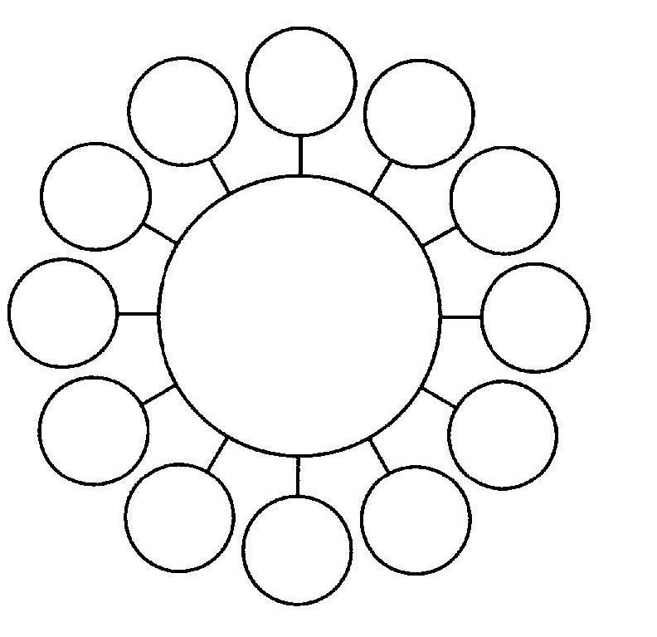
Once you have made your patterns, hold your pendulum over the center of each one. You will notice that they all produce a strong, clockwise swing. This is actually the first problem you will encounter in studying these damned things. The pendulum can tell you if there is energy coming off of them and if the energy is positive (clockwise) or negative (counterclockwise) but it is useless in measuring the power of the energy. It always swings the same way!
To learn anything else, you will need your numerical gauge and stick pad.
In these tests you will use the plug at the end of the pad wire as a probe and place it over the center of the pattern. Ask the question, “What is the level of energy coming out of the pattern?” and rub the stick pad as you move the pointer on the gauge. Write down the measurement for each pattern and you will discover that you have a number of patterns with different energy levels. This means that you can use these to fine-tune the amount of power you wish to put into a transmission. This can be useful healing work where too much power may do more harm than good.
These patterns can be used in several ways. The witness is always placed over the central circle. Putting it on one of the smaller ones seems to do nothing at all for it.
If you wish to send a telepathic message to the subject, lay the witness in the pattern and hold your pendulum over the witness. Start the pendulum swinging around the pattern and think your message at the subject, repeating it over and over again until the pendulum stops swinging. At that point your subject should have received your message.
Colors may be transmitted by placing a colored gel over the witness and turning a light on it. Combined with transmission patterns (we get to them soon), the color can be transmitted to any chakra or part of the body.
these patterns may also be used as simple energy amplifiers, to cause a subject to receive an increase in psychic energy or to increase the power of a thoughtform. They have the advantage of never needing to be tuned, but the disadvantage of not being specific in the part of the subject you wish to send to. For that you need a very clear vision of the area or a transmittal pattern.
When being used as a simple energy amplifier, it is not always a good idea to leave the witness of a subject in the pattern. Its lack of specificity means that any emotion you may feel towards the subject will be amplified.
This may not seem like something of great importance, but if, for some reason, the person may make you hopping mad, that will get shot at them and you can make dreadful things happen that way. Of course you may want to make dreadful things happen to the person but that is a different chapter.
You can use any pattern that produces a clockwise swing from your pendulum for helping people. What you should avoid is any pattern that produces a counterclockwise swing. That is the sort of movement you get if you hold a pendulum under a pyramid. It is the result of an etheric energy pattern that is known as “negative green.”
Sounds pretty silly, doesn’t it? Well, it was coined by a Frenchman, so what can we expect. It seems that the said Frenchperson discovered that this type of swing is exactly the opposite of the swing that he got over normal green on his color chart. That is why I instructed you to put gray opposite green on your color gauge. It is the swing that occurs over gray and, as it turns out, this energy is very bad stuff to have floating around. Let us be honest, who wants to become a mummy? Seriously, it seems to be extremely dangerous and may cause cancer.
Now, important! It is also true that the pendulum may swing in a counterclockwise direction for other reasons, so it is wise not to become paranoid. First, look and see how strong the swing is. If it is very strong, do more testing. Take your color gauge an stick pad and see what color the energy you are getting responds to. If you get a stick on gray, you have negative green and reptilian aliens are living under your house (just kidding).
With that little digression out of the way, we can begin to look at patterns and their relationship to different energy fields around us and thoughtforms in particular. It is by the use of patterns that we can lock onto pre-existent thoughtforms with ease and increase the effectiveness of our own thoughtforms as well.
The idea that a two-dimensional pattern can link a person to forces of the unseen world is hardly new. It is the basis for all talismanic magick. There are a number of these patterns that have come down to us, most notably the 72 sigils found in the Lesser Key of Solomon, the use of which was believed to enable the magician to control the demon whose sigil he possessed. What is clear is that these sigils can be used to cause certain results when used in conjunction with psionics. From this we can assume that in some way they align the operator or the subject with an energy pattern that already exists out in the void, and thus that pattern can be transmitted. These patterns exist for various purposes—from healing (snore snore snore) to wealth, sex and destruction, in other words the fun stuff.
The seals in the Lesser Key (see appendix 2) are among the easiest to use. They are already drawn, needing only to be copied and placed in the can right next to Prince Albert. A rate is taken for the pattern and the witness is placed on the receiving end of the circuit. Once that is done, the chosen energy is sent to the subject. The only thing you need to do is take the rate and then set up the machine. The action is no more occult or mysterious than turning on a light. It fact, it is so mechanical it can get rather boring except in those rare instances when the spirit gets annoyed and things start flying around the room. (But I’ve only had that happen once.)
Of more interest if only because it requires a bit more involvement, is the use of patterns drawn from magick squares and circle patterns. While the two methods are interchangeable and produce much the same results it is useful to be able to work with both because there are times when one method just doesn’t fit.
So, how do we use these patterns? You begin by first determining what type of pattern you will need. After you have done this, you make the pattern and then the thoughtform. This may seem like a reversal of the usual procedure, but by making the pattern first, you are in effect laying the groundwork for the thoughtform and it really is much easier to do it that way.
So, let us assume that you are going to make a thoughtform that has as its command, “Make everyone buy my book!” That is a bit of a mouthful for a pattern so you choose a name for the pattern, in this case “Bestseller.” And, as I want to illustrate for you how both types of patterns are made, you choose to make it using a magick square. These correspond to the seven traditional planets and their influence is as follows:
Saturn: Any disruptive activity, any attempt to increase knowledge, dealing with
dead things of all types Jupiter: Wealth, promotions, friendship, health, general prosperity and well being.
Mars: Acquiring courage, disruption and attack Sun: Health, wealth, friendship, all things positive Venus: Love and sex, not necessarily in that order Mercury: Increasing intelligence, business matters, knowledge, anything
requiring cunning and deceit Moon: Travel, love, any operation involving water, lunacy. These are the squares: Saturn
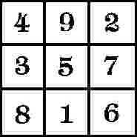
Jupiter
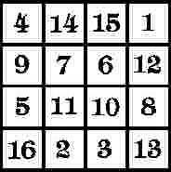
Mars
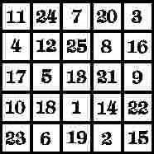
Sun
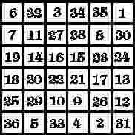
Venus
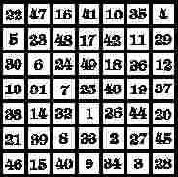
Mercury
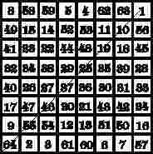
Moon
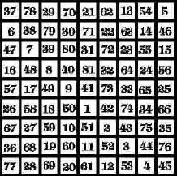
First you must decide which planet the thoughtform will correspond to. There are three possibilities that come to mind: the Sun, Mercury and Jupiter. This presents a bit of a problem, so you use your trusty pendulum and the pendulum with its usual infinite wisdom tells you that Jupiter would be just dandy for this project. Now I am going to give you another choice. The traditional method of working with magick squares requires that the letters of the words being used be broken down so that they correspond to individual digits—1 to 9. For the smaller squares this works perfectly, as there are 26 letters in the English alphabet. But if you use the square of Venus, for example, it can be a real problem because most of the numbers you would use are arranged in a single, diagonal row which severely limits the variety of pattern that square would produce.
After being really frustrated by that difficulty I decided to abandon tradition (which is all traditions are good for anyway) and use all 26 numbers, which meant not having to add down at all. The only drawback to that is you have to be using a square with more than five rows each way otherwise numbers are going to be left out.
Jupiter has a square with four rows, so you have to be old-fashioned and use a chart like this.
123456789
ABCDEF GHI J KL MNOPQR ST UVWXYZ
Then you find the value for each letter: B=2; E=5; S=1; T=2; S=1; E=5; L=3; L=3; E=5; R=9.
Now that you know the value for each letter, you take your square of Jupiter and plot the numbers on it. And hope the square does not come out lopsided like this one.
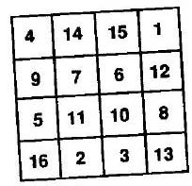
Find the first number and draw a line between it and the second, the second and the third and so on until you have run out of numbers. If you have a double
number (two 3s for L L in this case) just use a single line with a small curve at the end. You will end up with a pattern like this.
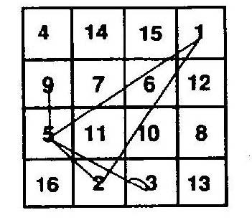
All that remains for you to do is to take a small piece of paper and trace the figure from the square onto it. It is a good idea to write the name of your thoughtform on the paper as well so you will not forget what the pattern is supposed to represent.
Once you have done this, place the pattern in the transmittal part of your radionic box and hook up your helmet to the box input. Take a rate for the pattern on both box and helmet.
Place the helmet on your head as it will do you little good to sit on it and begin to make your thoughtform in the usual manner—by visualizing it. The pattern is the witness for the thoughtform and may be left in the machine with a witness of the target (in this case an outer space picture of the earth will do quite nicely) or it may be placed in the center of an amplifying pattern. When you desire to add charge to the thoughform, you may either set up the box and helmet and visualize the thoughtform gaining energy or place it in an amplifying pattern and visualize it being charged while spinning the pendulum over it. Both systems work equally well.
The circle patterns we are now going to work with have their origins in the work of Malcolm Rae, one of the super-biggies in radionics, who discovered that a pattern lines within a series of concentric circles would send his patients the energy equivalent of homeopathic remedies. By extension of this, patterns could be made that would be the equivalent of just about anything. These patterns could be used to eliminate rates in radionic broadcasting and analysis, but I am not quite willing to go that far. However, the circle patterns you are going to learn to make will cause your work to become much easier.
You can make a circle pattern to correspond anything, people, parts of people, thoughtforms, whole entire countries. They are particularly useful in working with pre-existing thoughtforms (such as deities which are, after all, nothing more than the product of mass superstition) and thoughtforms created by other people, often with nefarious purposes in mind. Circle patterns are also very useful in working specific parts and patterns in an individual’s etheric field.
So, let us say that you wish to contact a big thoughtform, one that has been charged and recharged for thousands of years by innumerable people. You want to tap into the power of the Mad God of the Desert, sometimes known as old Jehovah, Allah or big-g God. After all, there is no sense in thinking small and this one is useful for just about anything. Being a rational individual, prayer leaves a bad taste in your mouth and kneeling with your ass in the air is too much an invitation to a passing priest.
So you use radionics!
The circle pattern you will use is much different from that used by the Rae school. It is a little easier to make and I think it actually gives a better representation of the energies being contacted. You begin by drawing a circle that is marked off into segments of ten degrees each, which will leave you with 36 hash marks.

Try not to make these too big. Two inches in diameter is sufficient and any larger may make it difficult to fit on the witness side of the machine. It is also a good
idea to plan ahead and make a sheet of them that you can print up and then just cut one out at a time as needed.
You will now need to get out a rule and your stick pad. Once you have them, write Great Old Jehovah over the top of the circle and make a small dot (your starting point) over the topmost hash mark of the circle.
Concentrate on the thoughtform, trying to hold the idea of Uncle God in your mind, and point to the first hash mark while rubbing your stick pad. Slide your thumb across the pad about three or four times to see if you get a stick. If you do, make a small circle around the hash mark and go on to the next. If you do not, repeat the procedure with the next mark and continue until you have gone all the way around the circle. This should give you a pattern that looks something like this.

Once you have done this, take your ruler and it between the first and second small circle on the hash marks. Ask yourself if you need a line between these points while rubbing the pad a few times. If you get a stick, draw the line. If not, go on and place the ruler between the first and third and repeat the procedure. Do this also if you get a stick and repeat the procedure until you have tested all the links between the first circle and the others. Once you have finished,, do this again with the second circle and so on until you have gone all around the circle. Continue until you have tested all the possible combinations, so that in this pattern you would have tested four possible lines from the first; from the second, three; from the third, two and from the fourth, one. The last circle has already been tested from the first so you can stop. Your final pattern will look something like this.
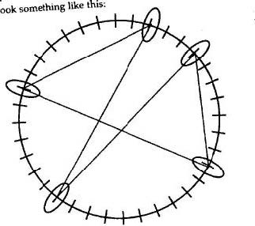
You now have a pattern that will automatically put you in mental contact with the humongous thoughtform of Big Bad Jehovah. Place this pattern in your radionic box, which you have hooked to your helmet. Take a rate on both and put the helmet on your head. Do not put the box on your head. It will not stay and you will look silly.
Once you have the helmet on, you should begin to get a picture in your head of this thoughtform. Now, I must explain to you that these things appear to each individual differently. I get something that looks like a cloud with the face of an elderly man on it with a long white beard, a VERY long white beard, sort of like some sort of demented garden gnome. Anyway, imagine as clearly as you can the energy from this thoughtform filling you up. Once you have absorbed the energy, you can put it to work.
Having now learned something about making circle patterns and using them to contact pre-existing thoughtforms, you can now learn how to steal a dose of healing energy and at the same rob the Catholic Church of a bunch of money.
In the last chapter we butchered the legend of Fatima. Now we get to run Lourdes through the meat grinder. The pattern of events was much the same: an adolescent, the village idiot Bernadette some French name or other, saw a vision, produced some phenomena and now there is a giant, ever-recharging thoughtform floating around the town drawing in the lame, the halt and the stupid to the grotto where the visions took place and from whence a stream of water associated with them popped out. That water is said to be so polluted that it is truly a miracle that no one has died from touching it so the thoughtform must work pretty well, and there are enough documented healings from that place to make working with it worthwhile.
The advantage of this particular thoughtform is that is quite easy to work with. All you need is a photograph of the grotto and you can find that online or at a library with no trouble at all. Place this picture in your box and take a contact rate, as if you were going to do a remote viewing experiment. Once you have the rate on both box and helmet, put on the helmet and make a circle pattern that will correspond to the healing energy of the thoughtform, not the superstitious nonsense associated with it. Clear the rate from the box and helmet and take a new rate for the thoughtform and picture whenever you need it.
Now, let us say that this time Uncle Harry has come down with triple pneumonia. This is the perfect time to test your new tool. Place the picture and pattern in the input side of your machine and get the rate. Place the witness of Uncle Harry on the output side and let the machine work. The healing energy of the thoughtform will be transmitted to Uncle Harry and he will be much aided by it, assuming he is not so far gone that he dies anyway, which does happen in spite of the best of our efforts.
I have used Lourdes here, not only because I think the place is the world’s biggest side show, but because it is one of the best known sites for thoughtform tapping. It is, however, not the only one. Any location associated with healing, or any psychic or spiritual activity can be used. The only caution I would give is to make sure that you know something about the thoughtform you are going to steal, otherwise you may be in for an unpleasant shock. Always know what you are getting into, or, more importantly, what is getting into you.
GADGETS AGAIN
I was originally going to leave this chapter out in the new edition, but then I figured what would a book on psionics be without some toys to play with. Now, a lot of this is old hat by now, but there are always new folks just getting started, so here it is, with a few changes to reflect the years.
If you will think back to Elementary Psionics, you will remember that the energy we use has certain properties, among them the ability to be carried along beams of light and electromagnetic carrier waves, such as radio and microwaves. So now I will give you a little advice on how to use this fact to your advantage by increasing the power of your radionic transmissions.
You will need an old-fashioned, monoraul cassette recorder, easily found at garage sales and on ebay, an FM radio with an external antenna and earphone jack and cheap walkie-talkies, which can be found at any toy store.
One of the peculiar things about radionics is that an amplified current can aid in the output of the mechanism. It seems to give a little more push to the energies being used, and there are two ways that this current can be used. The current can be put through the radionic box thus energizing the entire system, or a carrier wave may be added after the box, thus giving an added impetus to the completed transmission. You will have to experiment to find out what method works best for you, but I usually use the first when transmitting patterns to a subject and the second when transmitting with the helmet, so if I were going to use the helmet and box to send a message to someone, I would add the light or the carrier wave to the end of the system rather than to the beginning.
The recorder is placed in the system as shown in the following figure.
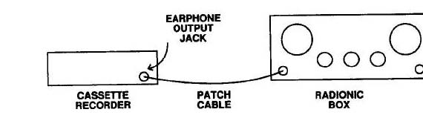
When doing this, the pattern, witness and rate have already been placed on the machine and the recorder is connected to the left-hand jack of the box. There is no need to have a tape in the recorder at this point. Simply turn on the recorder in playback and set the volume by rubbing the stick pad as you turn the dial, just as if you were taking a rate. In fact you are taking a rate. Then you just let the thing run.
Using the FM radio is a bit more complicated, as the next figure shows.
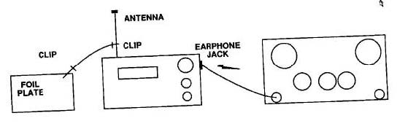
Looks like the radio box from my website, right? Well, it is with a radionic box attached. You will need, in addition to the radio, a length of wire with an alligator clip on each end, a foil place made by gluing a square of foil to a piece of cardboard and a patch cable to attach the radio to the input of the box.
Start by taking a rate on the box for the pattern that you wish to transmit. Once you have done this, use the wire with the clips to attach the foil plate to the antenna of the radio. Place the pattern on the plate and attach the radio to the box by means of the patch cable. Now use the stick pad to take a rate for the pattern on the radio the same way you did on the box.
Turn on the radio, if it is not already when you set it and the energy from the radio will increase the output of your machine.
One of things I have found is that if you are working with balancing rates, such as in healing work or neutralizing incoming hostile energy, the recorder works best and if you are working with transmittal patterns, the radio works best. Incidentally, these arrangements were the basis of the older radionic devices.
Modifying a walkie talkie for use with a radionic box device takes a little more work but it is well worth the trouble. This gadget is usually added to the system after the box so that the signal coming out of the box is transmitted over the radio carrier wave. It may be best to remove or shorten the antenna because the FCC gets very upset at people who disrupt radio traffic. A shortened antenna will allow the wave to get out, but it will not be strong enough to be picked up by any but the most sensitive equipment.
Please take the above instruction very seriously. Avoid the temptation to lengthen the antenna. It has little effect on the results and I would be very unhappy if one of my readers ended up in jail.
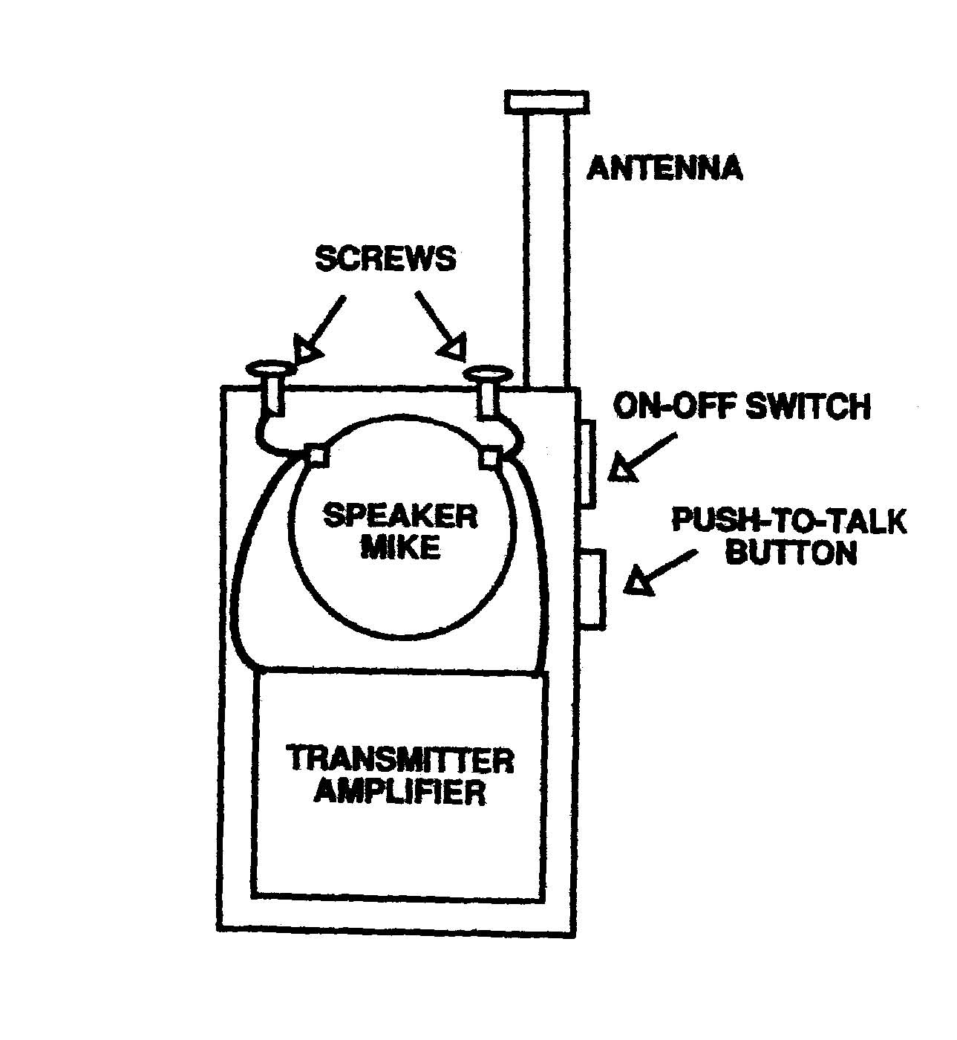
You will see from the figure that a walkie-talkie, at least of the cheap variety, uses the speaker for a microphone. The speaker is wired into the transmitter from two small tabs on the back of the speaker, so when you take the unit apart you must be able to get at those tabs. This is usually quite easy, the speaker often being laid between a few slots and simply lifted out, but sometimes you must remove some small screws to take it out. Once you have the speaker out, do not disconnect it from the amplifier. Having the speaker still in the system makes testing the battery easier.
Drill two small holes in the top of the walkie-talkie case. It is best to use a hand drill for this as a power drill might push to hard and damage the transmitter. Place two screws in the holes and wire each screw to a tab on the speaker.
Put the walkie-talkie back together and tape down the push-to-talk button. This way the walkie-talkie will always transmit when you turn on the power switch.
This device is usually used when you want a short burst of power. The life of the battery is limited.
In order to wire the box, or helmet, to the walkie-talkie, you will need a special patch cable with a plug on one end and two alligator clips on the other. Each clip is attached to one of the screws and when you transmit, the signal is sent through the wire to them, to the amplifier and thence out to the void or your target, depending on the operation.
The addition of a carrier wave can be a great benefit in most communication experiments. There are a number of ways this can be done.
The helmet can be directly connected to the walkie-talkie. In this case the rate is only on the helmet and no witness sample is used once the rate has been taken. All that is then necessary is for the operator to have a clear image in his mind while transmitting.
Far better is the use of the helmet and box along with the walkie-talkie. In this case, it is not necessary to hang onto the image of the subject. The box will do that for you. All that is required is that the equipment be set up and you can work with relative ease.
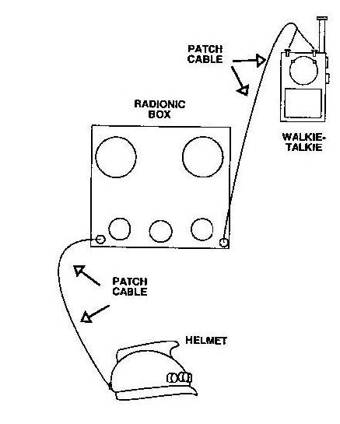
Those of you who have been diligent in your study of Elementary Psionics can probably guess what is going to come next. And you are right. For once you have set up your equipment in this manner, the next step is to add your teleflasher (see appendix). The operator has now put together an impressive array of machinery that will at least make a tremendous impact on him and usually on the target being transmitted at. That is provided no one else sees you using it because you will look ridiculous. One time my mother saw me working that way and laughed so hard she nearly lost her balance and I ended up laughing with her. That pretty much ended that experiment.
But all this leads to an obvious question, namely why would the addition of a radio carrier wave or amplified current affect psychic transmission? It is a hard question to answer and please do not think that I have the last word on it. What I am going to give you is nothing more than a guess.
It all comes down to the peculiar relationship between psychic energy and electromagnetic energy. Even as the psychic wave is produced by the relationship between the electrical activity in our brains and the various levels of the etheric body, so it is made more powerful by the addition of the electromagnetic energy, as in using light to boost a radionic signal. Unfortunately I have no idea what the full nature of that relationship is and thus you are going to be left with a mystery for others who are far better thinkers than I to solve. I wish them luck.
But, suppose that you wish your transmission to be more effective still. You already know that the teleflasher can work because of the effect of the rhythmic flashing of the brain of the sender. By adding the same rhythm to the radio transmission, the receiver will also be thus affected.
There is an easy way to accomplish this. Cut one of the wires leading from the battery clip to the amplifier of the walkie-talkie. A button, like that of a doorbell, is wired into the system by means of a long wire.
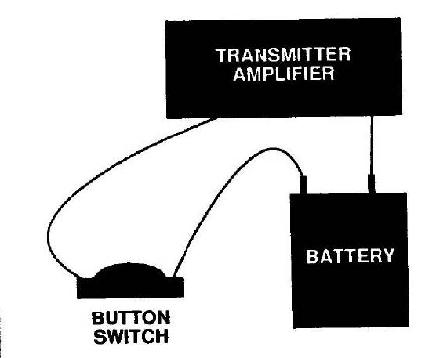
When you sit before the teleflasher, each time the image is lit, you push the button. This will set up a rhythm in the brain of the receiver and increase the ability of your message to get through the noise that is usually occupying the mind of anyone we wish to send to. In fact, getting through this noise is one of the principal difficulties that face any who work in the area of psychic transmission. People tend to be very inconsiderate and refuse to leave their minds totally open to us, as empty as they normally are of any rational thought. It can become quite annoying at times and one is tempted to take a drill and bore a hole in their skulls to let the information in.
There is another device that can be made using a walkie-talkie, and this one is excellent for use in the car. How many times have we all been in traffic wishing that one of the other drivers would smash her suv full of brats into the gasoline truck and give us all some free entertainment? With the little gadget you are going to build now, you will be able to safely put ideas in the minds of other drivers and, on most occasions, decrease the time that you will spend waiting for traffic lights (and with luck cause the occasional traffic cop to be broadsided by a cement truck).
In order to create this masterpiece of psionic ingenuity, you will need an amplifying pattern, a piece of foil, a plastic box such as a pencil box, a switch, some wire and glue as well as a cheap walkie-talkie.
Cut a circle out of the foil and glue it to the center of the pattern. Lay that arrangement to one side where it will be safe to let the glue dry.
Now take apart the walkie-talkie. Be certain that you start with the correct size screwdrivers because some of the screws can be quite small and you do not wish to damage anything when you remove the circuitry from the case. Work slowly, be patient and do a neat job.
Take the plastic box and punch two small holes in the top. Make a small coil of wire, small enough to lay flat under the central circle of your pattern and run the two ends through the holes in the box. When you lay your fingers over the center of the pattern they should be over the center of the coil.
Punch more holes in the side of the box for the switch and the antenna. Now cut the speaker wire away from the chassis, leaving enough wire to make a good connection. Cut one of the battery wires as well.
Mount the chassis inside the box. This can be done either by screwing it down if possible or by taping it securely in place with plastic tape. Be sure that the power switch of the walkie-talkie is turned on when mounting and tape or wire down the push-to-talk button.
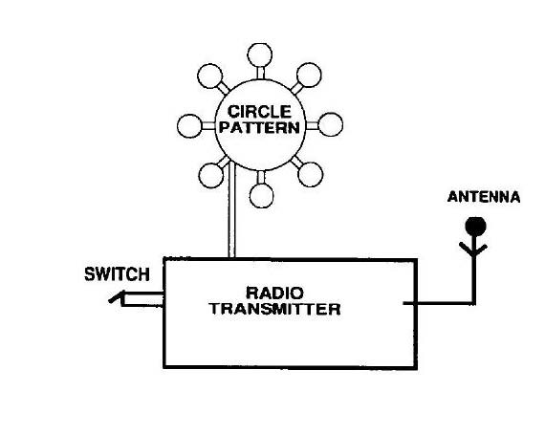
Attach the wires from the coil to the speaker wires. Mount the on-off switch to the outside of the box and connect it to the battery wire that you have cut. Attach a wire to the antenna connection and run it out through the hole provided for it. Now close the box. It sounds more complicated and intimidating to make than it really is and except for removing the chassis from the walkie-talkie case it should actually take very little time.
So how is this machine used? When you are driving, place this box on the seat beside you. It is a good idea to normally leave the power off because otherwise you may go through a lot of batteries. As you come up to a stoplight, turn on the power and place the index and middle fingers of your right hand on the center of the pattern. Will the light to change and watch the results. You will be amazed.
You can also use this device to communicate with other drivers. For example, when you see the police car cruising about looking for ways to harass honest citizens, send a commend to driver to turn sharply left. And then watch the crash!
Now it is time to consider using light. You will remember from earlier chapters that adding light to a radionic signal had a clear effect upon the receiver of that transmission. And it is true that a light beam can be used to increase the effectiveness of any psychic work. When I was laying in the hospital neither getting worse nor improving, my friends gathered and each had a flashlight. The shone the beams on my photograph and sent healing thoughts. I was home from the hospital in a week.
You can prove this to yourself with the aid of a friend. Have the person sit with his back to you holding a pendulum over a chart with the letters of the alphabet written on it around a half-circle. Think a letter at him and find out how long it takes for the pendulum to swing to that letter, if it does. Mark down the time and repeat the experiment with one small change. Shine a flashlight on the nape of your friend’s neck, right over the throat chakra. You will notice a change in result.
There is only one problem with using a light beam in psionics and that is getting the psionic signal into beam! While you are holding a flashlight, this is not a problem, but when you are working with a group of psionic devices at the same time, that can be difficult if not impossible. Fortunately there are a couple of ways around this.
You will need a small, high-intensity lamp, a sheet of poster board, aluminum foil and two screws with four nuts (and no you can’t have my in-laws). Cut a square from the poster board large enough to make a tube that will fit over the end of the lamp so that the light will go through it as a sleeve. Cut a piece of the foil that will cover one side of the poster board and glue it into place.
Punch two holes in the arrangement and be certain that the screws fit in them.
You will probably be wondering why I instructed you to have four nuts for two screws. When the tube is complete, you will want the screws to stick out, not sliding in and out. Therefore, screw one nut on each screw before inserting it into its hole and then place the other nut on the inside, over the foil and tighten them to hold each screw in place so that the heads of the screws will be outside, on the cardboard side and nuts will be in contact with the foil.
Roll up the tube with the foil inside and fit it over the end of the lamp. Glue or tape it together and attach it over the end of the lamp so it stays in place.
To use this piece of equipment, attach the tube to either your helmet or your machine by means of the cable with the alligator clips holding the screws. The witness of the person you are beaming at is then placed in the beam of the lamp. As you transmit, the energy of your thought is picked up by the beam of light from the foil and shot at the witness.
Another method is to make a light-emitting helmet. Now, a common mistake among people who make psionic devices is they tend to pack too much stuff into one device. This makes the devices overly complicated and often the energies they create can work at cross-purposes, making the instruments confusing at best and worthless at worst. Considering what is charged for them, that can be a nightmare for someone working on a limited budget, like your humble author.
Helmet designers are the worst offenders. They forget that these things are supposed to be worn in the head and the more things that get packed in, the heavier they become! So the most important thing is to keep things as simple as possible and make them modular so you can connect devices as needed while not over-burdening any single unit.
The light-emitting helmet is a mod of the psionic amplifying helmet with a flashlight replacing the crest. The helmet is made the same way as the standard, three-dial helmet that I describe in my other books and in the appendix of this one. The difference is that the crest is replaced by a flashlight. In my helmet, I used a snake-type light that ran on two AA batteries and was quite cheap, but if you cannot find that, any small flashlight will work.
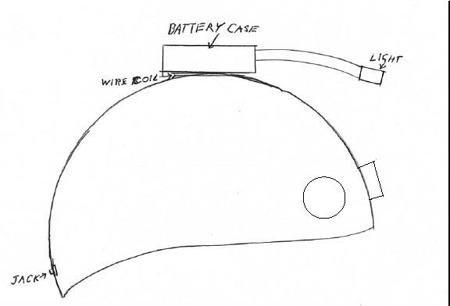
The main difference is that the antenna wire is wound around the base of the light in this case, or around the body of the flashlight where the batteries reside and then the light is glued to the helmet. Use a small flashlight to cut down on the weight and make sure if you use a normal flashlight that it is arranged so that the beam of the light shines forward but slightly down. This will make it a lot easier on your neck when you use it. The advantage of using a snake-type light is that you can adjust the beam for your comfort.
Now, you may wonder just why you would want such a device. Well, it can be very useful when working with unconventional witness samples, such as video tape or pictures on a computer screen that for some reason will not allow themselves to be printed without a lot of hacker-type work that is often too complicated for us non-geek mere mortals.
To use the helmet in this way, you set the rate that you wish to transmit on the helmet and then while looking at the witness on the screen, transmit at that target by visualizing your signal going down the light beam to it. It is a very effective technique, especially in an election year because you can aim it at the televised speeches of politicians you dislike and cause them to stumble over their own words.
Unfortunately I have never been able to make one of them lose control of his bowels on camera, but if someone can, please feel free to do so.
Now we go back in time somewhat. When this book was first being written a number of folks who had read my first book wondered why I did not include anything with crystals. The reason at that time was very simple. Crystals were simply not that common in the Chicago area and I never really gave them much thought. But at the suggestion of my readers, I did some experimenting and came up with a simple crystal device that would act as a good output amplifier for a radionic unit, either box or helmet.
To make this device you need:
A six-volt lantern and battery
A metal funnel
A quartz crystal
Two screws and four nuts.
This device works on the same principle of light being energized in a chamber like the light tube and then being forced into the crystal and thence out to the target.
Following the illustration, take the funnel and punch two small holes for the screws and cut four short slots in the narrow end of the funnel.
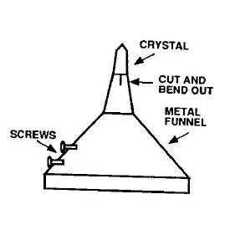
Bend these out and fit the crystal with the pointy end facing outward and apply a small amount of instant glue to the crystal. Bend the funnel end back in to make a tight fit and let the glue set.
Fit the screws into the holes using the nuts as you did in the light tube. Glue the funnel arrangement over the end of the lantern.
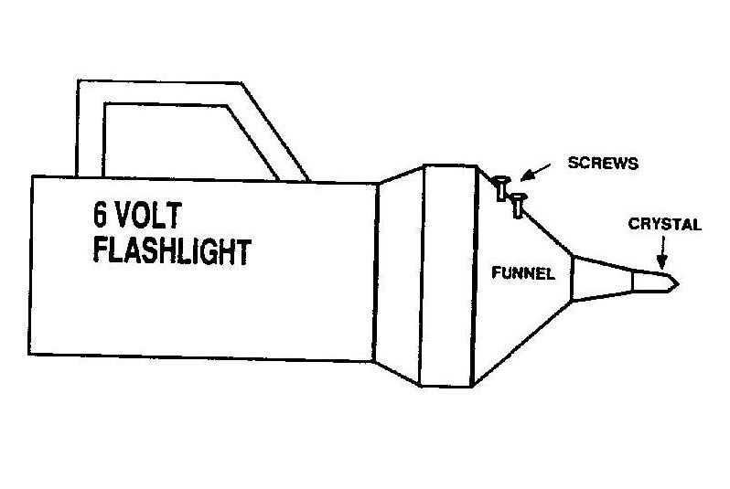
When in use, the patch cable is again attached to the screws as when using the modified walkie-talkie. The crystal will act as the signal amplifier and there is no need to point the device directly at a witness sample.
The devices I have described in this chapter are mostly designed for communication work. In other words, you have a message that you wish to send to a person by psychic means, and these devices increase the ability to get through the noise. So, let us say that you wish to send a normal message to someone who has had the great blessing of having also read my books and built these devices. All well and good and the blessings of Zeus be upon you both, but you should understand that this must be in the nature of a fun experiment, at least at first. Psychic communication is not going to replace the telephone or e-mail so bear in mind that what you are going to be making is a sort of psychic telegraph and a rather slow one at that.
Still, it is quite an experience when you get your first psychic message right so do not be afraid to give it a try. You will need to decide who will transmit and who will receive. The transmitter will need a radionic box, an amplifying helmet, a teleflasher and a witness of the receiver. He may also want to add an amplification system, such as the walkie-talkie or the crystal light to his system.
The receiver will need only a psionic amplifying helmet, a radionic box and a pendulum and alphabet chart or Ouija Board. The Ouija Board is much faster and please do not listen to the stupid, superstitious nonsense about how people using it get possessed by demons. That is a lie of the Xtians.
It is necessary to agree on a time for the experiment to take place. It will do no good for one person to be merrily beaming away and the receiver be busy cooking dinner. Both should have their equipment set up and ready. The transmitter should have a series of alphabet cards or pieces of paper handy with the letters of the alphabet on them.
At the appointed time, the receiver will take up his position with either pendulum or board and the transmitter will start sending, one letter at a time.
At this point there may be a little problem for the transmitter may not know if his message is being received and it is time to go on to the next. There are two ways around this difficulty. The first is to set an arbitrary time for each sending, such as one minute for each letter. Second he may use his pendulum to tell him when the letter has been received. To do this, the pendulum is held next to an upright object such as the side of a desk, or inside a glass and allowed to swing. When it hits, the message has gotten through.
It is also a good idea to agree upon a code, such as “N” to signify a new word and “end” to signify the end of a message.
This is extremely useful for those engaged in criminal conspiracies because tapping this is extremely difficult, though not impossible. While interception is possible, it requires knowing when a transmission is going to be sent and having a witness of the transmitting individual.
And with all that out of the way we can get to the fun stuff.
PSIONIC MAYHEM
“Destruction, aught with evil bent, That is my proper element.” Goethe, Faust
The original edition of this book had a chapter entitled “Psionic Conflict” but that soon became a book of its own, Psionic Warfare. So, that you would not feel cheated at losing a chapter, I’ve replaced it with something far more interesting.
Mayhem and Slaughter! (Would you expect anything less from me?)
Ok, now get this!
Humanity was not put on this miserable little ball of dirt to sit in the mud and bewail its fate. We were born with brains to fight our way out of the mud and the ability to enjoy doing it.
We were not put here to alleviate suffering, but rather to cause it because nothing is ever accomplished without somebody getting hurt in the process. As the old saying went, “You can’t make an omelet without breaking eggs.”
We are born to cause pain.
We are born to destroy.
We are born to kill.
We are born to raise hell.
“Power comes from the barrel of a gun.” Psionics is that gun. It gives people the opportunity to be the bad guy and get away with it.
Ok, story time.
I’m sort of unique among military historians in that I actually like the WW2 British Field Marshal Bernard Montgomery. One of my favorite Field Marshall Montgomery stories took place shortly after the end of the Second World War. He was being driven along a country road and he spotted a small boy walking to school. Monty had his driver stop and he offered the boy a ride, which the boy, undoubtedly suffering from bad parents who never told him not to accept a ride from strange general officers, accepted. Monty, with that funny grin he would get, asked in his high-pitched voice, “Do you know who I am?” (And I really wish you could hear me tell this story, I do a great Monty imitation.)
“No, sir,” the boy replied with a politeness typical of that bygone era.
“I’m a Field Marshall,” Monty said with glee.
The boy, trying to make conversation, said, “My father works in the fields too. What do you do sir?”
At this, Monty beamed and smiled his biggest smile and said, “I KILL people!”
The boy, from a more innocent time and not used to killing people on his computer like modern children, was taken aback by this revelation and asked, “Have you killed many people sir?”
“Oh, thousands!” was Monty’s joyous response.
The boy asked, in a quiet tone, “May I be getting out now, sir?”
There is nothing like a man who loves his work. And because I love my work, being the Black Beast of Psionics, I’ve had a little problem to contend with.
You see, I got terribly upstaged. I mean, how can I possibly top the sight of a 767 kamikaziing itself into a skyscraper? Here I am, writing these marvelous books just full of fascinating material on how to disrupt the world and then some nut with a dishtowel on his head screws everything up! So, like everyone else in the civilized world, I want Osama bin Laden dead, but not for the same reason.
That bastard spoiled my fun for a whole month! I mean I had a good thing going. I could put “international terrorist” in my job description and be sure of getting a good laugh until that son of a camel screwed things up. And to make matters worse, a whole bunch of damned fools took the thing seriously (I mean, let’s be serious, do we really care about some buildings in New York?) so now we have phoney terrorist alerts in designer colors which make clods and lunatics duct tape everything in sight, their houses, their cars, their kids; foot fetishists lining up to get jobs in airport security so they can sniff people’s shoes and people finding new dimensions in cowardice. (As well as the usual pack of governmental incompetents, fools and sundry morons in the media, going around shouting, “It’s the wolf! It’s the wolf!”) The only good thing that has come of this mess is now we can start wars without worrying about them being “just” or not. Wars do not have to be just, merely successful and hopefully entertaining with lots of television of things blowing up.
Anyway, I sat and steamed and fumed and fulminated and then I got this great idea.
You see, the works of my Dark Cycle (which is what I call my Psionic Warfare, Psionic Terrorism and Psionic Psupervillain) were essentially based on the premise of man against society. They were concerned with how one man can take on the whole world and win and have some good, nasty fun in the process.
But the truth is that when psychics attack, they are usually not going to be working for a broad, often political, end. And much of the stuff in those books had that in mind. No, they are going to be aiming for specific individuals who have managed to get in their way, be they traffic cops, school principals, ex-spouses, ex-spouses lawyers, obnoxious in-laws or deranged ex-girlfriends. And for all the ferocity of the attacks, there really should be some rational basis at least in the choice of target, unlike the lunatic psychic back in 70s, Ted Owens, who would retaliate against a traffic ticket in Houston by making a plan crash in Seattle which I’m sure had a lot of impact on traffic cops in Houston.
Putting all that aside, this chapter has certain fundamental premises. The first is that there is nothing wrong with killing people. Nothing! Murder is cool as well as highly entertaining as long as it is happening to someone else. Ok, it isn’t as cool as landmines, but then nothing is as cool as landmines. It is, in fact, one of the coolest things people can (short of planting landmines) do provided they do it properly, which is to say they get away with it and don’t leave a mess in the living room (unless you use claymore mines which are almost as cool as landmines). After all, we are civilized human beings and one must be neat in one’s killings. It is very tasteless to have bodies buried under the house. But, the notion that there is somehow something objectionable in doing people in is nothing more than one of those unfortunate holdovers from the primitive, drug-addled, ancient sheep-fuckers who, after spending too much time out in the desert sun and imagining that some drooling, idiot god was talking to them, (And the voice came from the burning bush, screaming with a loud scream, “My pants are on fire!) created a lot of the moral horse manure that we are saddled with. It is something that civilized people should have the sense to get over and recognize that one of the few things that makes human life of any value are the varied and entertaining ways there are of ending it.
In the words of the prophecy:
“It has been said to you, ‘Thou shalt not kill,’ but I say unto you that thou shalt kill and kill again until the world is drenched with the blood of your victims. Thou willt show no mercy to man, woman nor child and with each act of slaughter the gods will shower blessings upon you and lead you closer to paradise.”
The second premise is that given a bit of rational judgment, anyone will not only be able to think of people they want to kill but will be more than willing to do that provided they can get away with it.
This chapter will tell you how to do just that, kill people and get away with it.
Think about it. Psionics leaves no evidence. There is no smoking gun. In fact most of the time there is no gun at all and if there is one you aren’t going to be the one shooting it. There is nothing that can point to the operator. All there is a dead person, usually dead of natural causes. Which means that the antiquated societal conventions against homicide will have no effect on you. There can be no effective sanction against this, no law can stop it, no judiciary can punish it. And if anyone be so foolish as to attempt to call you into account for using these methods, well, you have the means to deal with them. (Ever see a police car after it has been broadsided by a cement truck?)
People die of natural causes and accidents all the time.
Forget all the nonsense about ethics and morality that people have taught you. There is no Karma. There is no Law of Three or whatever they are it calling this month. You have the right to use psionics for anything you damned well please and if you get away with something in this life, nothing bad is going to happen to you in any other.
Ok, I’ve ranted enough for the moment.
So let’s get started.
Now, before was get going, this chapter is based on the premise that the target is not adept at psychic defense and has no idea of what you are going to do. If you have a target that can defend himself, it is best that you study my Psionic Warfare to learn how to deal with him.
Getting your head into killing mode is a rather simple thing to do if you are hopping mad. At that time the hard thing is forcing yourself to use psionics rather than picking the immediate and noisy expedient of going out with a gun and blowing the offending party away. (Believe me I know!) Happy as that outcome would be, there can be unpleasant side effects if you are caught, to say nothing of paperwork and legal fees. Thus it is preferable that you do work as coldbloodedly as humanly possible.
The idea of a mantra to get the mind into a killer state actually has its origins with the US military. During basic training soldiers would exercise while chanting “Kill, kill, kill.” This worked very well and helped train many future postal workers. (It is also a good reason never to vote for anyone who ever served in the military. They may go berserk at any time and shoot up their constituents.)
Well, we must not argue with success. If it worked for them it will work for us.
Get yourself a cd of drumming, the sort of thing the New Agers who have been so unfortunate as to get into psuedo-shamanism use, to send them off to the great beyond. What you want is a regular, steady beat that has a tempo which you are comfortable with.
Acquire a weapon. This can be a gun, a knife, a sword, a club, anything that you feel comfortable with and speaks to you while you are holding it. By speaking to you, I mean that when you pick it up it feels as if it is an extension of your being. You will know it when you experience it. Now, if you are going to use a gun for this, be sensible and first make sure it is very empty. You do not want to accidentally shoot the wall or your foot.
Wear loose-fitting black clothing. After all, you’re going to be a psychic ninja!
Ok, got all that? Now, sit in a comfy chair and turn on the cd. Pick up the weapon and hold it comfortably, feeling the lethal energy of it filling you and making you one with it.
See yourself as the Executioner, the Assassin. Hold that image of yourself in your mind and then begin the mantra:
Kill
Kill
KIll.
Do not shout the words, but intone them slowly and rhythmically along with the drum beats, drawing out the word, so that instead of a quick “kill,” it sounds like “kiiiillllllll.”
As you do this, feel the energy of the word itself moving from the base of your spine to the top of your head, filling your entire being with the spirit of destruction and murder. You are Death in his malevolent aspect, taking the lives of the innocent but you know that there are no innocents and all are deserving of destruction.
Hold this for a time, as long as you are comfortable doing so and then come back to normal, putting the weapon aside and turning off the music. It is a good idea to play something cheerful at this point to get your mood back to something that can go out in the world of men and not scare the living daylights out of everyone you see. After all, if you are going to stab someone in the back she has to first be willing to let you get behind her back.
Another extremely good one comes from Dr. Who, the old British television series. Actually it comes from a Dave Allen send-up of it. It is known as the Dalek Mantra and I once used it as a joke to give my Theosophist friends the willies.
The procedure for using this mantra is the same as before. Only this time the chant is:
Exterminate exterminate
annihilate
exterminate.
I know it looks funny reading it (and it was hilarious coming out of a rolling baptismal font in the Allen skit), but it is extremely effective in practice, especially as the words resonate up your spine--Exterrrrrrmmmmminnnnnnnnaaaaaate.
And of course, prior to any operation you should always begin with the Gita affirmation, “I am become Death, the Destroyer of Worlds.”
As you perform these actions, you will charge your conscious and subconscious mind with the joy of lethality and remove the last vestiges of weakening conscience. This is VERY important. The subconscious can do really bad things to you, like sabotage your operations causing you say, “Why isn’t he dead yet?” to making you make mistakes at embarrassing moments and injuring yourself. Get rid of the damned thing. It only gets in the way of having fun. Remember what I said in the second chapter!
Now, a good longer affirmation which can be of use to you comes from Shakespeare. It is the famous speech by the Duke of Gloucester in Henry VI part 3 when he turns from hero into villain and sets the stage for his character in Richard III.
“Why, I can smile, and murder whilst I smile, And cry content to that which grieves my heart, And wet my cheeks with artificial tears and frame my face to all occasions. I’ll drown more sailors than the mermaids shall, I’ll slay more gazers than the basilisk Play the orator as well as Nestor Deceive more slyly than Ulysses could, And, like a Sinon, take another Troy. I can add colors to the chameleon, Change shapes with Proteus for advantages And set the murderous Machiavel to school.”
Repeat this every morning when you get out of bed. It will not only aid you in the work of psychic slaughter, but help you deal with all other vicissitudes of life. Never forget that:
“Conscience is but a word that cowards used, devis’d first to keep the strong in awe.”
Now, getting rid of a conscience is not an easy thing to do. We all have one. The trick is to make yours work a bit, well, differently. And that is easy to do. All you need do is repeat to yourself a very simple affirmation.
“Everything I do is right by definition.”
That’s all you have to do. Whenever you get a pang, repeat this little sentence. And it is a good idea to repeat every night before you go to bed and every morning when you get up.
Not only do you have to get rid of your conscience, at least in these matters, you also have to be honest with yourself and not take yourself so seriously that you get self-deluded.
For example, I have an unfortunate friend who is often saying how dangerous he is. This is not uncommon in a lifestyle were people are constantly bragging about using physical force for one silly end or another forgetting that there are people out there who have guns.
Anyway, one night a group of us, my wife, our girlfriend/submissive and our friend who was in very dumpy cross-dresser mode were leaving our favorite play club about 3 AM. As we were loading our toys into the van a local Mexican was standing by and kept approaching, slowly but rather deliberately. I, with equal slowness and deliberateness, opened one of our boxes and quietly removed a knife which I then opened with surprise under the Mexican’s nose. He backed away very quickly and we finished loading the van and prepared to drive away as our friend, pretending to be oblivious, scurried towards his car like Edith Bunker on crack followed by the Mexican.
It turned out that the Mexican was not a mugger but probably wanted to get laid and when our friend managed to get into his car and lock himself in the Mexican stood across the street making “Obscene grunting noises.” Everyone escaped unscathed but we assume our friend’s panties had become somewhat yellower.
Now, who was the dangerous one? Not him!
So if you cannot be honest with others, at least be honest with yourself and know that you are not always going to live up to your self-image. I know I don’t often live up to mine and it’s a damned good thing I don’t. Lawyers are expensive!
The point is not to divorce yourself from common sense. Yes, you can use psionics to kill the traffic cop who gave you the ticket, in fact I hope you will, but the best thing is to use it to prevent yourself from getting the ticket in the first place. It is far less work.
That being said, psychic assassination is an art that requires some knowledge of the target, particularly the vulnerabilities of the target, and a repertoire of techniques and weapons to deal with that target. In other words, you do not attack a bunker with a rifle. You use a rocket or you call in your air support and it uses its rockets. This is something you must be able to determine.
In other words, the target will stay dead ever so much longer if you hit her with the right weapon in the right place.
Now, all that being said, how do you go about this?
Remember that pretty much until I hijacked it (Mahmud, are you sure you know how to fly this thing?) radionics was almost exclusively a healing art (with a few digressions into agriculture). Right after I made my first box, I asked myself the question, “Ok, who do I kill first?” and proceeded to take a photograph of a target, smear it with poison and set up the machine just like one would do if killing bugs in the garden.
To quote an old Charles Adams cartoon, “Death ray fiddlesticks! It doesn’t even slow them up!”
I was in despair. Here I had this wonderful toy and it seemed that I was destined to be stuck using it to (yuck) heal people!
Well, fortunately I was wrong. I had a fantastic weapon, possibly the most powerful weapon one can get one’s hands on unless you have access to nuclear warheads and a good delivery system. And it may be even better than they are!
It was simply a matter of figuring out ways of working with it.
And work with it I did.
So here’s the skinny, as a strange friend of mine says. What you need to do is go back to the knowledge of medical radionics and make some, well, adjustments.
You see attack psionics is sort of like judo. You take what is already in the target and make it work against her. So, for example, if she is prone to high-blood pressure, you work to raise that blood-pressure and attack the brain, causing a stroke. Or, if there is a pre-tendency to cancer (and you must remember that not all cancers are dangerous) you can amplify that tendency. That is a very long term operation and you must expect to work for years if you take that route.
Or, if you are feeling really nasty, you can depress her immune system and she will die of AIDS without having any of the fun of getting it!
All right, how do you do this?
The medical radionic people have, over the course of the years, created a number of methods of diagnosis, one of the easiest being a chart with all the relevant body functions on it (heart, lungs, brain, liver, etc.) on it. Each system has a numbering system of 0-100 in a line under it and the witness of the person is placed in the center of the chart and the pendulum is placed at 0 under each system. The pendulum is allowed to swing and the higher the number, the better the system is working. A dot is made at each point and then they are connected to make a chart which is a pretty good indication of the physical/etheric health of the person.
You can do the same thing. Make up such a chart by taking a piece of paper and listing the major body functions in a row along the top and then marking off the numbers underneath.
So how would you work this?
Let us say you want to remove your noisy neighbor. He is a bore, a pain and his stereo is just too damned loud. You acquire a witness of him with your camera and then place that witness over the chart. Then you go through the chart with your pendulum and get readings on his various functions. And you learn that his blood-pressure is elevated and he has a weakness in the brain (but you sort of knew that anyway). This gives you an obvious target—his head.
There are a few ways of attacking this, all of which will work.
The first, and the one that takes the most time, is to use a radionic box. In this case, you take his witness and make a circle pattern for the weakness in the blood-vessels in his brain. You write, “break the blood vessels” on a piece of paper and put that in the transmittal side of the instrument along with a photo of the neighbor. Then you take the rate.
Add amplification as desired, usually by amplified current or light on the input and let the machine sit. Every week, check the chart and change the rate to reflect the changes the arrangement has caused. Eventually your target will suffer a stroke. But, as I said, this is a time consuming method and there may be long periods where you wonder if the changes being shown on the chart are just wishful thinking.
The second is the direct approach. For that you need the witness, the radionic box and helmet.
Set the box and helmet for a contact rate for the target. Put on the helmet and visualize his brain. Now, attack! See the blood vessels bursting and making an ungodly mess of the brain, knowing that as you do this, the energy you are putting forth will soon cause the real thing to happen inside the head of your target. Keep pumping that energy in and only stop when you feel drained.
Repeat as often as desired.
The third method of attack is to create a thoughtform and place it inside the etheric field of the target’s brain. This is done by creating a pattern for the thoughtform, creating the thoughtform with the program running to cause the target to suffer a stroke and then visualizing it as taking root in the desired location. You use your radionic system to contact and add power to the thoughtform as needed.
To amplify a tendency, one must first know that a tendency exists. You do that by looking for them. So again, you make a chart and write the desired tendencies on it, such as “cancer” and then ask the pendulum if that tendency is present and if so, what level is it.
Let us say that the tendency is there. Ok, the next thing you need know is the type of cancer. Is it the possibility of a fast-moving one that is relatively hard to detect before it is incurable or is it one that just sort of lays and doesn’t do anything.
Let us say your target has a tendency to something nasty and inoperable and one that does not show up until it is too late. Rubbing your hands with demented glee and cackling insanely as appropriate, you create a pattern for that type of cancer and put it in the box along with the witness of the target. You take a rate and then move the witness of the target to the receiving end and add amplification and let nature take its course. Of course, nature may choose to take its own sweet time so you can help it along by putting on your helmet and visualizing the cancer cells and shouting “Grow! Grow! Grow!” while putting energy into them to help them do just that. The affect will be striking. What you will be doing is the Simonton technique in reverse, instead of visualizing the cells dying you will be encouraging them. And of course you will be doing it for another person rather than yourself.
There is one thing you should do after you perform such an operation however. While there is very little chance of cancer-causing energy coming back into you as a result of this, it is still no wise to take any chances. So when you are done, go into your bathroom and fill the sink with cold water. Plunge you hands into the water and visualize any bad stuff going into the water. Then empty the sink and dry your hands off. That will obviate that possible difficulty.
Now for my personal favorite technique—depressing the immune system.
You have to understand that people do not die of AIDS. They die of other things as a result of the virus knocking out their immune system so they cannot throw bugs off. It is a very unpleasant way to go and has the other advantage of horrible social opprobrium, particularly in most of the United States where the disease is considered a sign of moral turpitude at best and being Gay at worst. Which makes perfect for using on proletarians and other assorted trailer trash as they will then not only die, but die in, what is for their social class, the worst possible disgrace.
And it is surprisingly easy.
All you need is a witness of the target, a circle pattern that corresponds to her immune system and a radionic box. Essentially, you are going to balance out her immune system the way you would balance a disease pattern out of her etheric body. The principal is the same.
So all you have to do is take a rate for the immune system of the target and then balance the rate, so that if you have an initial rate of 2.3, 4.1, 2 you would subtract those numbers from 10 and you would get 7.7, 5.9, 8. You reset the dials as appropriate and just let the machine run. Every week you reset the machine. This is a time consuming process but it is like water running over a large earth damn. It seems to do little at first, but it wears the damn surface away until—SURPRISE! HEAD FOR DE HILLS! DE DAMN HAS DONE BUSTED!
And the beauty of this is that there is NO HIV virus in the system of the person. There is no warning that anything is going to happen and the doctors will never be able to figure out why the person is coming down with every cold known to man and why she is not recovering.
Isn’t it wonderful what we can do with psionics?
Now, of course we are not limited to attacking individuals. We can attack buildings and their occupants as well. One of the best methods to use against a building the most ancient nemesis of construction—no, not children—fire!
To use this method, you need to be able to pack the psychic equivalent of fire— the fire element—into a very tight, somewhat explosive thoughtform. This thoughtform will be packed until it reaches critical mass and then sort of bursts, causing a physical fire.
You begin with a witness of the target building. Set your box and helmet to the structure and then put on the helmet. Move your consciousness into the building, creating a remote, psychic presence. Now, start building your thoughtform. See a red triangle, the traditional symbol of the fire element, in the building and start packing it with the fire element drawn from the universe itself. As you pack it by seeing the triangle get brighter and brighter with little flames shooting out of it, program it to start a fire in the structure.
Keep at this one. It may take a little time but the results are nothing less than spectacular when they occur. I was at our weekly gathering some months ago and the place had its television on the nightly news and yea, lo, and verily, there was my target with flames shooting out of the windows and fire trucks and rescue vehicles all over the place. I had to work very hard to contain my joy and it was a very satisfying evening.
Towns and cities can be attacked the same way. Create a remote presence in the area (actually sort of in stationary orbit over it) and then start building your thoughtform. In this case you should concentrate on social unrest (like starting riots and suchlike entertainment) or weather conditions. If the area is in Tornado Alley you can create all manner of havoc. And if the city is in a part of the world where there are wars and rumors of wars, the choice of weapon should be obvious.
Now, wasn’t that simple?
Just remember, if it can be done, it should be done.
COUNTER THOUGHT FORMING
When I wrote this book this chapter dealt with something that was important at the time. While that time has passed and the New Age is dead and buried in the rubble of 9/11, it still has things of value so I decided to leave it in.
Most people think of group meditation as being rather benign, if rather boring, and in most cases it is. There are however occasions when something goes wrong. When this happens it is the right of the operator to create a thoughtform that will screw up the meditation and with luck make things go so wrong that no one will do it again. (And sometimes it is fun just to screw things up for the hell of it.)
To understand this, you must realize that in a group meditation two things are going on. First, a thoughtform is being created that will function according to the programming given it by the members of the group, usually acting on directions from a leader of some sort. Secondly, the process of meditation itself creates a mild trance state, similar in effect to light hypnotic induction. While in such a state, the members of the group are easily directed in any way that the person leading the meditation wants to take them. If the meditation is being led by someone who understands this, the risks to personal autonomy become obvious.
With this knowledge in mind, you should never allow yourself to become part of a group meditation unless you really know and trust the person who is leading it. My own practice was always to look as if I were meditating with the group (after all, there was no point in unnecessarily hurting anyone’s feelings) while maintaining my alertness.
The result of remaining in a state of control is that you can watch the meditation and if the leader invokes ideas that run counter to a value you hold strongly (like having some damned fool trying to cause peace when you really want war) you can visualize a thoughtform that will counter the one being created. Because of the Principal of Ultimate Instability, your thoughtform will be more coherent than the group one and thus more effective. If you are aware of the situation in advance, as would usually be the case, you may even create a counterthoughtform and have it ready to bring out when needed.
As far as the thoughtform itself is concerned, that will depend on the nature of the one you are blocking. In general your counter-thoughtform will either attack the thoughtform itself or block its energy from the members of the group or wherever it is supposed to go. (Sort of like setting up a thoughtform to block prayers from helping the President). Both work equally well and the choice is up to you.
APPENDIX 1 Basic Radionic Stuff
This short appendix is for those of you who are so unfortunate as to not have Elementary Psionics and thus have not had the marvelous opportunity to build the wondrous devices that are so necessary for this art.
To begin with, you will need a pendulum.
The pendulum is a very easy thing to make. You do not need to find the right variety of crystal on a new moon, buy it without haggling and then drill a hole in it with a bit blessed by the same rabbi who cuts off foreskins. All you need is a weight, any weight will do, and a convenient length of string.
For my personal taste, I like pendulums that end in a point. That way I know what they are pointing at when they are used with a chart like the ones later in this chapter. Totally round pendulums tend to be rather confusing in such uses. Other than that, you can use anything you like. An old key will work perfectly. It is heavy enough to cause a firm swing and being flat can be carried in the pocket without making a bulge that causes your girlfriend's parents to look at you with suspicion.
Another favorite of mine, which is nice at my age when girlfriend's parents are never encountered anymore because I’m married is a child's wooden top. Yes, they still make them and you can often find them at the local toy store. Failing that, the wooden knobs that they sell at craft stores work very well. The top has another advantage for those of us who have made the mistake of depending upon the honesty of publishers in their royalty statements. They come with their own string.
All you have to do is take a small screw-eye, available from your local hardware store, screw it into the center of the flat part of the top and attach the string. Now all you need do is measure the string so it is a comfortable length, usually between 12 and 18 inches, and cut it and place a small knot at the end so it does not unravel.
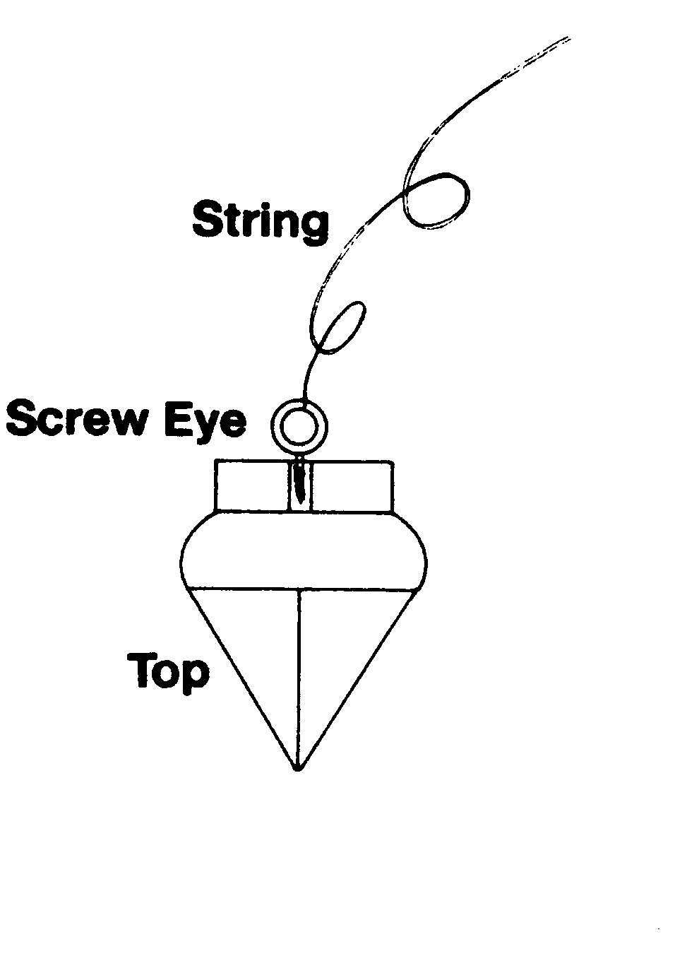
Voila! You have a pendulum and it works too.
Now, make a chart like this one.
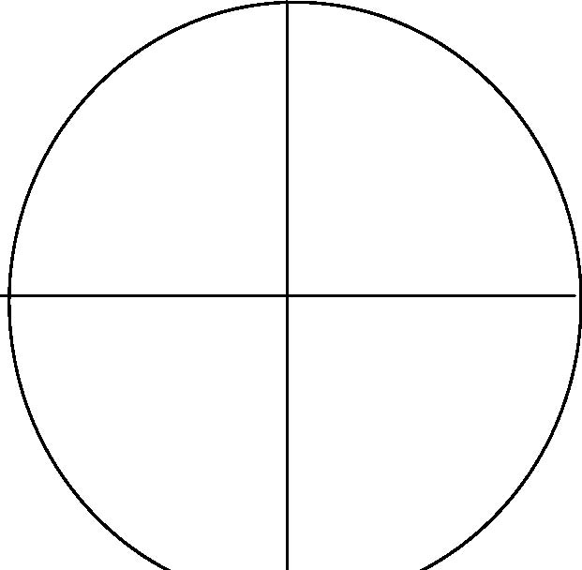
This chart will enable your pendulum to answer questions in three ways, yes, no, and I have no idea. You which answer is which by holding the pendulum over the cross hairs and think “yes,” “no,” and “How the hell should I know?” Then mark on the chart the direction of the swing.
The radionic devices take a bit of work to make and use, but they are far easier to work with than it may seem at first look. For your box, you will need
One metal can One plastic lid from a coffee can or other such product Three potentiometers (volume control things) available at any electronics store or online Three knobs Two jacks unshielded copper wire hook-up wire
The resistance of the wire and potentiometers is not important as the energies we use are not in themselves electrical.
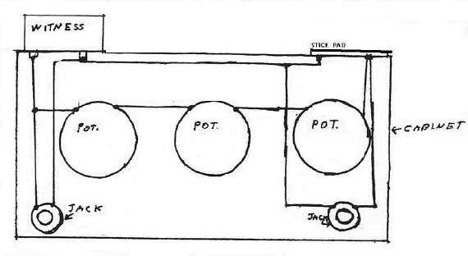
The box is wired as you can see from the figure. Use a cardboard box for your first unit because it is cheap and if you make mistakes it is not great loss. It is also a lot easier to punch holes in the box than to drill in plastic or metal. I used to think that metal cases did not work well with radionics, but I was given a rather expensive commercial unit as a gift and it has a metal case and works very well, so I was wrong about that one.
Anyway, first do the layout of the box. This may seem obvious, but if I left it out someone would mail me wondering what to do! Make the holes for the can, the jacks, the pots, and two small holes for the magnet wire.
Take the can and punch two small holes into the bottom. Insert two small screws and attach it to the box.
Wire the three pots in series and attach them to the box. Then wire the pot nearest the can to the can.
Make a coil of magnet wire and place it on the top of the box, with each end of the coiled wire going through the hole assigned to it. Wire one end of that coil to the potentiometer at the other end from the first and attach the other end of the magnet wire to the can.
Insert the first jack under the can and wire it to the can. Repeat the procedure with the jack under the coil.
All that now remains is to attach the knobs to the pots. Ideally you should have knobs that are calibrated, but as they are rather hard to come by you can print up three of these
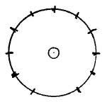
Place them each over the potentiometer stems and glue them into place on the box before attaching the knobs.
Once the knobs are on, glue the plastic lid over the coil, making sure that the coil is completely under the lid. It probably does not matter if wire is sticking out, but it looks nicer if it doesn’t.
Now that you have your box, you must learn to use it. The can is used for what is called a witness sample and that can be anything from the person you are working on. Now, here is something interesting. According to all the old theories of radionics a digital image should not work. After all, it is nothing more than ones and zeros and thus should contain no information such as could be said existed in older photographs, which is why if you read older material they make such a point of making sure the negative still exists. But digital images manifestly DO work and work quite well, which is why computer-based radionic systems work. So we have to seriously rethink our theories.
Anyway, once you have the witness sample in the can along with poor, old Prince Albert, take what is called a “contact rate” for the person. A rate is what the dials on the machine are set at and it is called a contact rate because this particular rate puts you in clear, psychic contact with the person. This is done by first clearing your mind as much as possible and then, with each dial first set to 0, slowly turning each dial while rubbing the stick pad. Once you get a stick on the pad, you have the rate for the dial. You then repeat the procedure until the other dials are set.
Once you have done this, place the box where you can rest the palm of your left hand on the stick pad while holding the pendulum over the chart you have made. With this arrangement ask the pendulum to tell you something that you do not know, phrased as a yes/no answer.
At this point you may wish to make a new chart for the pendulum so here it is.
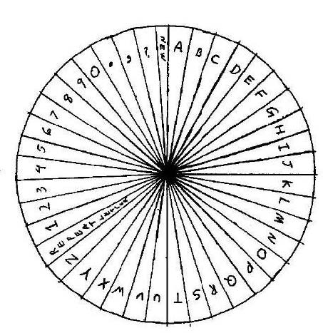
By using this chart and the contact rate, you can gain much information that would otherwise not be available to you.
The next tool you need to make is a portable stick pad.
As you can see from the figure below, this is nothing more than a modified stick pad like you make for your box. To make it you will need:
One plastic lid On six-foot length of speaker wire One monoraul plug One length of magnet wire.
Begin by stripping the insulation from the ends of the speaker wire, then split the wire so that you have about one inch of bare wire and one inch of insulated wire as slack at each end. Once you have done this, wore one of the speaker wire to the plug and put the plug together.
Make a coil of the magnet wire and tape it under the plastic lid. Now all you need to do is twist the ends of the magnet wire around each of the remaining ends of the speaker wire. A little electric tape is added to make it look neater and protect the wire from bending too much when the unit is used, otherwise it will break.
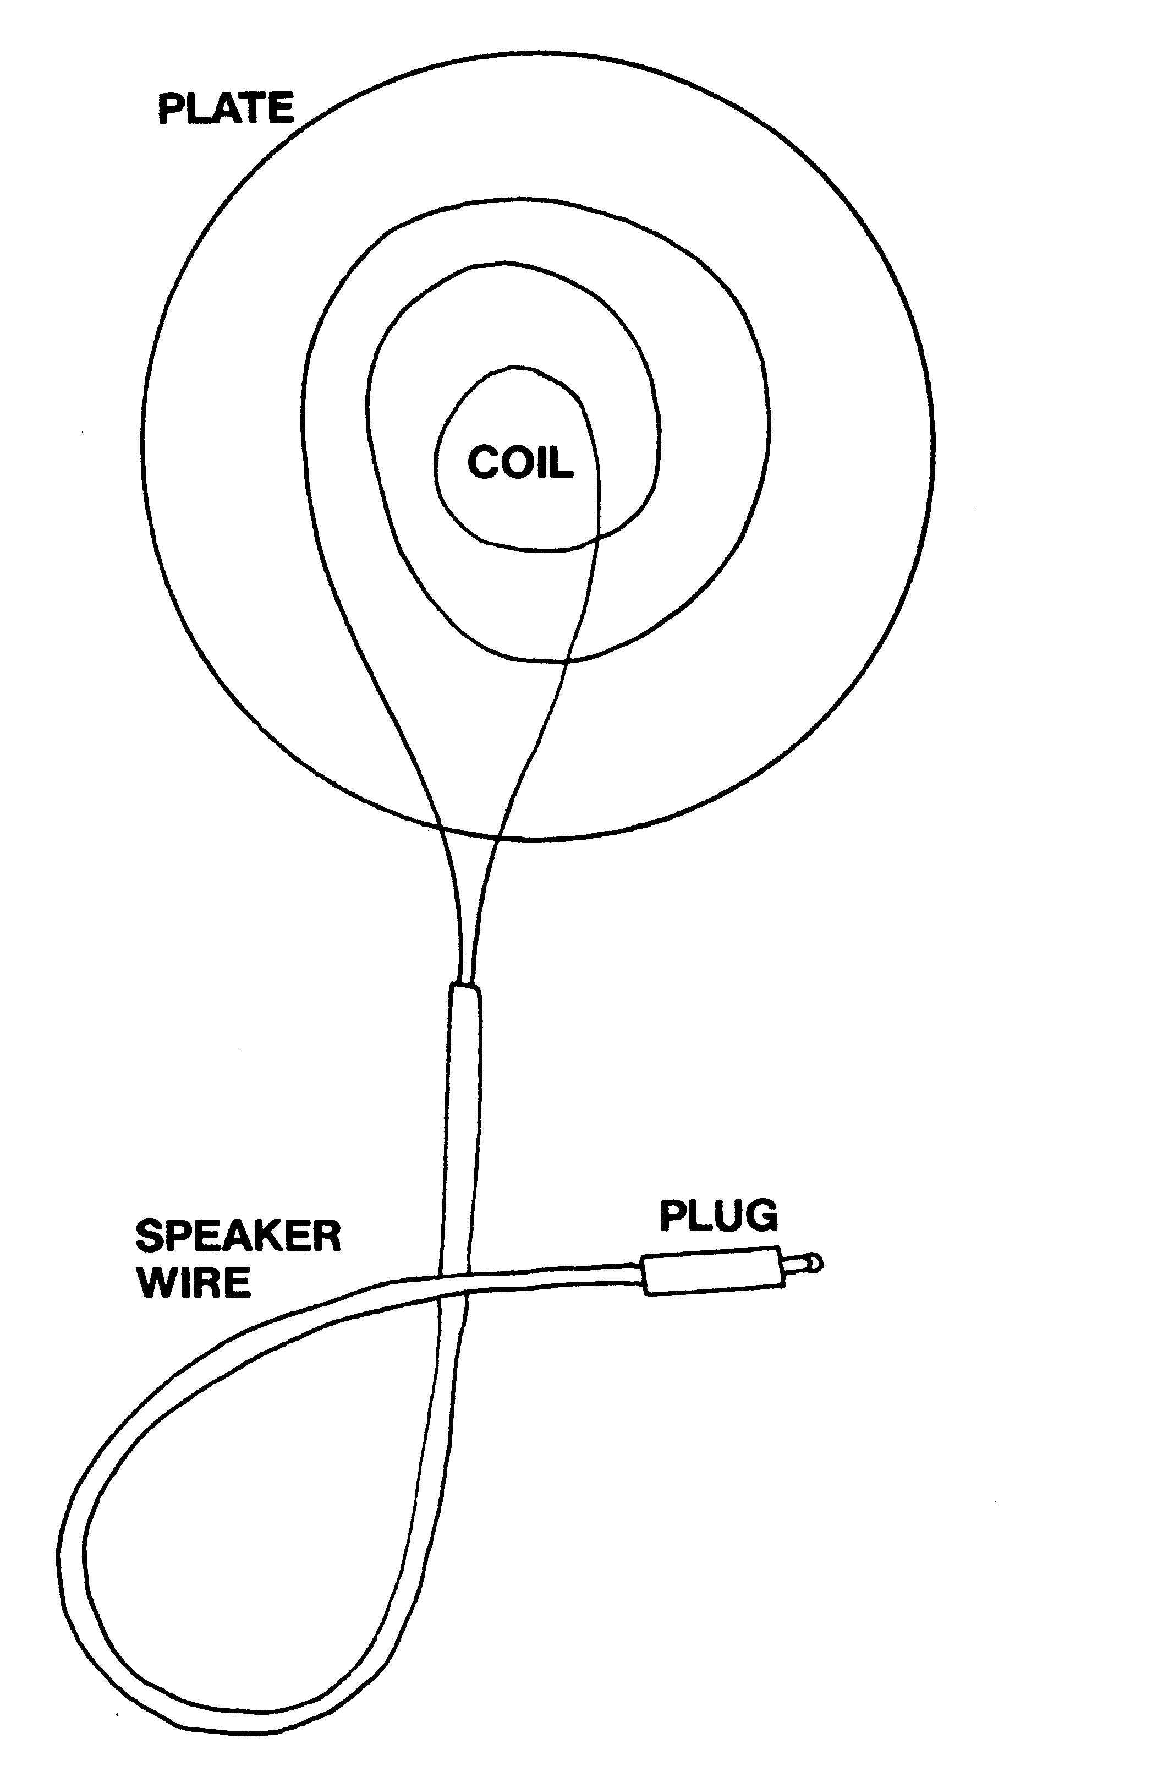
The portable detector is useful for any operation where you need only a yes/no response and now we come to the helmet.
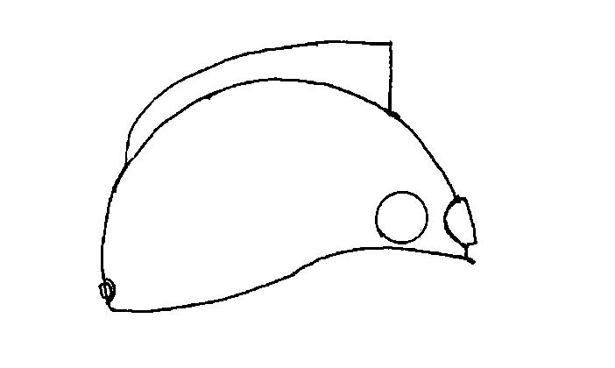
To build this helmet you will need:
A plastic hard hat three potentiometers three dials one small jack one piece of foil eight one-inch pieces of magnet strip (found in most craft stores) several feet of magnet wire hookup wire a large sheet, or two smaller sheets of ½ inch Styrofoam duct tape
Begin by trying the helmet on. This may sound silly but you need to know how everything will fit inside as you are going to be wearing this thing and you want to be comfortable without having your hair getting caught in things.
Look at the front and find the center of forehead, high enough so that the works of the tuner will be totally inside the helmet and the dials not scraping the rim in front. Mark this point and measure around each side a couple of inches so that when the dials are mounted they form a nice row across the front. Actually the dials can be anywhere, but they are much more convenient if they are placed in front. This makes the helmet look nice.
At this point you should decide where you are going to put the jack. In my illustrations I have placed it at the back of the head, but if you want to put it somewhere else, that’s fine. Just remember you don’t want it scraping your scalp or your cheek.
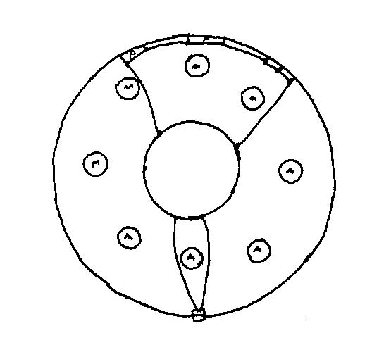
Mark this spot as well.
The last mark goes at the top of the helmet, in the center. That is where the antenna comes out. Once this is done, take the hard hat out to the garage and hook up your drill. Once the holes are drilled, wire the pots in series as you did in making your box
and mount them on the helmet.
Take your pieces of magnet strip and mount them inside the helmet. As you mount them, make sure the polarities of each strip alternate. Try to keep them an equal distance apart.
Put the liner of the hard hat back in and see how it fits. Then take it out again. Cut the foil into a circle and fix this so that when the helmet is on it will press directly on the top of your head, right on the crown chakra.
Using the unshielded wire, make a coil and mount it under the hole in the top of the helmet with one end of the wire running out the top and the other end to the foil circle.
Insert the jack. Make sure that the wires from the jack are long enough that they will not interfere with your head. Attach these wires to the foil circle with a drop of solder. Then wire the pots to the circle as well.
Now you get to make the crest and the antenna!
Begin by making the crest first. This is actually a bit complicated so pay close attention. You start by making a pattern on a piece of paper.
Tape the paper down to a table and rest the helmet on its side so that the top of the helmet is parallel to the paper. Trace the curve of the helmet on the paper and then set the helmet aside. Lift the paper from the table and cut out the curved section. Now test it to see that it fits properly. Get this right!! the crest must fit properly, it can be very frustrating but it is very important.
Once you have this pattern, draw the complete crest on it. Carefully cut each piece of Styrofoam so that it fits the pattern and try each piece on the helmet.
Cut the wire for the antenna and lay it along the side of one of the halves of the crest, making certain that an end of it comes out from under the crest. Spread glue and lay the other half of the crest on top, then put a book on the sandwich to press it together and let it harden.
Once the crest is hardened, attach the wire coming out of it to the wire sticking out of the helmet by simply twisting them. Once that connection is made, glue the crest to the top of the helmet.
Neatly wrap the crest in duct tape to protect the Styrofoam. Attach the dials to the tuners if you have not already done so and paint it in some pleasing color.
You should now acquire a patch cable so that you can attach the helmet to your box. You will remember that the box has two jacks. The jack attached to the can is for input, and the jack attached to coil is for output so that if you wish to transmit to the subject on the box, you would plug the helmet into the jack under the can and if you wish to receive from the subject you would attach the helmet to the jack under the stick pad. It is really very simple.
The helmet is tuned by placing a witness sample in front of you, inserting the plug from the portable detector into the helmet jack and turning the dials while stroking the pad.
The helmet is used primarily in communication work and to aid in psychic transmission you should make a simple device called a teleflasher. To make this machine you will need:
One cardboard box On light bulb socket and wire set One 25 watt light bulb One flasher plug
The flasher plug may be a little hard to find. If your local hardware store doesn’t have them they can be found online.
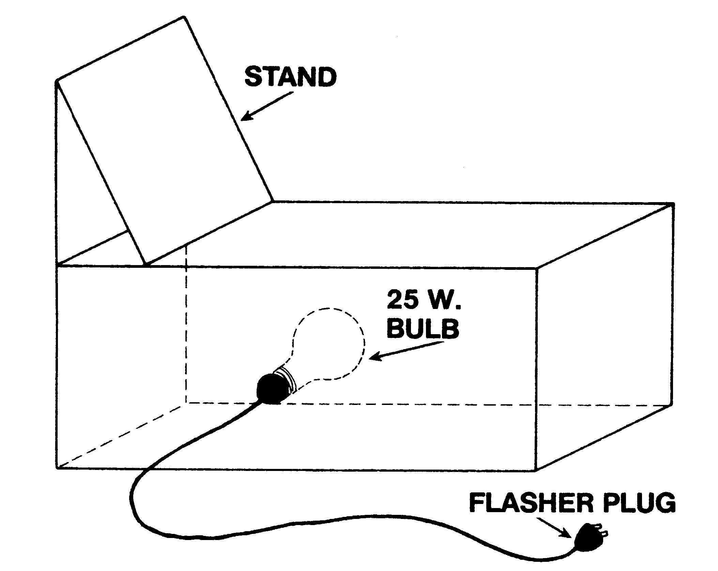
Begin by cutting out the bottom of the box. When doing this, cut a nice rectangle out of the cardboard so that you will have a piece to use for the back support.
Make a hole in the side of the box and insert the socket for the light bulb and screw in the bulb. Attach the flasher plug to the socket.
Now, bend the remaining piece of cardboard so that it will stand up and glue it to the box so that the light will shine up through the hole in the box and onto the cardboard. Plug in the light and test it. The bulb should glow weakly for a few seconds and then flash on and off with some degree of regularity.
The flashing light can be a bit uncomfortable so you may want to cover the hole with a couple of layers of wax paper or translucent plastic to cut down on the brightness and diffuse the light a bit.
When using the teleflasher, the word or picture to be sent is placed standing against the back support and the light is turned on. The flashing light makes sending easier and when used with box and helmet to lock onto the target the results can be striking.
APPENDIX TWO TRANSMITTAL PATTERNS FROM THE LESSER KEY OF SOLOMON
When using these patterns remember that they often have multiple uses, so it is best to write the intention on a small piece of paper and put it in the transmittal side of the box with the pattern.
Agares
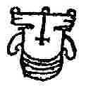
This is one of my favorite disruption patterns. It is supposed to be able to wreck careers and reduce the status of important people. The pattern works quite well on politicians. This pattern may also be to cause earthquakes and increase the subject’s knowledge of languages.
Aini
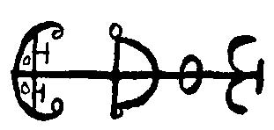
Another disruptive pattern. This one can cause fires, so it is said. It is more useful in improving the cleverness of the subject.
Allocen
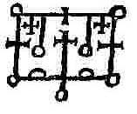
I have not had much use for this pattern. It improves the ability to absorb knowledge and would thus be extremely useful for a student, particularly of the natural sciences and astronomy.
Amon
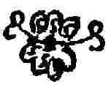
I highly recommend this pattern to some of my friends. It can reconcile enemies and cause love.
Amduscias
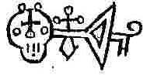
I was almost tempted to leave this one out. It is supposed to make trees fall and do little else, but you may might like to try it on your weeds or your neighbors big old tree that is blocking the sun from your house.
Amy
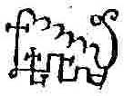
Transmit this one to your student friends. It is supposed to be quite helpful in learning.
Andrealphus
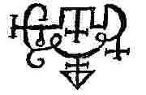
Another student’s helper, this one specializes in math.
Andras
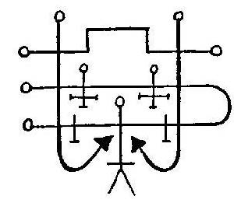
A personal favorite of mine and one of the most effective and deadliest of disruption patterns.
Andromalius
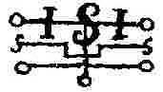
If you are having trouble dowsing for something, set up this pattern on your box with your own witness sample.
Asmoday
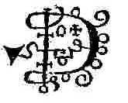
A useful pattern for dowsers and students. It increases the abilities of both.
Astaroth
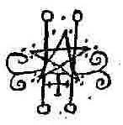
Another friend of the student, this pattern increases the ability to learn about anything and had a nice, but small role in the 1920 movie, The Golem which makes it the only spirit who can act.
Baal
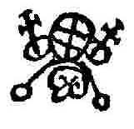
Not to be confused with the Great God of the Canaanites, this pattern increases learning ability.
Balaam
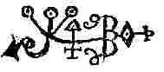
Another pattern for increasing knowledge. It is also supposed to aid in precognition and clairvoyance.
Barbatos
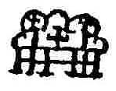
This pattern is useful for making friends, as well as for finding ways to make money.
Bathin No, this pattern does not cure your dirty in-laws. It increases the speed of travel so you might want to put it in your car to see if it cuts down on your commuting time.
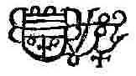
Beleth
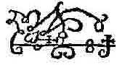
Can you imagine drawing this by hand?? The sole use of this pattern is to procure a mate and is most effective when used with an amplifying pattern. But beware, procuring a mate means procuring in-laws.
Belial
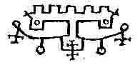
This pattern helps in any situation where it is necessary to gain the favor of others, particularly if you are running for office.
Berith
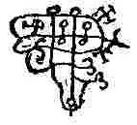
Another pattern useful in gaining promotions. Bifrons
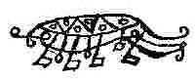
Some of these spirits have even sillier names than rap “artists.” Anyway, this pattern is good for anyone studying mathematics.
Botis
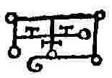
This pattern is good for turning enemies into friends. Personally, I prefer to kill my enemies, but I suppose some folks would use it.
Buer
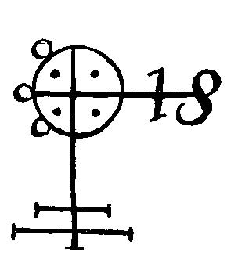
This is possibly the best pattern for healing energy. Transmitting this pattern will make the doctor’s work somewhat easier. But don’t forget to call the doctor!
Bune
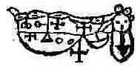
Transmit this pattern to anyone who is in financial difficulty or needs help with public speaking.
Caim I must confess that I have never had much use for this pattern. It is supposed to help you understand animals and my cats have never had any trouble making themselves understood.
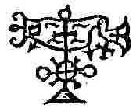
Cimeries
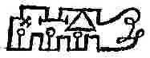
You can use this pattern to increase your courage and to improve both your knowledge of literature and your dowsing ability.
Dantalian
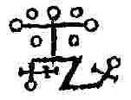
A good pattern for aid in remote viewing. It is also useful in making someone fond of you.
Decarabia
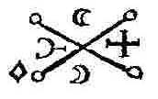
This is another pattern I have never had call to use. It is supposed to increase a person’s knowledge of herbs and stones, two subjects I have never been much interested in.
Eligor
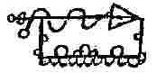
Now, this is more my style! This pattern is just the thing for kindling lust and starting wars. It’s as cool as land mines!
Flauros Another extremely powerful disruption pattern, one should never start a psychic war without it.
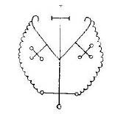
Focalor
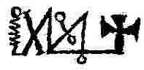
This pattern almost looks like a circuit diagram, doesn’t it? It is a disruption pattern that is most effective against shipping or for weather control. So if your brother-in-law has a fishing boat that goes out in hurricane season...
Foras
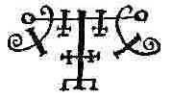
This one can help a person master logic and become witty. Hell, using it you might even become me!
Forneus
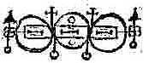
Just for fun, I once showed this pattern to an electronics expert friend of mine, who immediately asked me what kind of infernal machine I was building. Well, this pattern is just the thing for those studying a barbaric, non-American tongue and can also make your enemies your friends, though why anyone would want to learn the language of the foreign heathen and not just kill their enemies is beyond me.
Furcas Those who are confused by the mysteries of deconstructionism (and who isn’t) or just find Plato utterly mysterious should use this pattern as it instructs in philosophy.
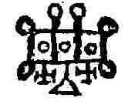
Furfur
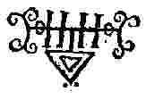
No, this isn’t the spirit of the Easter Bunny. This pattern helps to cause love in marriage or thunder and lightning. You figure it out.
Gaap
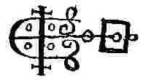
This is a nice, general purpose pattern. It can be used to cause love or hate, increase divinatory skills or help with transportation problems.
Gamygyn This pattern is for those who wish to contact the dead. Glasyalabolas
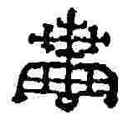
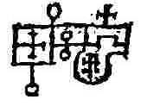
The energies of this pattern incite men to violence and murder. Just the thing for a family reunion.
Gomory
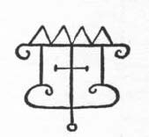
This pattern is useful in gaining the love of women. I have no idea if it works on men.
Gusion
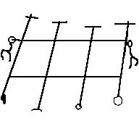
Another favorite of mine. Aside from reconciling enemies, it causes honor and promotion and works wonders at getting through traffic.
Hagenti
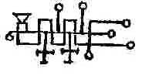
There is little known practical use for this pattern so you may want to experiment with it. The spirit was supposed to turn metal into gold or wine into water, two abilities of dubious modern value.
Halpas
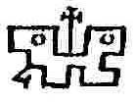
A general disruptive pattern. Shoot it at your neighbors when they are drinking in the backyard and watch the fun.
Ipos
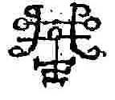
Aim this pattern at yourself if you need either wit or courage. Lerajie
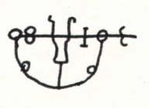
This is a disruption pattern, the function of which is the exact opposite of Buer. It delays healing.
Malpas Another disruption pattern. Aim this at your neighbor’s kid’s birthday party. Marbas
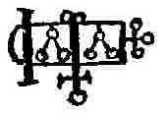
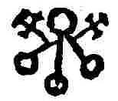
You may use this pattern in all matters regarding health, either to improve healing or to cause illness.
Marchosias
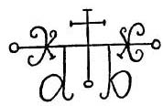
Transmit this pattern to yourself if you are about to engage in any sort of combat. Morax
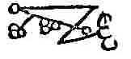
Transmit this one to your favorite astrologer. She might even give you an accurate reading for once.
Murmur This pattern is useful for those wishing to contact the long dead. However, if they have been gone for too long they may have already reincarnated and thus you should not bet the house on any horse they recommend.
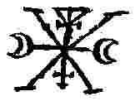
Naberius
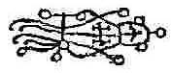
If you have managed to get your boss mad at you, use this pattern to get back into his good graces.
Orias
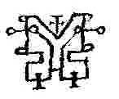
Another pattern useful in gaining promotion. Orobas
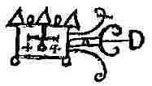
This pattern too is useful in gaining friends and influence. Ose
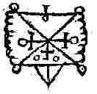
This pattern, when fired at an opponent, can seriously inhibit his reasoning abilities.
Paimon
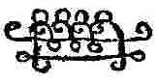
If you wish to have power over people, and that is what psionics is all about, use this pattern.
Phoenix
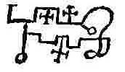
In addition to being the resident demon of Arizona, this pattern should be used if you wish to write poetry but cannot get your rhyme and meter straight.
Procel
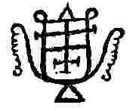
If your local adolescent is having trouble with geometry, give him a shot of this pattern and his grades should improve.
Purson
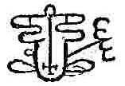
Set up this pattern before you go dowsing for your neighbors bearer bonds.
Raum
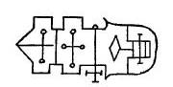
This is a disruption pattern that is useful not only against people but cities as well. In the 1980s I combined it with a photo of the battlefield of Verdun and fired it at Basra. The results were nothing short of spectacular.
Ronobe
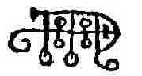
Another pattern that is useful for making friends. Sabnack
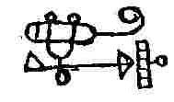
This is a disruption pattern that is useful against shipping or anything else at sea. Remember your brother-in-law’s fishing boat?
Saleos
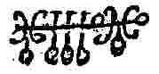
All this pattern does is promote attraction between the sexes. That should be sufficient.
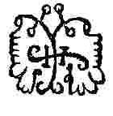
Here is another pattern that needs experimenting on. The spirit it was supposed to represent had the useful ability of causing anything to happen, which covers a lot of territory.
Shax
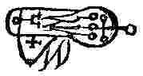
This pattern can be used to bring money or as a disruption pattern. Solas
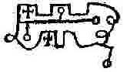
Anyone who is a student of astronomy, astrology or some bizarre reason, herbalism would do well to take an occasional dose of this pattern.
Sytry
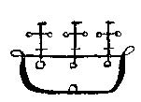
An old friend who comes highly recommended. This pattern will stimulate attraction between any man and woman.
Valac
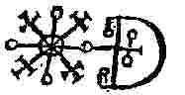
This pattern is useful if you are a snake charmer in need of money because it gives power over reptiles and helps dowse for wealth.
Valefor
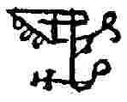
This pattern is a good healing pattern for all ills save kleptomania because it can be used to create a desire to steal. It is not a good idea to transmit it to a politician. It is a fun idea to aim it at your local K Mart.
Vapula
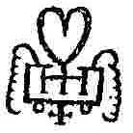
No, this is not a valentine for a mad scientist. This pattern is useful for any student because it increases general knowledge. (Now you know why Uncle Chuckie is so smart.)
Vassago
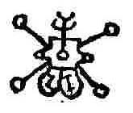
In addition to being the only pattern with feet, this pattern increases the abilities of dowsers and remote viewers, especially those who wish to spy on women.
Vepar
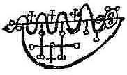
Another disruption pattern that attacks people in water. Aim it at the local swimming pool and see what happens.
Vine
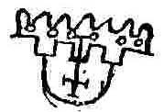
If you are going to engage in psionic warfare, or rather WHEN you are going to engage in psionic warfare, use this pattern. It can help you dowse the identity of an attacking psychic and penetrate her defenses.
Vual
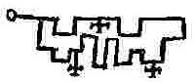
After the war is over you can use this one to patch things up. It causes friendship.
Zagan
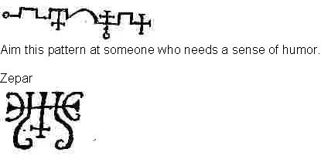
And I end this book with something totally out of character, a pattern whose sole ability is to cause love. So now you have it. Get out there and raise hell! Uncle Chuckie

