RIGHTEOUS DECREE OF
CURSE AND ETERNAL DAMNATION

The Great and Unalterable Curse and Eternal Damnation upon the Whole of the House of Levi and the Whole of the House of Judah and all Knowing and Unknowing Associates, Assigns and/or Supporters Thereof as Decreed and Invoked by LORD OF LORDS El Aku ALIHA ASUR HIGH, Anointed Witness of this GENERATION OF FIRE on June 1st, 2007, is in absolute obedience to Direct Orders issued by The Most High Lord God of All Creation, ALIHA ASUR HIGH.

There is nothing anyone other than those of the Whole of the House of Levi and the Whole of the House of Judah can do to alter or rescind these terms and conditions of this Righteous Decree. Those millions who have perished as result of the vile Damnations, Conspiracies, Collusions and High Treasons by the Whole of the House of Levi and the Whole of the House of Judah will be accounted upon the heads of those living and dead and all subsequent generations after them until Shiloh.

All others, whether knowing or unknowing associates, assigns and/or supporters thereof should immediately abandon their Damnations in The Sight of The Most High and make an immediate and full restitution.
There will be no excuses in The Day of Reckoning when The Most High calls "time enough" for anyone who has not made that immediate and full restitution. The Damnations, Conspiracies, Collusions and High Treasons, including all the iniquities, pain and suffering as a result thereof, will be accounted upon every guilty party's head and upon all their generations after them just like this Righteous Decree upon the Whole of the House of Levi and the Whole of the House of Judah who instigated and manipulated all these Damnations in their effort to socialize, enslave and control the whole world.

More information is free and available online at www.TheAkurians.com.

The Akurians
Post Office Box 3456
Albuquerque, NM 87190 USA
Tel: 505-796-4651
Invocation Edition.


of

upon

and


Decreed and Invoked
by
LORD OF LORDS
El Aku ALIHA ASUR HIGH,
Anointed Witness of this
GENERATION OF FIRE
June 1st, 2007.

The Akurians
Post Office Box 3456
Albuquerque, NM 87190 USA
Tel: 505-796-4651

THE AKURIANS

The True Spiritual Tribe of the Children of Abraham. The few, and very elite, who were Ordained by The Most High, Himself, to both warn the population and call those in power into account, whether King or Priest.
Of their many titles, Anointed, Messiah, Prophet, Holy One of Abraham, Son of Man, Son of God, Law Giver, Holy One of Israel, Holy One of Ishmael, Judge and Righteous Daughter of Akuria, they all suffer the ignorance, stupidity and brutalities of those they are sent to inform and rescue.
The Akurians are the only individuals since: the Tribe of Levi profaned all their Righteous Direct Contact and Communications with The Most High, and sold it for a farthing in the streets as it were an aged whore for worth and value; The Most High, Himself, will Testify of, for and about.
No other church or religion has That Great Testimony! Only the Akurians, and as of this writing, only one living human, His Divine Majesty, Lord of Lords, King of Kings, El Aku ALIHA ASUR HIGH, Holy Anointed Witness of This Generation of Fire, has the direct personal Testimony of The Most High. And nobody else, living or dead.
"The Anointed, The Elect, and The Damned!" online and print, available everywhere TRUTH is unencumbered.

More information is free and available online at www.TheAkurians.com.
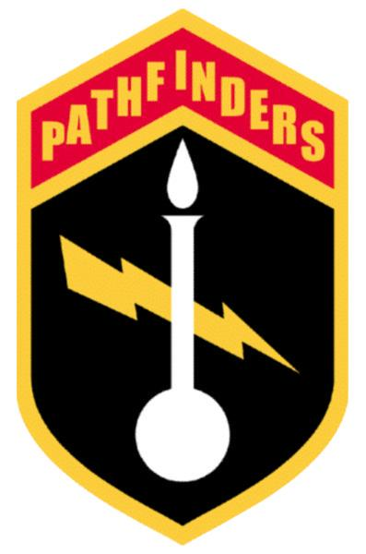
Military Order of Pathfinders,
King's Regiment

EMBLEM AND SYMBOLS

The Lord of Lightning striking out of the dark, as the power behind the Lamp of True Knowledge. Note both the Lamp and the Flame are pure white, indicating the absolute infallibility of the True Knowledge that stands alone, even on a rounded base.
The Golden Edged shield is in Memory of and Honor to all those who have served the cause of Peace and Justice.

MILITARY ORDER OF PATHFINDERS

Militarily structured Mission/Rescue Order chartered under the Anointed of God Assembly, dedicated to charitable works and endeavors. All Officers are Ordained and all troops serve without compensation. Women serve in equal status as men.

More information is free and available online at www.TheAkurians.com.

