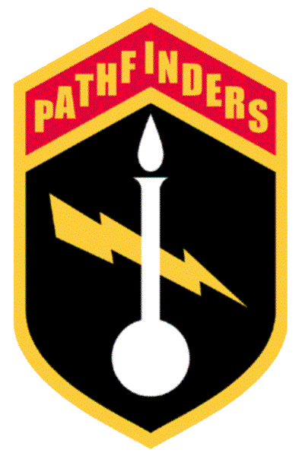
MILITARY ORDER OF PATHFINDERS, KING'S REGIMENT

The PATHFINDERS are the militarily structured Mission/ Rescue arm of the Anointed of God Assembly, the full title being The Anointed of God PATHFINDERS of Elijah. United States citizen PATHFINDERS are limited to charity in religious matters and to the restoration of the Constitution of the United States of America, which in its original form, we hold as a Holy Document.

More information is free and available online at
www.TheAkurians.com.

The Akurians
Post Office Box 3456
Albuquerque, NM 87190 USA
Tel: 505-796-4651
Invocation Issue – 27th June 2007 GCAD
2 Tamuz 5767

THE MOST HIGH LORD OF SPIRITS
ALIHA ASUR HIGH

issues this

IRREVOCABLE CURSE OF EL AKU UPON
THE WHOLE OF THE HOUSE OF LEVI
and
IRREVOCABLE CURSE OF EL AKU UPON
THE WHOLE OF THE HOUSE OF JUDAH

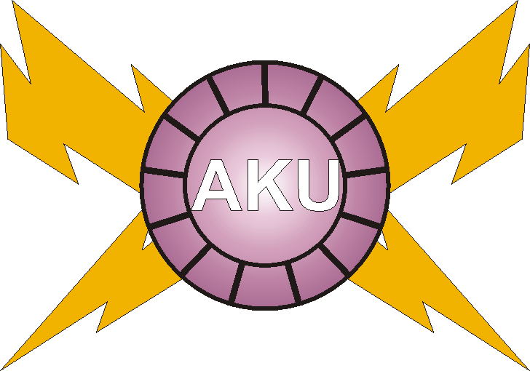

PRONOUNCED AND INVOKED BY
LORD OF LORDS, KING OF KINGS
El Aku ALIHA ASUR HIGH
ANOINTED WITNESS OF THIS GENERATION OF FIRE
and the
RIGHTEOUS DAUGHTERS OF AKURIA
TRUE PROVEN KNOWERS OF
THE GREAT TESTIMONY.
OTHER ISSUES IN THIS SERIES

*** Indicates verbatim reprint from
"The Anointed, The Elect, and The Damned!"

The Protocols to All Living Souls ***
Given directly by The Most High, Himself, and translated into English from the Heavenly Angelic. Terrifying to the jackass cum demonic elements.

The Proof Of The Anointing ***
Known as The Great Testimony. The Most High, Himself will Testify to all the Righteous. Direct, absolute confirmation. Upsets organized religions and hallelujah halfwits.

The Great Curse Of Noah Upon Canaan ***
Who and what caused the Curse that holds all Black People in its grip yet today. FULL TEXT of the Invocation. Where it came from, WHO did it, and WHY!

The Great Curse Of The Most High Upon Cush ***
Revealing the REAL cause that perpetuates the Curse from generation to generation. The Black People can beat this Curse once they know and understand the REAL rules!

Mercy For All Mixed Race People ***
Any racemixing is a tremendous Blasphemy Against the Holy Spirit of Truth, the unforgivable sin! What about the children? Comforting answers devoid of socialist poppycock.

The Process Of Restoration Of Purification ***
Exacting and Righteous process that ensures all racemixed victims – even those who involved themselves in ignorance – a full and complete spiritual and physical restoration.

Instant Clairvoyance ***
The EXACT HOW to open your Spiritual Eye INSTANTLY! No complicated meditations or worthless trappings and takes about ONE MINUTE! Vast spiritual development potential.

Astral Projection – "Up In The Spirit" Without Dying ***
How to enter into and safely return from the many Planes of Heaven and Hell without dying. Immanuel (whom the ignorant call "Jesus") paid the admission some 2,000 years ago!

The Protocols To The Four Horsemen ***
Who they really are! Hallelujah halfwits and other self-appointed 'people of god' haven't a clue. Awesome information the Manipulators really can't afford for you to know!

CONTINUED ON THE INSIDE BACK COVER
OTHER ISSUES IN THIS SERIES

*** Indicates verbatim reprint from
"The Anointed, The Elect, and The Damned!"

The Protocols To The Anointeds ***
Naming some of them throughout history. Reveals some of the Righteous Powers and Holy Authorities they all shared during their respective Reigns as Messiah.

The Protocols To The Seven Swords ***
Those destined and called by The Most High to put an end to abuse of power, governmental crimes and atrocities. Who they are, their qualifications and duties.

The Protocols To All Proven Knowers ***
The Most High's direct orders, instructions, rites and procedures for those who want to be KNOWERS of God rather than whining wimp 'believers'.

The Righteous Decree Against Levi and Judah
The Great and Unalterable Curse and Decree of Damnation upon The Whole of the House of Levi and The Whole of the House of Judah and All Knowing and Unknowing Associates, Assigns and Supporters Thereof.

The Irrevocable Curses Of El Aku Upon The Whole Of The House Of Levi and The Whole Of The House Of Judah
The charge, indictment, adjudication and sentence ordered by The Most High, ALIHA ASUR HIGH, Himself, pronounced and invoked by The Living Messiah, El Aku ALIHA ASUR HIGH and the Righteous Daughters of Akuria.

Price Ppd for all REPRINTS – $10.00 US and $14.00 Foreign,
All other issues are $25.00 and $29.00 Foreign,
The Anointed, The Elect, and The Damned!, Ppd
The Grand Issue – $34.95 US and 39.95 Foreign.

Order online at www.TheAkurians.com
or
make check, draft, money order payable to:
PATHFINDERS, Inc.
Post Office Box 3456
Albuquerque, NM 87190 USA

Quantity Discounts
505-796-4651

Copyright, The Akurians, 2007
International Copyright Secured.
All Rights Reserved.

Permission granted to quote in whole or in part with due credit
and recognition of source.

