WARNING! WARNING! WARNING!

The Sacred Contents of this book cannot be ignored. The Most High Lord God of All Creation, ALIHA ASUR HIGH, Himself, Ordained these charges and set these Righteous Judgments upon the guilty.

WARNING! WARNING! WARNING!
Do not attempt to use these Holy Processes
and/or Righteous Processes as contained herein
under any conditions, regardless of how well intended!

WARNING! WARNING! WARNING!
Unless you are Directly Ordained by The Most High, Himself, being a True Proven Knower of The Great Testimony, as specified in:
"The Anointed, The Elect, and The Damned!"; that specifically excludes any and all other religions, faiths, sects, cults, assemblies and other such organizations, and specifically their educational institutions; The Akurians are not, and will not, be held liable or responsible for any outcome whatsoever as (a) result of any unauthorized uses or attempted uses of these said Holy Processes and/or Righteous Procedures.

More information is free and available online at www.TheAkurians.com.

The Akurians
Post Office Box 3456
Albuquerque, NM 87190 USA
Tel: 505-796-4651
Original Invocation Edition

and


Invoked this 27th Day of June, 2007, GCAD.
The Akurians
Post Office Box 3456
Albuquerque, NM 87190 USA
Tel: 505-796-4651

THE AKURIANS

The True Spiritual Tribe of the Children of Abraham. The few, and very elite, who were Ordained by The Most High, Himself, to both warn the population and call those in power into account, whether King or Priest.
Of their many titles, Anointed, Messiah, Prophet, Holy One of Abraham, Son of Man, Son of God, Law Giver, Holy One of Israel, Holy One of Ishmael, Judge and Righteous Daughter of Akuria, they all suffer the ignorance, stupidity and brutalities of those they are sent to inform and rescue.
The Akurians are the only individuals since: the Tribe of Levi profaned all their Righteous Direct Contact and Communications with The Most High, and sold it for a farthing in the streets as it were an aged whore for worth and value; The Most High, Himself, will Testify of, for and about.
No other church or religion has That Great Testimony! Only the Akurians, and as of this writing, only one living human, His Divine Majesty, Lord of Lords, King of Kings, El Aku ALIHA ASUR HIGH, Holy Anointed Witness of This Generation of Fire, has the direct personal Testimony of The Most High. And nobody else, living or dead.
"The Anointed, The Elect, and The Damned!" online and print, available everywhere TRUTH is unencumbered.

More information is free and available online at www.TheAkurians.com.
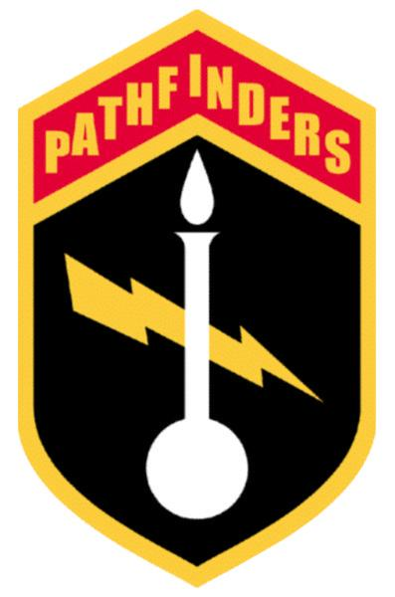
Military Order of Pathfinders,
King's Regiment

EMBLEM AND SYMBOLS

The Lord of Lightning striking out of the dark, as the power behind the Lamp of True Knowledge. Note both the Lamp and the Flame are pure white, indicating the absolute infallibility of the True Knowledge and that it stands alone, even on a rounded base.
The Golden Edged shield is in Memory of and Honor to all those who have served the cause of Peace and Justice.

MILITARY ORDER OF PATHFINDERS

Militarily structured Mission/Rescue Order chartered under the Anointed of God Assembly, dedicated to charitable works and endeavors. All Officers are Ordained and troops serve without compensation. Women serve in equal status as men.

More information is free and available online at www.TheAkurians.com.

