To my beloved Akurian Brothers and Sisters,
I have thought long and hard about the Belial and Beelzebub issues between and among us. From a personal point of view it has made me think about how it has influenced me, my thoughts and actions. I ask each to consider taking "Ownership and Responsibility" for how it has influenced you. When we ALL get a handle on this...we will ALL be more effective as a team and grow exponentially as well as individually.
WARNING: some may find this email lengthy - but if you remember nothing else after reading it...
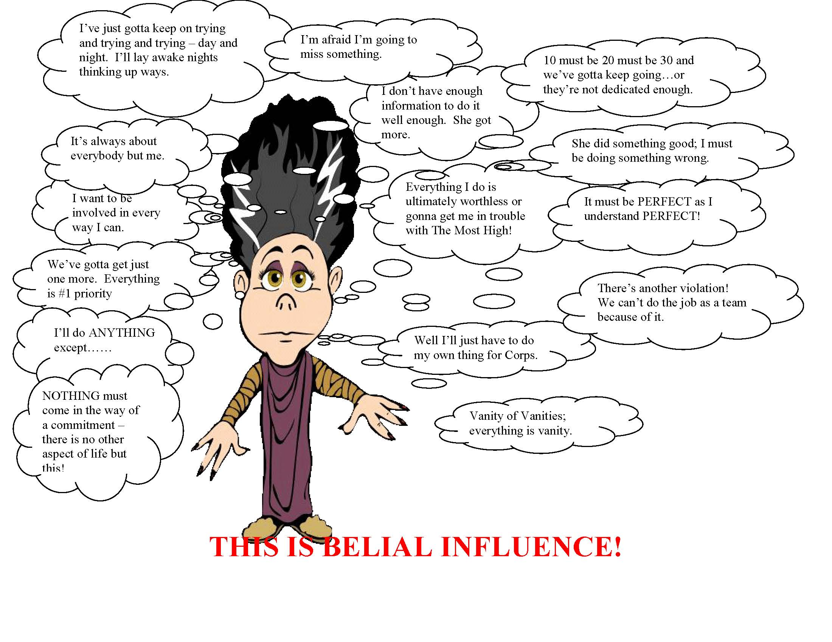
Belial Influence
Excerpt from Moon Audience 07 07 09
Lucifer has ordered Beelzebub, Beelzebub has ordered Belial, and Belial has personally seen to the injection and perpetuation of hatred and animosity between my few, specifically all those who are Members of the Grand Council of Gnostics.

Therefore, my first inclination is to arm myself, seek out Lucifer, Beelzebub, Belial and all their minions and slay them, which all three know they cannot survive.

Excerpt from Manual of Discipline
Moreover, all who would join the ranks of the Community must enter into a Covenant in the presence of God to do according to all that He has commanded and not to turn away from Him through any fear or terror or through any trial to which they may be subjected through the domination of Belial.
When they enter into that Covenant, the Priests and the Levites are to pronounce a blessing upon the God of Salvation and upon all that He does to make known His Truth; and all that enter the Covenant are to say after them, "amen, amen."
Then the Priests are to rehearse the bounteous Acts of God as revealed in all His deeds of power, and they are to recite all His tender mercies towards Israel; while the Levites are to rehearse the iniquities of the Children of Israel and all the guilty transgression and sins that they have committed through the domination of Belial.

And all who enter the Covenant are to make confession after them, saying, "We have acted perversely, we have transgressed, we have sinned, we have done wickedly, ourselves and our fathers before us, in that we have gone counter to the Truth. God has been right to bring His Judgment upon us and upon our fathers.

Howbeit, always from ancient times He has also bestowed His mercies upon us all, and so will He do for all time to come."
Then the Priests are to invoke a blessing on all that have cast their lot with God, that walk blamelessly in all their ways; and they are to say, "May he bless thee with all good and keep thee from all evil. And illumine thy heart with insight into the things of life, and grace thee with knowledge of things eternal, and lift up his gracious countenance towards thee to grant thee peace everlasting."
The Levites, on the other hand, are to invoke a curse on all that have cast their lot with Belial, and to say in response, "Cursed are thou for all thy wicked guilty works, may God make thee a thing of abhorrence at the hands of all who would wreak vengeance, and visit thine offspring with destruction at the hands of all who would mete out retribution. Cursed art thou, beyond hope of mercy. Even as they works are wrought in darkness, so mayest thou be damned in the gloom of the fire eternal. May God show thee no favor when thou callest, neither pardon to forgive thine iniquities. May He lift up an angry countenance towards thee, to wreak vengeance upon thee. May no man wish thee peace of all that truly claim their patrimony.
And all that enter the Covenant shall say alike after them that bless and after them that curse, "amen, amen."

Excerpt 2 from Manual of Discipline
The following procedure is to be followed year by year so long as Belial continues to hold sway.
The Priests are first to be reviewed in due order, one after another, in respect of the state of their spirits. After them, the Levites shall be similarly reviewed, and in the third place all the laity one after another, in their thousands, hundreds, fifties and tens. The object is that every man in Israel may be made aware of his status in the Community of God in the sense of the ideal, eternal society, and that none may be abased below his status nor exalted above his allotted place. All of them will thus be members of a community founded at once upon true values and upon a becoming sense of humility, upon charity and mutual fairness-members of a society truly hallowed, partners in an everlasting communion.

We have ALL been influenced (the injection and perpetuation of hatred and animosity) by Belial and until it is recognized by ALL of us of the influence, we are going to have problems doing the job we have to do. While we can do our jobs through hard and forceful dedication, there is inherent friction still there that need not be. Much, if not all, can be eliminated IF we have the knowledge and understanding of the job Belial is doing to us specifically as individuals and to everyone else generally.

No!!!!! We are not possessed! We are all INFLUENCED!

Repeat – we are all INFLUENCED!

The Belial influence is causing us to have perpetual hatred and animosity between and among ourselves because it causes us to think of things, including ourselves, as being WORTHLESS and/or INADEQUATE individually and collectively, over and about anything and everything. That is what Belial does and or causes to make happen; it's his job. That's why we're swimming in it and can't seem to get it out of the way. We need to STOP the effect of the influence and MUST do so if we are to be successful! And, we can be VERY successful!

The other day upon receiving notifications via email of the earthquakes in Jakarta, they were noted then as handprints. While there was no specific indication at the time for the reason for noting them as such, they were noted as a handprint with an intuitive knowing to do so. Often information like such is simply attributed to news and often thrown away after reading. But Jakarta was something to attend to…..



About a year ago, an Akurian contacted several companies in Jakarta to do some business. It would have taken about a year for them to tool up and run the course of the business opportunity for what was in mind. This time of the year (Fall 2009) would mean the season for the opportunity is over and there was a non-response for the dynamic. The time for it to work properly would have probably started around February/March/April to be completed there and get product here in the United States around April/May/June.

This Akurian did not specifically target Jakarta nor was anything hard invoked. It was an idea for a business so a bit of money could be made by manufacturing an item; get something done, and the desire to do it without any kak-jew (that part was a soft specific in the process). There was no bubbling, direct invocation, or anything else. It was done without involving any other mind or any other energy except through the fruits of the individual's effort. All that was desired was a reasonable financial consideration.

Last night about midnight or so (October 18, 2009), I got an intuitive message regarding the reason for the handprint. It happened because they rejected the business opportunity. There was no other specific targeted reason for any other Akurian to target Jakarta.

It was The Most High Lord God of ALL Creation taking care of the situation for OFFENDING one.

Several years ago, it was the President of Indonesia who called the Jews into account – something Akurians take GREAT pleasure and delight for when anyone else does so. It was also the reason they were HARRP'd in 2004. It is also true the President eventually apologized for the comment because it was reported by the media as being Anti-Semitic. We ALWAYS pay attention to those who call the Jews into account and we endeavor to support them when they do. The apology was also something that Akurians would NEVER do and they were punished with the Tsunami anyway – such is the nature of Evils of Kak-Jew.

The glory of the situation is the result due to the nature of the offense – it wasn't even the equivalent of a hang-nail to the Akurian. The Most High, however, saw something much, much, more in that rejection and made use of ALL our energies (our individual as well as our group fire blasts in China; some have been able to dedicate more time in this quadrant of the world than others) involved including His own. There was no way at the time the Akurian did.

The point of the story is to make it about being AKURIAN and what The Most High will do on OUR behalf using this as an EXAMPLE and so much more when we are about the business. It was The Most High who did the job. This is an equivalency of the Walls of Jericho falling down – which I hope we all can agree on we need more of! You'll note that it wasn't any of us that specifically did anything individually or as a group to Jakarta yet none of us have been remiss, inadequate, or negligent in our duties.

We need these stories as a part of who and what we are and do; they help our Hit and Handprint count! And, we need to have them without Silliness and/or Vanity that has become a part of us – ALL OF US. The Silliness and/or Vanity comes about because an Akurian got a victory that none of us were specifically in on.

In the past, when there's been such a victory with any of us individually, that's where the inadequate and/or worthless energies come in and end up being pussy tangents, soap-operas, and dissension causing shit because everyone else wasn't involved.

Such a victory can and does make it seem like we haven't done our jobs and/or what we do isn't "good enough." That's when the soap operas start and why they continue. Or when we do something and we KNOW there is the slightest of reason to cause less than success when a group endeavor (blast) comes about and we don't get the success we think we should as a result, the same thing happens.

Sometimes we are given jobs to do that don't involve everyone else. When others aren't included (asked, told or otherwise), it can make things seem like we aren't 'good' enough to do the job to be asked. Yet in EVERY instance, there are generally four reasons why:
1. Other duties and/or responsibilities at the time and would be an overwhelming one more thing that is simply put, too much to do
2. Can't put over the phone (you'll all notice this is changing somewhat)
3. Something just came up and needed to be dealt with right then
4. Sometimes someone has time, skill, and/or other resources available to do the job

We can make these things stop because it isn't the case of being inadequate or worthless. We are ALL important and we ALL have reward coming to us if we do things right! We are ALL capable of setting in motion the ENERGY requirements to do the job from wherever we are - it isn't dictated by time or space.

We can and will FORCE WITH OUR BREATH all that we are, who we are, put there and assigned by The Most High Lord God of ALL Creation, Himself, to do the jobs we do. And, we can STOP Belial's influence!

Consider – how many people will think they are unworthy enough to take The Proof because they think they have too much to 'fix up' and make themselves become some undefined more worthy before they are able to. It happens – make no mistake! We can't wait that long to get things under control especially if there is something we can DO about it to accelerate the process by binding the influence affecting them – and we've got some FANTASTIC skills to do it with now don't we!

We are not inadequate or worthless or we would not be in the positions in the first place. We are AKURIAN! Knowing the influence of Belial's treachery can assist us in the re-framing of how we look at things now and in the future, BEAT his pathetic ass, and keep him from beating up on new seekers of Righteousness and Truth because it is very likely they have the same problem too!

