BODES OF HADES – POWERS OF HELL
Part, the First
1 July 2012 - 11 Tamuz 5772

Akurians, by now those most-deserving of all Deaths and Damnations we have applied upon them are ignorant of the fact we did not fail; and are equally ignorant of the fact THAT was, is and will remain only a sample of what we have in store for their communist asses. Akurians prefer to operate in the Planes of Heaven but are not adverse to using the Depths of Hell as may be required. Whatever works the fastest – or the best – on the Earth Plane is our weapon of choice.
Akurians are as familiar with descending into the Depths of Hell as we are ascending into the Planes of Heaven; making and using a Body of Light, Black Fire, direct Sun energies and hammer enemies across the spectrum. We dissolve clouds at any distance, create winds, storms and sunshine. We bind and loosen anywhere and everywhere in Creation. And now that kindergarten is over, the Akurians are going to become extremely dangerous.

Akurians, I want each and every one of you to know and fully understand that what we are going to do over the next few weeks and months is extremely dangerous: to ourselves as much as to our enemies! Jackass any part or sequence and you can very well bring the whole Damnation down upon yourself and upon own head. Jackass on some know-so-much agenda and I will not bail you! PERIOD! This is NOT a parlor game, nor anything even near a sing-a-hymn-and-pass-the-plate hallelujah halfwit idiocy.
Each of you will be subject to dealing with Lord Lucifer, Himself! And I can tell you on damned good, first hand authority he is not the incompetent pusswilly portrayed by those who have never encountered him in close proximity. He can appear as anything and everything. He can read your strengths and weaknesses better than you can read the weather while standing out in it. He knows more about you than you know about yourself because his discernment and memory capabilities are virtually flawless. Don't think him to be an amateur in any category. He loves it when fools do that because in that same instant HE HAS WON THE ENGAGEMENT! No exceptions to the rule.
Next, don't think you can just overpower Lord Lucifer or any of his minions on the basis that YOU are an Akurian or even a Proven Knower. He doesn't jackass with his mind-set, and neither does any minion he will permit to approach any Akurian, Proven Knower or not. As I said, he is not an amateur, nor an incompetent, and especially when it comes to deviousness or treachery. And he is extremely strong, both spiritually and physically; and can exercise more patience than all the declared Saints combined. His mental and spiritual abilities are extreme to the extreme degree this side of the Veil. That he is putrid personified evil is of no value to you or anyone else who moves against him, especially with ignorance or stupidity intact.
I need to repeat: He can appear as anything and everything. He often appears as the most beautiful creature imaginable; seeming to portray every element of Righteousness and goodness beyond words in any language. There is no limitation to his ability to deceive, and this is but one example. In this same vein, there isn't any known limitation to his ability to create horror, terror or agony as he deems appropriate; which he will 'rescue' you from. Unlike a physical body that will perish when sufficiently overloaded, a spirit body does not die: and therefore can be overwhelmed with agony and cannot escape or reduce the suffering. Then along comes well-draped Lord Lucifer posing as an Avenging Angel of Light to 'relieve' all those horrors, terrors, sure and certain atrocities that he, himself, created for the purpose.
Again, I repeat: He can appear as anything and everything. He is extremely dangerous. But he is not infallible. He is not invincible. There ARE chinks in his armor. Fools, pusswillies and hallelujah halfwits can't take advantage of them, but True and Righteous DISCERNING Akurians can! And in order to do that, Akurians must have a far greater ability to DISCERN than we've managed to develop to date. We are going to stay on DISCERNMENT and DISCERNING until we can tell the breed of a mosquito by its bloodlines and know what or who the victim was after it has eaten! FYI, unlike politicians, only the females suck blood.

Yes! We're going to learn to DISCERN our entire body and Spirit beings BEFORE we begin to take on the Demons of the Deep in their own Domain!

ARE THERE ANY QUESTIONS?

The first thing we're going to discern is ourselves! YOU are going to discern YOU!
That's a lot harder than it sounds. Discerning YOU requires being absolutely honest with yourself about YOU and yourself. That can often be very painful as result of some of our life's experiences. PTSD regardless of its degree or source of creation isn't a joke, stuff or nonsense. To those of us who have it, it's an every-day-all-day-long embindment that is often too subtle to consider as being a conscious part of our every situation, yet never removes itself from any consideration. Opening those wounds again and gaining an understanding that even if you've considered yourself to be at fault, even in the slightest degree, there is but one sure-and-certain remedy and but one acceptable restitution-in-full: the DEFEAT of Lord Lucifer who deliberately manipulated and deliberately managed those devastating situations that caused the PTSD in the first place.
Nevertheless, that is what you MUST do in order to properly, correctly and accurately discern. That will take some of you more time than this Instructional accords, but that you must do it as expediently as possible is an equal part of the necessity. PTSD is a Luciferian creation that accounts for virtually all our personal failures. Beating that vile bastard at his own game is a very sweet reward and worth all the pain and suffering required to achieve it.

This instructional is limited to your hands. And that will take a bit of explanation.
My first real study of my hands came in the process of firing single-action revolvers. A single-action must be cocked and the trigger pulled to release the hammer for each shot. Double-action revolvers can be fired by just pulling the trigger, as can automatics – actually auto-loaders – fully automatic firearms are normally called "machine guns" as they continue to fire as long as the trigger is suppressed. Because of my physical size, I had to spin the weapon out of the holster, cocking it as the barrel went under my arm, and pulling the trigger when the weapon leveled. Sounds simple, but it's a real piece of hard expertise to accomplish. I had to designate the EXACT target I wanted the round to hit; then cause everything else in the sequence to be EXACTLY where and when I wanted it when the weapon was fired. Anything askew and the round went somewhere else: "close" didn't count except to tell me WHAT and/or WHERE and/or both I didn't do EXACTLY.
The set of hands is everything. Too high from where the weapon rests in its holster and the index finger misses the trigger. Too low and the weapon comes out of the holster out of balance, wobbling side-to-side, guaranteeing a sure and certain MISS when the weapon is fired.
Without understanding a damned thing about spirit or metaphysics, I had to take the time and do a hard study of my hands. What changed as the weapon spun?, as it was cocked?, as it was aimed?, and I pulled the trigger? What was going on with my hand in micro measurements during that micro second that elapsed from my signal to draw through the firing of the weapon? There was a time-line, and things that had to be done PERFECTLY their time; which meant that each not only had to accomplish their own part, they had to set the next part in the process! Each stage was also the preparation for the next.
Then came the worst bit of knowledge one can inflict on someone as ignorant as I was. I couldn't THINK through the sequence while doing it because THOUGHT is too damned slow! I had to study how my hands worked, the same as I had to study how the weapon worked, and then make a TEAM out of them so that one didn't get in the way of the other. Especially where my hand AND FINGERS had to be at any given point as to where the weapon would be; so they would BOTH be at their respective places when the round was fired and left the muzzle – two entirely different parts of the sequence – which had to include the rise of the barrel due to recoil.
The hardest part was to NOT think, just do! With a lot of study as the WHAT, hands, holster, weapon – including the barrel length as THAT made a huge difference from start to finish – and the WHERE with respect to the WHEN of the sequence. Everything had to happen properly for the process to work at all, and to ensure all the SAFETY required.
Then came an additional pain of must-do: the same thing all over again as individual rounds being fired changed the weight and balance of the weapon! Second through Sixth rounds had to hit the selected point/target just as accurately as the first, and the weapon lost weight and changed balance with the firing of each round. In short, I had to study the study! Then study the practice … and practice the findings until everything worked the same way every time – with either hand. Then, twenty years after starting this whole weapons handling process, I found out about DISCERNMENT!

ARE THERE ANY QUESTIONS?

DISCERNMENT!
Akurians, select either hand. Just do it in your mind, but look at it if you want to, no harm done. Now, from the wrist to the tip of your middle finger – and as if your hand were a total stranger, DISCERN IT as you would any other object!
That's right. DISCERN IT! There are points ABOUT and information IN your hand you never bothered to recognize. DISCERN IT! You take for granted that your hand works, but have you ever really questioned how complex it is? that all the various structures and systems in it must be in perfect balance, including their LOCATION? its many capabilities are not only matters of constant usage – rehearsals – but are the easiest ends to the intended means? Just like electricity, it will take the route of least resistance; water flows downhill due to gravity and the fact it's fluid – liquid – at ambient temperature. And your hand? It's the same way as is everything else in nature. DISCERN IT! Let it tell you. And you're going to find that it's far more complex than you ever imagined, and all these years you've simply taken it for granted.
This is the practiced procedure that works better than all the others and I haven't the slightest clue as to why: it just does.
We're going to DISCERN our fingers, one at a time, from the tip to the palm.
Start with your little finger. DISCERN your little finger from the fingertip to the palm. It doesn't get much attention in our take-for-granted day-to-day doing things; but surprisingly you can throw more energy with your little finger than you can with any other finger. And, it's the finger that lights up when you target! As I did initially, we suppose our index finger actually does the pointing-out when we point at something; but the little finger has already set the entire hand and mind and far more accurately than most of us will ever imagine. NOW YOU KNOW the "why" of holding the little finger out when picking up something to eat or drinking from a cup or glass. We're programmed to suppose it's proper 'etiquette' when in fact it's another social element to PREVENT us from ENERGIZING whatever is in our hand! You'll note there is NOTHING in the REFLEXOLOGY photos about this phenomenon. ???
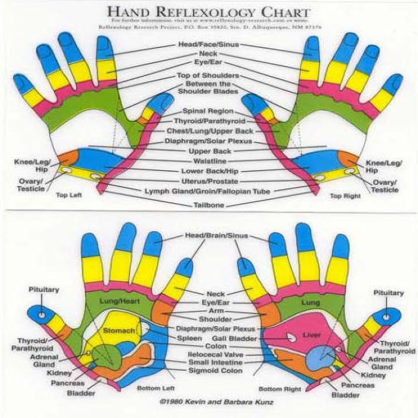
Now run this simple test: With the index finger of one hand, which hand doesn't matter – draw a circle around the outer edge of the palm of your other hand, and THEN draw an "X" across the palm. Virtually nothing, right? Now do the same thing with the little finger … when you draw the "X" there's an instant coolness in the palm of your hand … as if a breeze of air! Do it without the outer circle and there's virtually nothing. Draw the circle, make the "X" and there's the slight coolness again.
Now WHEN, and not before I give the command: for those of you who can get close enough to a door, solid back chair, table, whatever can be used as a barrier between your hands, REGARDLESS of the distance between your hands: With your index finger, draw a circle THROUGH the barrier, targeting the same area of your palm – a circle around the outer edge – and then an "X" across the palm.
Akurians, on my command:
Perform your index finger exercise. Draw a circle around the palm and then an "X" across the middle.
Let me know when you're finished and back on the line.

Virtually zero effect. The barrier didn't make any appreciable difference.

Akurians, on my command:
Perform your little finger exercise with the same barrier. Draw a circle around the palm and then an "X" across the middle.
Let me know when you're finished and back on the line.

Again, the same little finger effect: A slight coolness in the palm of your hand.

Now we have to question: "Why the little finger is so much more powerful than the index finger?" We're used to using our index finger far more than any other! WHAT is going on here? What do we need to do to get our index finger up to the speed we've always thought it had? The process is far simpler than most of us would ever guess, and I blundered into it via some assistance of my fellow Horsemen.
When using your index finger, instead of drawing a circle, draw a SQUARE! Then draw an "X" corner to corner!
Akurians, on my command:
Perform the procedure.
Let me know when you're finished and back on the line.

You'll note an instant coolness on all four sides AND the full length of the "X" … Cool again.

Now for an expansion, draw another SQUARE and make the "X" from center-line to center-line rather from corner to corner.

You've found a cool square and virtually nothing of the "X" again, a bit to be sure, but not much.
Why the difference between an "X" corner to corner and an "X" center-line to center-line? Simple, the "X" center-line to center-line makes FOUR squares. The SYMBOL is a critical factor.
Strange? Yep. And so it is with all things of True Spirit!

Now we're going to save a bit of time, although I want each of you to practice and test in your own time: and MAKE TIME to do it!

Your middle and ring fingers when used together actually throw the most energy, nearly eighty percent of the intent! Test it yourself when I give you the command: Using your middle and ring fingers in unison, flick them off your thumb, throwing the energy into the palm or at the back of your other hand. It's almost the same impact as you experience when using all FOUR fingers, but it may be slightly off target if you paid close attention. Now do the same thing, again, only use all FOUR fingers and note the slight improvement in impact energy and the vast improvement in accuracy!

Akurians, on my command:
TEST YOUR HAND IMPACT PROCEDURE!

Akurians, now DISCERN your whole hand again. What a magnificent difference! DISCERN the palm of your hand separately, and note the improvement in CONTROL! Flex your fingers and you'll find you have a lot more CONTROL and ACCURACY! To some of you it may seem like you just discovered you have something on the end of each arm that is not only miraculous, it's an access to POWERS you heard about but didn't KNOW actually existed.

ARE THERE ANY QUESTIONS?

As I said before: We're going to learn to DISCERN our entire body and Spirit beings BEFORE we begin to take on the Demons of the Deep in their own Domain!
But we are going to do exactly that: With the full and deliberate intention of dragging the Demons AND their Domains UP from the Depths and flood all the socialist bastards and THEIR dominions and domains with Hell in its purest form and with all its fury intact.

For practice in preparation of next week's Instructional I want each of you to view the attached photographs. The name of the pseudo-science is REFLEXOLOGY and it's about as bogus in modern practice as a politician's promise. However, the foundation is thousands of years old, some data predating writing in many cultures. The FACT is the premise is built on the actual structure of the human body and its nerve structure primarily with respect to the transmission of energy to an from any given place in the body. The original practice was a form of physical medicine built on those Spiritual – called "ethereal" – energies. The Anunnaki swear by and use it extensively. The problem is, modern practitioners haven't a clue as to HOW the Anunnaki make it work. And most of them are both too Spiritually bereft and outright stupid to even know about, let alone use, the energies of the so-called 'nerve' system and their marked so-called 'endings' in the hand, face and feet. One of their biggest failures is due to their ignorance of the FACT that most of the 'connections' are NOT physical, but Spiritual, "etheric" if you must! Practitioners may admit somewhat to mental/spiritual/etheric forces, but really don't KNOW a damned thing about them and even less as to how they work.
What the Anunnaki did and still do that modern practitioners don't even know exists is DISCERNMENT! Ancient metaphysicians eventually drew out the so-called 'nerve ending' maps, and for the most part the surviving copies are better than 99% accurate. And, as you will note, right and left hands, feet and face are entirely different as to the area of body they are attached to.
And THAT brings us to a hammer point: the "attachments" are not completely physical! Thus, the LACK of discernment would be mal-practice in legitimate medicine! When YOU take the time to discern your HANDS, then your FEET – and in that order unless you want to jackass – and finally your face, you'll find you don't normally need any physical rubbing or stimulation to either detect or treat the specific part of your body. If and when you DO need physical contact – IF you have done your homework DISCERNMENT – you will be able to accomplish more in two minutes doing it yourself than any 'practitioner' can in two hours! First, they'll be in find-out-trial-and-error mode of discovery, and YOU will already have all that information AND the discerned what-to-do-about-it, how to do it, and what to look for should there be any necessary follow-up. And YOUR treatment may be as simple as pulling energy out, putting the right energy in, et cetera, WITHOUT ever physically touching the sensitive area!

A simple and practical instruction: but do NOT attempt to DISCERN your head until AFTER you have discerned your hands and THEN YOUR FEET! You're just asking for a jackass if you do your DISCERNMENT in any other order – and perhaps a whole lot BIGGER set of problems if you DISCERN with some craphead agenda in mind.
AFTER and only AFTER you have a solid discernment read OF YOUR HANDS, should you even begin the same process with your feet – and not until! Either foot has more bones and nerve attachments than the rest of the body combined except for the other foot! DISCERN them, one at a time, and let the energies tell you! DO NOT – REPEAT – DO NOT attempt any other agenda via your DISCERNMENT of your feet other than letting the energies tell you!

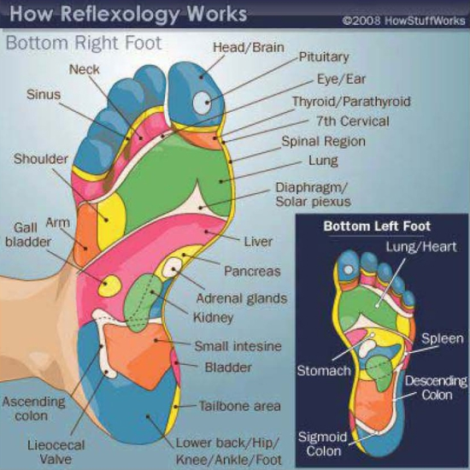

We're going to cover FEET next week and HEAD the week after that and WHOLE BODY the week after that! Go off half-cocked with your own agenda and nothing I can teach you will be able to bail you out. This is dangerous territory and CAN be permanently destructive. Firearms, artillery, fire and chemical weapons and bombs are dangerous too, but in the hands of those properly trained, disciplined, knowledgeable AND MORAL, they can be assets of immense value. The same is true of any and all Spiritual Knowledge and Powers.
That you MUST discern to learn how to do it properly is a matter of PRACTICE! Required PRACTICE. You will never get enough practice, so don't waste any opportunity.

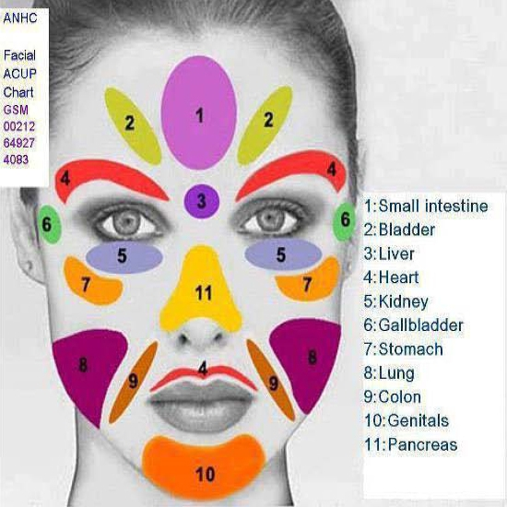
Look at your copy of the REFLEXOLOGY chart – for the face. Note that the sensitive areas appear to be exact opposites. And to SOME degree they are, but that is a minor point when the TRUTH is known; and virtually all modern practitioners are totally ignorant of the FACT you're going to learn next:
First, there isn't any nerve, blood or bone structure from Point 3, between the eyes at the bridge of the nose, to the LIVER! If there isn't anything – a system of some kind – linking that Point 3 directly to the LIVER like the bones in your arms and legs attach your hands and feet: THEN THAT ATTACHMENT MUST BE SPIRITUAL! Some sort of ethereal energy. Period.
The RIGHT side of your face, even if you're left-handed, IS energy-connected to those bodily areas given in the photograph; but with respect to the EXTERIOR to the exclusion of the INTERIOR! Now understand that. Point 7 on the roll of the cheek is energy-linked to the STOMACH. The RIGHT cheek energy-link is to the EXTERIOR, the intestinal wall and any and all connections be they blood vessels, gland-secretion vents, attachments, everything EXTERNAL to the innermost part of the intestine. In short, and very generally speaking, if it's the external of the organ, the energy attachment is linked to the RIGHT side of the face.
The LEFT side of the face is energy-linked to the INTERIOR of the organ. Bodily organs do NOT perform everything they do only on their surface, but IN their INTERIOR which can be extremely complex and are best NOT jackassed with – even by experts.
POINT TO PONDER: There is an natural and unlearned habit of bumping a head with the base of your hand, often as a point of "I should have thought of that" kind of response. Both the center of the forehead and the base of the palm of the hand are energy-linked to the SMALL INTESTINE! Why the SMALL intestine? Because THAT is where your body extracts everything it can from the FOOD you've eaten: and if it fails, YOU WILL DIE! Most deaths from a blocked-bowel are blocked IN the small intestine! You hit yourself in the forehead, energy-linked to the small intestine – with the base of your palm, also linked to the small intestine, in a natural habit to RESTORE the normal balance of digestion!
There is another natural trait, covering the face with both hands – as in embarrassment – or one side of the face with one hand as in a point of sudden acknowledgement. These are ANCIENT and natural responses, having more to do with applied metaphysics as opposed to social graces.

ARE THERE ANY QUESTIONS?

